MLS Self-Test (Automatic if power interrupted 3 seconds)
- Autopilot Disengaged
- Flight Director Switch to NORMAL
- Select MLS on FDMS
- Dial in Airplane Heading on HSI CSW
- Activate Self Test on IDCU
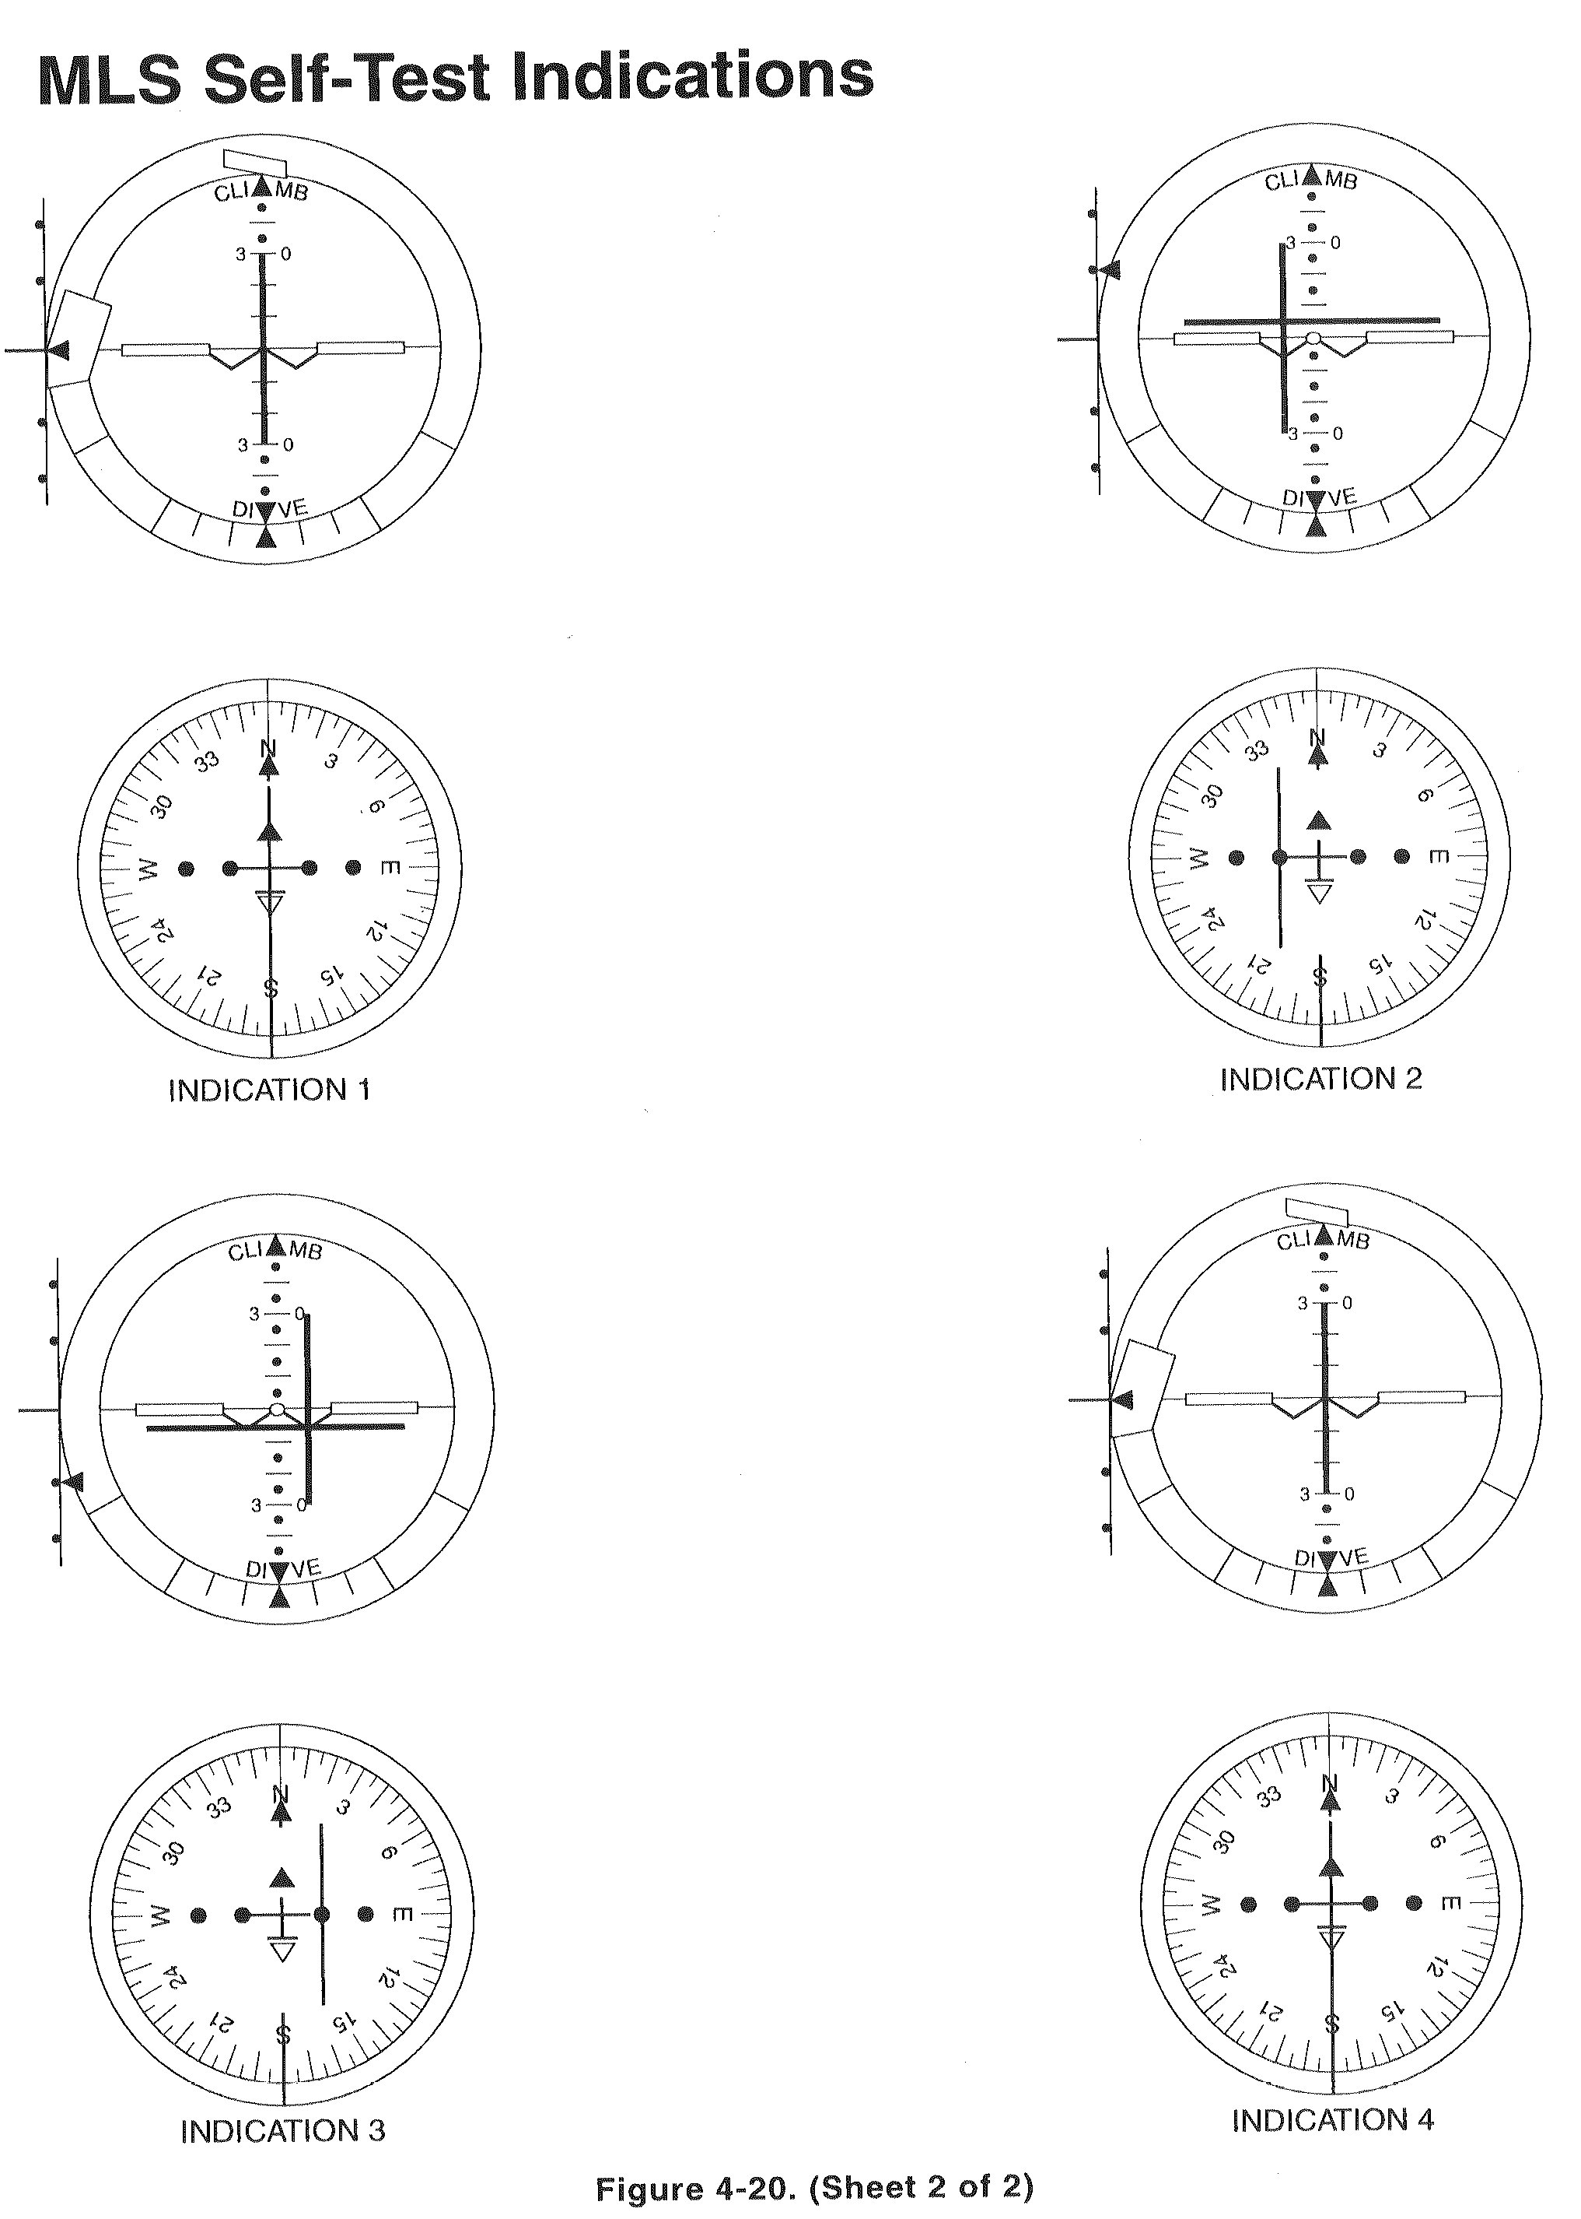
MLS Approach Guide
- MLS and TAC – ON
- Tune MLS – Desired channel
- Tune TAC – MLS TAC frequency if req’d (Warning 4-74) [Only if prior to SCNS OFP 40.07]
- MLS 1-2 Page – Verify AUTO mode selected (Default)
- MLS 1-2 Page – Select NON-COMP/COMP mode
- Select COMP for COMPUTED MLS approach
(Warning 4-74)
- Select NON-COMP for MLS approach (Default)
- MLS 2-2 Page- Verify 4 letter ident (Mxxx)
- MLS 2-2 Page- Verify OVRD not selected
- Select MLS on FDMS
- Select approach heading on HSI CSW
- Verify – TAC not selected on either FDMS
- MLS 2-2 Page – Confirm TAC on MLS frequency
- Flight Director Switch – NORMAL
- Fly the Approach
- Intercept – MLS course
- Monitor – Ident on MLS 2-2 page
- Missed Approach – Retune TAC as required

