Instrument Study Guide

- When must you file IFR? (IWANA) 11-202 vol3 8.1.2.
  - When practicing Instrument approaches unless MAJCOM waives the requirement
  - Weather conditions do not permit flight according to VFR
  - Operating in Class A airspace
  - At Night (unless operational requirements dictate otherwise)
  - Operating within Federal Airways (does not include crossing)

- What is a published approach? (DROL)
  - Any DOD or NOAA FLIP procedure
  - A published Radar approach (PAR, ASR)
  - Procedure not in FLIP, but approved by MAJCOM for which an Operational requirement exists
  - Any MAJCOM approved Local use procedure

- What weather is needed to file to a destination (all weather ±1hr from ETA)
Destination Wx | Alternate Wx
0-0 ≤ Wx ≤ Published Mins | Wx ≥ 3000-3
Published Mins ≤ Wx ≤ 3000-3 | NP: Wx ≥ Published Mins + 300-1  P: Wx ≥Published Mins +200-1/2
Wx ≥ 3000-3 | No Alternate Required for weather criteria

- Describe the Takeoff Minimums
Non-Precision Approach | Precision Approach
Published Mins ≥ 300-1* | Published Mins ≥ 200-1/2 (24)**
*Published Minimums to the available non-precision approach | **Published Minimums to the landing runway in use. (24) is standard is prevailing visibility/RVR in 100s of feet

- What does the ANa mean to military pilots?
  - It tells pilots that the specific approach cannot be used in order to qualify the field as an alternate because of a lack of either weather reporting facilities and/or the capability to monitor the NAVAID.

- When is an alternate required (RUG,33)
  - Radar is required to fly the approach
  - The NAVAID you are using is Unmonitored
  - GPS is the only available NAVAID
  - Weather at destination is forecast to be less than 3000-3 (±1hr from ETA)

- When may you file through an area with an issued WW, CAWW, SIGMET?
  - If the storm has not developed as forecasted (determined by qualified forecaster) you may:
    - File VFR if existing and forecast weather for the planned route permit VFR flight
    - IFR flight may be permitted if aircraft is radar equipped, allowing detection and avoidance of isolated thunderstorms
    - IFR flight is allowed in positive control areas if VMC can be maintained, enabling aircraft to detect and avoid isolated thunderstorms.
  - Performance characteristics permit flight above existing or developing severe storms. (not used in training command)

- What is the normal instrument approach configuration?
  - Approach flaps, Props full forward, Gear down, landing lights, 130 KIAS

- When must the Landing Checklist be completed for an instrument approach?
  - Before the FAF/FAP or Glideslope Intercept unless “holding the gear” for SSE

- When should you configure for an instrument approach?
  - Non-Precision: 3 mi from FAF/FAP
  - Precision: 1 ½ dots below glideslope
  - SE Non-Precision: Approach Flaps, Props Full Forward after normal configuration point and before FAF/FAP, lower gear when field in sight and in safe position to descend for landing
  - SE Precision (ILS/PAR): Approach Flaps, Props Full Forward after normal configuration point, lower gear at ½ dot below glideslope (or 10 second gear warning for PAR)
  - SE ASR: Same as non-precision if NOT using recommended altitudes on final. If using recommended altitudes configure as in a SE precision approach

- What is holding airspeed in the TC-12? What the standard length of the inbound leg? (FTI)
  - Holding airspeed is 150 KIAS
  - 1 minute at or below 14, 000’ MSL
  - 1 ½ minutes above 14,000’ MSL
  - Max holding speeds: Navy 230 KIAS, AF 310 KIAS, FAA (0-6,000ft 200kias) (6,000ft -14,000 230kias) (>14,000ft 265 kias)
  - Holding direction is the same as outbound leg direction (example: “hold NW” > outbound leg 290)

- Explain the “triple drift correction” for holding (FTI)
  - Use course guidance inbound to determine drift correction, then use 3 times that drift correction on the outbound leg to compensate for lack of drift correction in the turns.

- What category is the TC-12? Can you fly an approach that only has Cat B mins? (FTI)
  - Category C ( 121 knots ≤ 1.3 times stall speed in landing configuration at max gross weight < 141knots)
  - Yes, local policy says we can fly the approach only if weather is better than 3000-3

- What are the four types of IFR departures
  - Diverse Departures
  - IFR (Obstacle) Departure Procedures (trouble T)
  - Standard Instrument Departures (SIDs)
  - Specific ATC Departure Instructions

- Describe a Diverse Departure? When will an airport have a diverse departure?
  - Fly runway heading to 400’ AGL before turning while maintaining minimum climb gradient (200 ft/NM) until reaching a minimum IFR altitude
  - When the airport has at least one IAP and no published IFR departure procedures (because no penetrations to 40:1 OIS)

- What is considered a good lead point for a 90° turn in the TC-12 at 150 KIAS?
  - 0.8 NM works well with as a no-wind lead point

- What are Navaid Characteristics?
  - Tune, Identify and Monitor all Navaids (TIM)
  - NDB – Not Line of Sight (not affected by terrain and obstacles but affected by thunderstorm)
  - VOR/TACAN/LOC – Line of Sight (affected by terrain and obstacles but not thunderstorms)

  - Accuracy of Navaids Signals
    - NDB- +/- 5 degree
    - VOR/TACAN - +/- 1 degree (one dot on HSI = 5°)
    - DME – ½ nm or 3% whichever is greater
    - LOC – 4 times as accurate as Tacan or VOR (one dot on HSI = 1°)
    - Glide Slope – fraction of a degree
    - Marker Beacons- very accurate
  - VOR – (VHF Omni-directional Range)
  - Primary indication of station passage, first positive TO-FROM
    - Identify by morse code
    - +/- 1 degree accuracy
    - Maximum error +/- 4 degrees on the ground and 6 degrees in flight.
    - Max difference between CDI and RMI is 4 degrees
  - TACAN – (Tactical Air Navigation)
    - Supplies directional and DME information
    - Identification through Morse code every 37.5 seconds.
    - +/- 1 degree accuracy
    - Primary indication of station passage is minimum DME
    - The DME line of sight range is 199 miles with an accuracy of ½ mile or 3 percent of the distance whichever is greater.
  - VORTAC – (VHF Omni-directional Range/Tactical Air Navigation)
    - Vortac combines VOR azimuth, Tacan azimuth and Tacan distance at one sight.
  - NDB – Non-Directional Radio Beacon
    - NDB only provides the direction to the station
    - Pilot must continuously monitor the NDB’s identification because there is no off flag
    - Accuracy is +/- 5 degrees
    - Station passage is determined when the pointer moves through the wingtip position
    - Because of dip error, adf pointer only gives accurate info in wings level flight

  - LOC – Localizer
    - Antenna is in Line with the Runway centerline.
    - Identification through a coded 3 letter station identifier preceded by the letter I
    - On Back Course localizers, always set the front course in the CDI
    - VOR needles will park when using loc and to-from flag will disappear.
    - The CDI is four times as sensitive for a localizer then a VOR or TACAN app.
    - Full Scale CDI deflection in localizer mode in 2.5 degrees.
    - Course Guidance at 18 NM and glide slope at 10NM
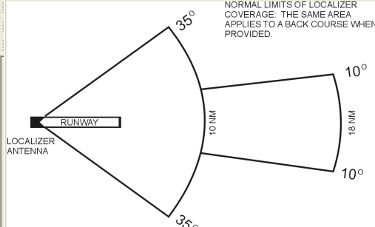
  - Marker Beacons
    - They serve to identify a particular location in space along an airway or on the approach to an instrument runway. Send a 75 MHz beam only detectable by the aircraft directly overhead.
    - OM normally located 4 to 7 miles from the end of the runway and marks the loc final app fix, OM is a blue light
    - MM normally located app 3,500 feet from the runway and marks a position on the glide path app 200 feet above the terrain, MM is an amber light
    - IM, present at locations w/ Cat II and III ILS, indicates DH, IM is a white light
    - FM and LFM fan markers are keyed to indicate on which radio range course you are located.
  - ILS – Instrument Landing System
    - ILS combines several navaids, normally includes:
    - Localizer
    - Glide Slope
    - Marker Beacons
    - Compass Locator (NDB located w/ MM or IM)
    - DME
    - ILS is a very accurate precision approach system.
    - CAT I can generally bring an aircraft down to 200 feet above the runway.

  - VOR/DME/TACAN STANDARD SERVICE VOLUMES
    - T (Terminal) From 1000 feet above ground level (AGL) up to and including 12,000 feet AGL at radial distances out to 25 NM.
    - L (Low Altitude) From 1000 feet AGL up to and including 18,000 feet AGL at radial distances out to 40 NM.
    - H (High Altitude From 1000 feet AGL up to and including 14,500 feet AGL at radial distances out to 40 NM. From 14,500 feet AGL up to and including 60,000 feet at radial distances out to 100 NM. From 18,000 feet AGL up to and including 45,000 feet AGL at radial distances out to 130 NM.

HIGH ALTITUDE LOW ALTITUDE TERMINAL
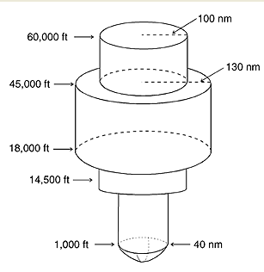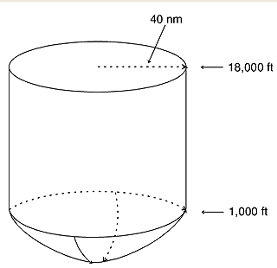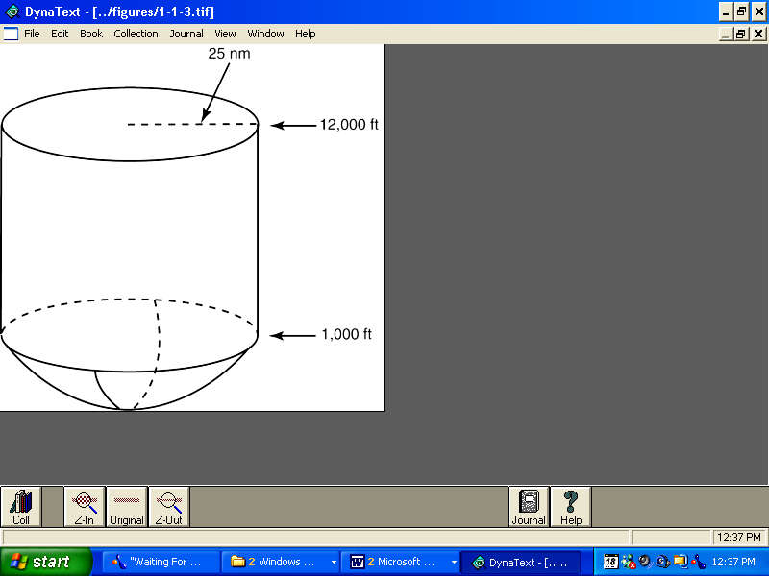
  - Nondirectional Radio Beacon (NDB)
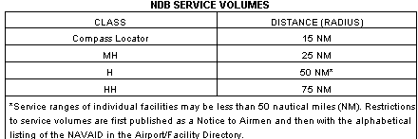
- What are common corrections for staying on an arc?
  - 5° below reference point for every ½ mile inside the arc
  - 10° above reference point for every ½ mile outside the arc

- What does the term “minimum fuel” mean? “emergency fuel”?
  - Min fuel is advisory only and indicates an emergency situation is possible should any undue delay occur. In TC-12 when fuel state indicates you will be airborne with needles in the yellow arcs.
  - Emergency fuel suggests need for traffic priority to ensure a safe landing.

- What are the required fuel reserves? What is it based on for turbine powered aircraft?
  - Alternate NOT required: takeoff to destination airfield plus a reserve of 10% of planned fuel requirements.
  - Alternate Required: takeoff to destination IAF, then to alternate airfield, plus reserve of 10% of planned fuel requirements.
  - In no case should the planned reserve be less than 20 minutes
  - For turbine powered aircraft, reserve fuel consumption based on max endurance at 10,000’.

- What are VFR cloud clearances (Class A-G)?
  - Class A not applicable
  - Class B 3 sm / clear of clouds
  - Class C 3 sm / 152
  - Class D 3sm /152
  - Class E
    - Below 10,000 ft 3sm/152
    - At or Above 10,000 ft 5sm/111sm
  - Class G Day Night
    - 10,000 ft 5sm/111 5sm/111
1sm/ 152 3sm/152
    - 1,200 AGL 1sm/ cc 3sm/152

- Describe the boundaries and altitudes of Class A, B, C, D, E, and G airspace

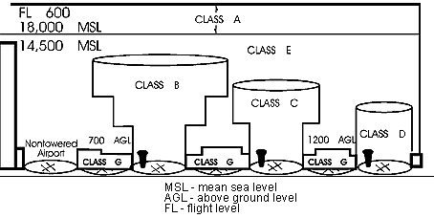

- What are the maximum airspeeds below 10,000’ MSL in Class B-G airspace?
  - 250 KIAS with the following exceptions:
    - >250 KIAS in restricted areas, MOAs, MTRs, or if the flight manual dictates
    - 200 KIAS in the airspace underlying Class B airspace
    - 200 KIAS in a VFR corridor through Class B airspace
    - 200 KIAS from surface to 2500’ AGL within 4 NM of the primary airport of a Class C or D airspace
  - note: In Class B, below Class C, and in C or D outside 4 NM or above 2500’ up to 250 KIAS is okay.
- What is the minimum altitude you can fly over U.S. Wildlife Refuges, Parks, and Forest Service Areas?
  - We use 3000’ AGL according to OPNAV 3710.7 and FTI
  - Air Force Pubs and FAR/AIM require 2000’ AGL

- When may you deviate from a flight rule?
  - An in-flight emergency requires immediate action
  - A deviation is required to protect lives
  - When safety of flight dictates

- Describe the 7 types of NOTAMS
  - Military Summary Reports: information about individual military aerodromes
  - Flight Data Center (FDC): regulatory in nature (changes to approach minimums, etc…)
  - Attention Notices: general notices to military pilots, broken into groups (USAFE, PACAF…)
  - D class (distant) similar to military summary report. Info about aerodrome, runway closures, etc…
  - L class (local): don’t need to be widely disseminated (i.e. taxiway construction, etc…)
  - Notices to Airman Publication (NTAP): four part book containing different types of notams
  - GPS notams

- Define Minimum Safe Altitudes:
  - Minimum Altitudes for IFR:
(Far 91.177) Mountainous are 2000 ft above the highest obstacle within a horizontal distance of 4 nautical miles In non-mountainous 1,000 ft within 4 nautical miles.
  - Minimum Sector Altitudes (MSA): MSA is normally based on the primary omnidirectional facility on which the IAP is predicated. MSAs are MSL alt and normally have a 25 NM radius. MSA provide 1,000 ft clearance over all obstructions but do not necessarily assure acceptable navigation signal coverage.
  - Emergency Safe (ESA): Altitudes depicted on approach charts which provide at least 1000 feet of obstacle clearance in non-mountainous areas and 2000 feet of obstacle clearance in designed mountainous areas within a 100 NM radius of the navigational facility upon which the procedure is predicated and normally used only in military procedures.
  - Minimum Enroute IFR Altitude (MEA): The lowest published altitude between radio fixes which assures acceptable navigational signal coverage and meets obstacle clearance requirements between those fixes.
  - Minimum Obstruction Clearance Altitude (MOCA): the lowest published altitude in affect between radio fixes on VOR Airways, off-airway routes, or route segments which meets obstacle clearance requirements for the entire route segment and which assures acceptable navigational signal overage on y within 25 sm (22nm) of the VOR.
  - Off-Route Obstruction clearance Altitude (OROCA): an off-route altitude which provides obstruction clearance with a 1000 ft buffer in non-mountainous terrain area and a 2000 ft buffer in designated mountainous areas within the United States. This altitude may not provide signal coverage form ground-based navigational aids, air traffic control radar, or communications coverage.

- When Do you not have to do the Procedure turn on an approach?
  - SNORT HOLD
    - Straight-in
    - NO pt
    - Radar vectors
    - Timed approach
    - Holding

- When should you not attempt to restart or preload an engine?
  - MOVE OFF – (Mechanical malfunction, Overheating, Vibration, Explosion, 0 N1, Fuel Fumes, Fire)

- IFR Operations : Two-way radio com failure (Far 91.185)
  - Route: Altitude: The highest of the following altitudes or flight levels
    - Assigned for the route segment being flown.
    - Vectored Minimum
    - Expected E expected
    - Filed Assigned

- Enroute Wx Facilities:
  - Pilot-to-Metro Service (PMSV) “Metro”
    - Usually 24hr, locations in FIH
    - FSS (Flight Service Station) : They translate and the interpret the wx along your route & help you find a new route if wx is bad
  - FAA Wx Broadcasts- TWEB / transcribed wx broadcast - HIWAS / hazardous wx advisory service
  - EFAS (Enroute Flight Advisory Service) commonly 122.00
    - “Flight Watch” - (6am to 10 pm)
  - In-flight WX Advisories – NWA issued severe wx over VORs

- Letter of Agreement and FIH procedures for Lost Comms:
LOA LOST COMM:
  - VFR: [1] Squawk 7600 (lost comm) [2] Get ATIS (CH 1). ATC may contact me on ATIS freq [3] If unable to get ATIS (and wx permits), course rules back to Navy Corpus > 3,500’MSL to determine duty runway [4] Make all radio calls “in the blind.” On approach, rock wings inbound for the break and check interval. [5] On short final, if no aldis lamp signal observed, waveoff. On 2nd pass, in no lamp signal and runway clear, land.
  - IFR: Immediately after takeoff: [1] Climb on last assigned heading/route assigned by ATC to 1,500’MSL [2] Wait 3 minutes while trying to contact Corpus Departure. If can’t establish comm in 3 minutes, climb and maintain 2,500’MSL [3] Reaching 2,500’MSL proceed directly to an approach fix for NAS Corpus and execute an approach.
    - In the GCA pattern: no comm for 1 minute, proceed direct to approach fix for Navy Corpus and execute an approach.
    - On Final: no comm for 15 sec (ASR) or 5 sec (PAR), alter course to intercept the VORTAC final approach course for runway in use and, if practicable, execute a TACAN/VOR approach; otherwise, climb and maintain 1,500’MSL, proceed direct to an approach fix for NAS Corpus and execute an approach.

FIH LOST COMM: (FIH A-6 to A-7)

In lost comm situation, can shoot any approach.

VFR: [1] Troubleshoot radios, headsets, and mike switches (check circuit breakers, transmit on UHF or VHF, change frequencies, transmit on Guard) [2] Squawk 7600 [3] Make radio calls in the blind [4] Tune up Guard and nearest VOR with voice capabilities (if applicable) ***[5] If able to remain VMC, continue flight under VFR, land as soon as PRACTICABLE (not possible), and notify ATC.

IFR: [1] Troubleshoot radios, headsets, and mike switches (check circuit breakers, transmit on UHF or VHF, change frequencies, transmit on Guard) [2] Squawk 7600 [3] Make radio calls in the blind [4] Tune up Guard and nearest VOR with voice capabilities (if applicable) [5] Route: [AVE-F] In priority order: Assigned, Vectored, Expected Further Clearance, Flight Planned. [6] Altitude: [AME] The highest of the following for the route segment flown: Assigned, MEA, Expected Further Clearance. If an EFC is given at a point where an approach begins and then comm is lost, start the approach at EFC. If comm is lost at a point where an approach is not begun, leave the point at the EFC (if given). If an EFC is not given, continue to approach point and start approach as close as possible to the time filed or amended with ATC enroute.

