T-44A Radios / NAVAIDS Guide


Step 15 of the Takeoff Checklist, RADIOS/NAVAIDS, can be very confusing the first few times around. This is an attempt to put some logical explanation behind the seemingly random button-pushing and number-entering associated with this checklist item.

It’s easiest to remember the actions in this item by using the mixer switch panel as a “visual checklist” for the radios and navaids. It may not make sense yet what each item really means, but keep reading.

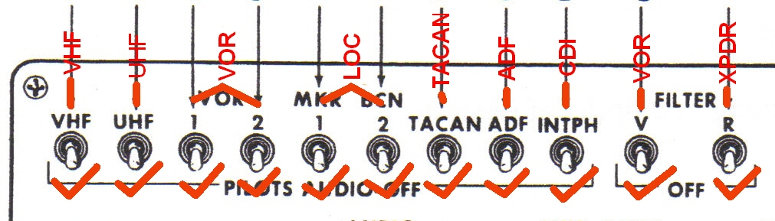

VHF
- Press COM1
- Enter 134.85
- Press PRE
- Swap the frequencies
- Swap the frequencies again so 140.325 is active and 134.85 is preset
- Press VHF 121.5 EMER switch (look for red light) and press again to turn off
- Press COM1 SQ DSBL so P and CP can adjust volume
- Press COM1 SQ DSBL to turn off

UHF
- Rotate DIM knob
- Press TEST
- Select READ
- Select MANUAL and rotate knobs
- Select GUARD and verify 243.0 displayed
- Select PRESET and verify preset channels change
- Set function to BOTH
- Select squelch OFF and adjust volume
- Select squelch ON

This completes the radios portion of the radios/navaids checklist item. For the remaining, use the TINT method for each switch on the audio control panel—Tune Identify Navigate Test.
MKR BCN 1/MKR BCN 2
- TUNE
  - Tune NAV 1
    - Enter in the nav waypoints you will need later on…WPT 1 – 114 (NGP) PRE WPT 2 – 1155 (CRP) PRE WPT 7 – 1103 WPT 6 – 1113 (ILS/DME for RWY13R at NGP) PRE
    - D-U-D WPT 6.
  - Tune NAV 2
    - Enter 1113 again
    - Notice the VOR needles park at the 90-270 position because a localizer frequency is tuned.
- IDENTIFY
  - This step is not required since the LOC test is internal only but instructors have you switch up VOR1 and VOR2 anyways because an ID can be heard
- NAVIGATE
  - Not applicable for a localizer.
- TEST
  - P places MKR BCN switches up one at a time and selects LO sensitivity. CP places MKR BCN switches up one at a time and selects HI sensitivity.
  - Press NAV TEST
  - Verify audio and adjust
  - Switch off MKR BCN 1 and 2
  - P and CP verify O/M/I lights illuminated and 1½ down on GS and 1½ right on CDI’s.
VOR
- TUNE
  - Tune NAV 1
    - D-U-D WPT 1. Notice that 114.0 appears in the NAV1 RRU window.
  - Tune NAV 2
    - Enter 114 into NAV 2. Notice that 114.0 appears in the NAV2 RRU window.
- IDENTIFY
  - Verify the Morse code ID on VOR 1 and VOR 2 and adjust the volumes.
- NAVIGATE
  - Select VOR/ILS and NAV pushbuttons on the FD.
  - Set P and CP RMI needles to VOR.
  - P and CP call out VOR 1 and VOR 2 needle courses. These courses should be within 4° of each other (they are all pointing to the same navaid).
  - P and CP center the CDI with the TO flag visible and call out course indicated. These courses should be within 4° as well, since the CDI and VOR needles should both be providing courses to the same navaid.
  - P and CP rotate the CDI 10° in both directions to check that the CDI can show full deflection.
  - P and CP rotate the CDI until the TO flag disappears and the FROM flag appears. The flag should switch at about the 90° position from the previous course.
  - Check DME. At NGP, DME should be between 0.2 and 1.0 DME (+/- 0.5 DME or 3%, whichever is greater).
- TEST
  - Press NAV TEST pushbutton
  - O/M/I lights should illuminate
  - P and CP compare VOR 1 and VOR 2 needles. Indications should be 003° (+/-2).

TACAN
      - TUNE
  - Press TACAN on FD
  - Tune CH 87X (NGP)
      - IDENTIFY
- Verify ID and adjust volume
      - NAVIGATE
- P and CP call out the TACAN course on the HSI.
  - The needles should point to the station with a max split of 4°
- P centers the CDI with the TO flag.
- P calls out course selected on CDI
  - Maximum split between needle and CDI is 4°
- Rotate CDI 10° left and right and check for full CDI deflection
- Rotate course selector knob until FROM flag appears as the course passes the 90° position.
- Check DME. At NGP, DME should be between 0.2 and 1.0 DME (+/- 0.5 DME or 3%, whichever is greater).
4. TEST
i. Press the TEST button on the TACAN control panel on pedestal.
ii. P and CP verify TACAN needle is pointing to 180° (+/- 2)
- P verifies DME top row reads 0.0 or 0.1 and the bottom row reads all 8’s.
- Release the test button
- P verifies DME top row and bottom row read all 8’s.

ADF
- TUNE
  - Press ADF Pushbutton
  - Enter 0382 (CONNOR LOM) USE
- IDENTIFY
  - Verify ID and adjust volume
- NAVIGATE
  - P and CP select ADF needle on RMI
  - Verify ADF points to CONNOR LOM (approx. 290° to 300°)
- TEST
  - P presses ADF TEST button
  - Verify ADF needles rotate 90° to the left
  - Release ADF TEST button and verify needles shift back

INTPH
- Set CDI to 130° (130° if outbound to central/south Seagull area, 100° if north Seagull, runway heading for touch & go’s, or the outbound radial to intercept the final approach course for the approach in use
- P and CP set heading bug (normally to the initial departure heading or to wind direction).

FILTR V (this whole step is about setting the navigation back up for flight after the testing is completed—in this case setting the navaids up for the Seagull area, which uses the CRP 115.5 VORTAC)
- P and CP select VOR on the nav needles
- P and CP select VOR/ILS on the FD
- P selects NAV 1 WPT 2 DUD
- P selects NAV 2 115.5 USE

FILTR R
1. Press XPNDR button
2. P presses and holds STBY button then XPDR 1 TEST.
3. Verify green IDENT REPLY light on.
4. P releases XPDR 1 TEST then STBY button.
5. Set transponder to assigned squawk and back it up on the pedestal.

P and CP complete the checklist item with “Checked, Set”

FILTR R can also stand for Radio, as in make a radio call to request a working block. To do this, the P holds the checklist and directs the CP to call Seagull on Ch 19.

“Seagull Control, say blocks available”

The pilot then continues the checklist and the CP returns to Ch 3.

The copilot will also be asked later on in the CPT block to set up the GPS, although it is not often used in the aircraft until RI’s because it’s not very good. To set it up, the CP will:

- Hit the “MENU” button and then the “Route” softkey
- Enter “KNGP” in Origin
- Enter “KCRP” in Destination
- Enter “CRP” in the TO field
- The instructor will have you check the RAIM. Press “MENU”
- Press “Next” to page 3 on the GPS display
- Press “RAIM”
- Enter an ETA
- Press “SV CONTROL”
- Enter any satellite number that is NOTAM’d out. (The sim instructor will give you the number)
- If the satellite is not needed for the GPS, it will display “Not needed”
- When done with this check, switch back to the prog page by pressing “Prog”
- Test the GPS slave works by pressing “GPS” on the flight director. The DME and course on the nav needles should match the course and DME shown in the GPS display.
- When done testing the slave, switch the flight director back to “NAV”

