PILOT/FLIGHT ENGINEER OPEN BOOK GOUGE
UPDATED FOR MARCH 2010 PAC-1

Cover Page:
Tear cover page off and mark the following:
- OAT from Fahrenheit to Centigrade 27-11
- Look for icing/engine anti-ice (below 8°C with visible moisture)

Gross Weight/Zero Fuel Weight Calculation
Add the following:
- Basic weight
- Fuel (if computing gross weight). Look up density on 3-7 if gallons are given.
- Weapons in bomb bay and on wings (external and internal)
- Buoys/SLCs (Plastic SLCs are included in the weight table) 5-8
- Wing pylons (if not included in basic weight)

Drag Count/Configuration
- Find the drag count for each store on 27-2/3/4, and then look up configuration on 27-4. Remember the drag count for a store includes its pylon. For configurations C and D, you must interpolate between charts. Normally, a P-3C is configuration B.
- AIP aircraft include ALR-66C(V)3 (add 90)
- For EP-3E, use a drag count of 1050 (configuration D).

Max Zero Fuel Weight
- Start with 80,400, or 82,400 for AFC-517 (explosive suppressive foam), and then add the weight of any external pylons and external wing stores.

Minimum Fuel for Flight
- Here you are figuring out how much fuel must be put in the outboard tanks. Take gross weight and subtract wing store and pylon weights (), then enter the chart on 4-10. The scale on the bottom has both pounds and gallons, so be careful. Find gallons and then use your fuel density, as the pounds scale is based on a standard density of 6.5 lbs./gal.

Fuel Required in Tank 5
- Compute total fuel GW-ZFW=FUEL
- Compute fuel in wings in gallons (1606 gallons for 1&4, 1671 gallons for 2&3). 3-2
- Compute fuel density (ex. OAT 0°C, JP-5 6.5 lb/gal) 3-7
- Multiply fuel in wing tanks by fuel density 2(1606+1671)x6.9 = 45222.6
- Subtract this result from total fuel (GW-ZFW)-45222.6 = 14777.4 lbs in tank 5

Forecast Power for Takeoff
- Max Power – 4600 SHP for OAT < 17°C, 1077° TIT for OAT > 17°C 29-17/18
- Reduced SHP 29-13 to 29-16, 1010° TIT 29-19
- If engine anti-ice is used (OAT < 8° C with visible moisture), add 13° C to OAT.
- To correct for increases in pressure altitude above sea level, decrease 12 SHP per 100 feet of altitude change. Do not correct for pressure altitude below sea level.

Runway, Crosswind Component, and Minimum RCR 30-5 (ex. RWY 27, 300@10G15)
- If winds are gusting, use constant speed for runway component and gust for crosswind component.
- Draw a diagram to figure degree separation of wind and runway. (30°)
- Measure across for headwind (8.7 knots), and down from gust for crosswind (7.5 knots).
- Continue down for min RCR (8.5).

Forward and Aft CG Limits
- Use 4-12. (Must use EPS-1 for EP-3E, page 4-4.)
- Always use gear down limit for forward CG. Use furthest right for aft CG. Gray area is caution area.

Refusal Speed
- First, use simplified speed schedule to compute V_{ro}, V_{lof}, etc. 29-21
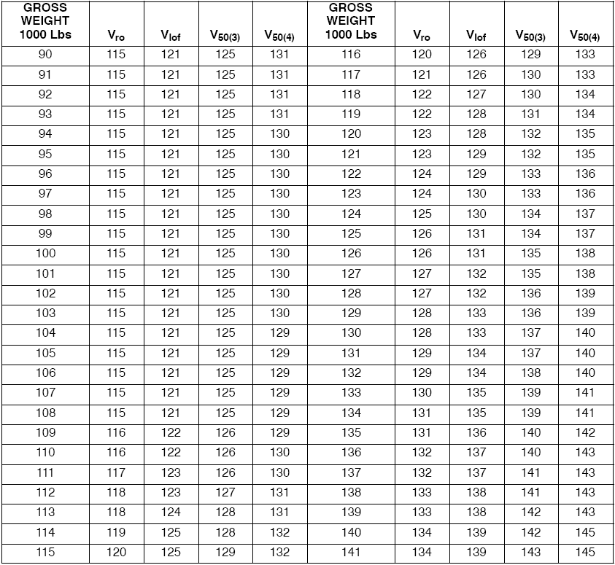
Figure 29-6 Normal Rotation and Climbout Airpeeds (Sheet 2 of 2) 01-75PAC-1 29-21
- Go to 29-23, Refusal Speed chart.
- Begin with OAT and PA, go straight across until you intercept the line for runway length, then follow guidelines to RCR. From there, go straight down to intercept GW, then straight across to intercept takeoff SHP.
- Add corrections from top of page (wind and slope). If V_{ref}>V_{ro}, then V_{ro} is your answer.
- If you need to calculate max braking speeds, go to 29-9.

Distance to 80 knots/Refusal/Liftoff/Rotate (DISTANCE TO ANY SPEED) 29-22
- Begin with speed asked in question and takeoff power. Go directly across to intercept GWT guideline. Continue up and go directly to the BASELINE. Then follow the guideline to the OAT/PA line. Then go straight up to determine uncorrected distance.
- Apply corrections for wind/slope. (ex. 5000’ uncorrected; 10 knots headwind, 1% downslope; 5000 – (5000x0.0125x10) – (5000x0.06x1) = 5000 – 625 – 300 = 4075)
- If water, snow, or slush on runway, use 18-6. (ex. ¼ inch water = 6% increase; 4075 x 1.06 = 4320)

Distance to Accelerate and Takeoff with Engine Failure at V_{ref} 29-24
- Enter chart with refusal/rotate speed and takeoff power. Follow same steps as in distance to any speed chart, apply corrections as required, both from the chart and 18-6.
- Minimum decision speed is V_{mc} ground.
- If decision speed > refusal speed, aircraft is overweight for takeoff.

Three Engine Rate of Climb 29-25
- Enter chart at PA and weight (each box is 200’ PA). Compute ∆T (standard day is 15° C). Each box is equal to 4° C. Find aircraft weight, go straight down directly to the BASELINE, and then follow guidelines to ∆T. Go straight down to the next BASELINE for configuration, then interpolate.
- For ∆T > 20° C, follow the guidelines all the way up to the +20° ∆T line, straight down to the BASELINE, then back up the guideline for ∆T in excess of 20°.
- Above +20° C ∆T, rate of climb calculations are approximations and may be in error as much as 100 fpm.

Oxygen Pressure Minimum and Maximum for Flight 3-5
- Solve for temperature and interpolate.

V_{mc} Air
- Determine density altitude 27-9, then use chart on 29-3.
- Use density altitude to intercept BASELINE, go across to baseline and follow guidelines to your SHP, then go straight across. Apply angle of bank correction to this number (2.6 knots per degree from favorable to a max of 13)

Stall Speed 27-12
- Compute apparent gross weight for aircraft from chart on bottom of page, or as follows:
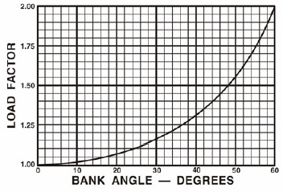  Figure 27-8 Stall Speed 01-75PAC-1 27-12
  15° | 1.035
  30° | 1.155
  40° | 1.310
  45° | 1.415
  60° | 2.00
- Use calculated apparent gross weight and intercept configuration line.
- For engine out, use chart power off stall.
- For power on, increase stall speed by 2 knots per 1000 SHP set on each operating engine (ex. 2500 SHP = 2500/1000 x 4 operating engines x 2 SHP = 20 knots).
- When wing stores place the aircraft in configurations D or E (greater than 700 drag count), increase speed 5 knots.

Stall Buffet 10-10
- Interpolate between weights and angles of bank to obtain uncorrected values. Apply SHP correction as with stall speed.

Maximum Speed in Moderately Turbulent Air 4-5
- Enter at aircraft altitude on left and read to “Max permissible speed with negative 1.0 G capability” line. Read airspeed from bottom.
- MUST USE EPS-1 FOR EP-3E, 4-2

One or Two Engine Performance at Loiter Speed 31-19 to 31-21
- This refers to rate of climb or descent and is always given at 1000’ PA and Maneuver Flaps.
- Enter at bottom with GWT and go up to OAT line (Note: STD day temp is 13° C due to 1000’ PA)
- Read left to rate of climb or descent.

Four Engine Maximum Range IFR Altitude Configuration D – FO-29
- Using GWT, intercept appropriate cruise power line (925° or 1010°) and ∆T. Go across to intercept appropriate pressure altitude line and ∆T, do not go straight to equivalent pressure altitude line. You can use those lines to assist you in interpolating climb altitude.

Four Engine Maximum Range or Loiter TAS/SHP/FF 33-4 to 33-49
- (ex. FL250, IAS 250, IOAT –25° C, GWT 120k)
- Solve for true OAT. Use 27-6 get a Mach number. (You can get one from the top of the next page, but it’s a harder interpolation.) Use page 27-7, take CAS and intercept PA, go straight down, this should give you an approximate Mach number, the number you get from the previous page will help you here. Continue down until you intercept the IOAT. You will probably need to interpolate. In the above example, the answer is OAT of –42° C, a ∆T of –7.
- Next, use 33-17 (USE CORRECT CONFIGURATION, OPERABLE ENGINES!)
- Using GWT (ex 120k), Interpolate TAS (349.5 KIAS). Apply corrections for ∆T (.69 x –7) for a no wind TAS of 354.33.
- Finally, correct for winds. 32-2

Cabin Altitude 2-128
- Find intersection of “Aircraft Altitude” slanted line and vertical “Normal Operating Pressure” line. Read left to obtain cabin altitude.
- Check your answer by comparing to the pressurization formula. This will be a few hundred feet higher, but use chart value.

Loiter Time Prediction – Four, Three, or Two Engine 32-8 to 32-18
- Given go home fuel, arrival fuel, and altitude:
  - Start with on-station weight and go up to intercept PA, then go across and note time.
  - Go to go home weight, up to PA, then across to mark new time.
  - Subtract the one from the other to obtain on-station time.
- Given arrival fuel and on-station time, find required fuel.
  - Start with on-station weight and go up to intercept PA, then go across and note time.
  - Add on-station time.
  - Intercept appropriate PA line, go down and read new GWT. Subtract weight to solve for fuel required.

Go-Home Fuel FO-25 Configuration D, Four Engine
- Calculate equivalent distance (Nautical Air Miles = distance x (TAS/GS)).
- Compute ontop weight (ZFW + ontop).
- Draw a straight line from ∆T and altitude across the page.
- Place a mark at the point where the line and ontop weight intercept.
- Use a piece of scrap paper and mark off distance in NAM with two ticks from distance scale on the bottom of the chart.
- Using these marks, place on altitude line with on mark on the ontop weight. The other mark represents the go home weight.
- Subtract ZFW from go home weight, this is the totalizer reading.

EDC Discharge Ratio 2-129, 128
- Typical questions utilize the formula that maximum discharge pressure (the “D” needle) = ratio (from the chart) x inlet pressure (the “I” needle). Ratio is determined by taking outside (not cabin) pressure up to the line, then across to determine the ratio. The rest is algebra.
- To determine maximum cabin altitude given a differential (or vice-versa) utilize the chart on page 2-128. Using pressure differential, draw a line up. Use the maximum cabin altitude (ex. 10,000’) and go across. This is the max altitude.

Climb Fuel/Time/Distance 31-3 to 31-14
- Correct for temperature by adding 1000 lbs to GWT for every degree above standard, subtracting for every degree below standard.
- Enter the chart on the left with the initial and final altitudes. Go right to the corrected gross weight and read down to obtain fuel/time/distance.
- The difference between these numbers will be the total fuel/time/distance used.

Flight Idle/Operational Descents 31-16 to 31-18
- To compute distance required to descent at flight idle from FL250 to 5,000’, use 31-16. Start from altitude; go across to the BASELINE. Go straight down from there (60 nm). Go to 5,000’, and repeat the above step (12 nm). Subtract 12 from 60 to obtain distance.

Landing Ground Roll Distance 30-3, 30-4, 30-6
- Usually no-flap or approach-flap questions. The procedures are the same.
- Sometimes, winds are given as a direction, so if you need to solve for HW, use 30-5.
- Start at temperature/PA intercept; go across to GWT, then down to wind BASELINE. Follow guidelines to wind (each tick is only 4). Continue down to braking effectiveness BASELINE. Follow guidelines to effectiveness percentage, then on down to slope. Obtain uncorrected distance.
- Now, for corrections. Always assume moderate braking unless told otherwise. Increase uncorrected distance by 2/3, or 1.67.
- Correct for flap configuration by multiplying by no-flap factor (30-6).
- For approach flaps, increase distance by 15%.

Maximum Braking Speeds 29-9
- Self-explanatory.

Maximum Endurance 33-2 EPS-1
- Must use EPS-1.
- Enter table with GW and altitude, interpolate.
- Apply correction factor for power or airspeed.
- Airspeed correction factors only apply to TAS.

Takeoff
VMC Ground 29-2
VMC Air 29-3
Reduced Power Forecast 29-13/14/15/16
Max Power Forecast 29-17/18
Normal Power Forecast 29-19
Normal Rotation and Climbout Airspeeds 29-21
4 Engine Acceleration Performance and Takeoff Distance (Dist to any speed) 29-22
Refusal Speed Chart 29-23
Decision Speed Chart 29-24
Takeoff Rate of Climb (3 and 4 engine) 29-25/26
Climbout Flight Path Performance (3 and 4 engine) 29-27
Climbout Flight Path Distance 29-28/29
Minimum Distance Takeoff – Distance to Liftoff 29-30
Minimum Distance Takeoff – Distance from Liftoff to 50’ 29-31
3 Engine Ferry Takeoff – Distance to Liftoff 29-32
3 Engine Ferry Takeoff –Distance from Liftoff to 50’ 29-33

Approach and Landing
Wind Component Chart 30-5
Landing Performance Ground Roll 30-3
Landing Performance Ground Roll from 50’ Height 30-4
No Flap Factor 30-6

Climb and Descent
4 Engine Normal Rated Climb Performance (Configuration D) 31-12
3 Engine Normal Rated Climb Performance (Configuration D) 31-13
2 Engine Normal Rated Climb Performance (Configuration C) 31-11
Flight Idle Descent 31-15
Flight Idle Descent at Limit Dive Speed 31-16
Operational Descent at 275 KIAS 31-17
Flight Idle Descent at Limit Dive Speed, Gear Down 31-18
Single Engine Performance at Loiter Speeds, 1000’ Configuration B 31-19
Two Engine Performance at Loiter Speeds, 1000’ Configuration B 31-20

Flight Planning
Max Range and Loiter Speed Schedule 32-1/2
Max Range TAS Correction for Winds 32-2
Fuel Planning on the Ground 32-2
4 Engine Loiter Performance Time Prediction (Configuration D) 32-17
3 Engine Loiter Performance Time Prediction (Configuration D) 32-18
2 Engine Loiter Performance Time Prediction (Configuration C) 32-16
4 Engine Composite Cruise Flight Performance (Configuration D) 32-28
3 Engine Composite Cruise Flight Performance (Configuration D) 32-29
2 Engine Composite Cruise Flight Performance (Configuration C) 32-27

Operating Tables
4 Engine Max Range (Configuration D) 33-40/41
3 Engine Max Range (Configuration D) 33-42/43
2 Engine Max Range (Configuration C) 33-32/33
4 Engine Loiter (Configuration D) 33-44/45
3 Engine Loiter (Configuration D) 33-46/47
2 Engine Loiter (Configuration C) 33-38/39

General (Performance Section)
CAS Conversion to TAS to Mach Number 27-6
Drag Count 27-2/3/4
Power Versus TIT at Zero Airspeed 28-7
Pressure Altitude Conversion to Density Altitude 27-9
Stall Speeds 27-12
Standard Atmospheric Pressures/Temperatures/Speeds/Ratios 27-10
Temperature Compressibility Correction 27-7
Temperature Conversion 27-11

General (Other than Performance Section)
Note: EPS-1 References are bold
Air Cycle Cooling System Valve Operating Schedule 2-126
ALD-9 Notes 10-1, 16-1
AOA Index Marks 2-68, 10-7
Cabin Altitude vs. Pressure 2-128
Cabin Compressor Performance 2-129
CG Limits 4-12, 4-4
Circuit Breaker Names/Locations 2-19/42
Conditions of Flight 24-2
Coordinator Positions and Power Lever Functions 2-86
Copilot General and Specific Duties 18-11/12
CRM 24-1
Danger Areas Around the P-3 3-9
Flying with Radome Extended 10-5
Frequency Converter 2-1
Fuel Availability 3-3
Fuel Density vs. Temperature 3-7
Ground Idle Thrust 29-9
Hydrostatic Fuel Gauge 3-7
Increased Takeoff Roll Due to Foul Weather 18-6
Landing Speeds Placard 8-38
Max Load Factors and Operating Envelope 10-12/13
Maximum Airspeed vs. Altitude (Max Speed in Mod. Turb. Air) 4-5
Minimum Fuel for Flight (Tanks 1 & 4) 4-10
NAVAIR Flight Restriction 4-7
Oxygen Table 3-5
Oxygen Usage Chart 2-135/136
Power Lever Positions vs. Blade Angle 2-80
Prolonged Flight in a Sideslip 10-14
Propeller and Wheel Brake Efficiency 8-42
Radio Efficiency 17-7/10
Slow Flight 16-1
Stall Buffet Airspeed (NOT Stall Speed) 10-10
Step Climb 15-22, 32-2
Thin Pack Parachute 17-6/7
Timer Motor 18-7/8
Tire to Runway Coefficient 29-9/10
Turbulent Air Penetration 18-10

