MAX EFFORT TOLD ASSUMPTIONS AND DECISION MAKING:

Refusal speed is based on runway available and is defined as the maximum speed to which the airplane can accelerate with engines at takeoff power and then stop within the remainder of the runway available, with two engines (symmetrical power) in reverse, one engine in ground idle, one propeller feathered, and maximum anti-skid braking.

Brake energy limit speed is defined as the maximum speed at which maximum anti-skid braking can be applied without exceeding the energy absorption limit of the brake system. It is calculated using two engines in reverse. Note: If critical engine failure speed is higher than brake energy limit speed, the takeoff gross weight must be reduced by the amount shown in figure 3-25 and the planned takeoff recomputed at the lower weight. If refusal speed is greater than brake energy limit speed, set refusal speed equal to brake energy limit speed.

The critical field length is the total runway distance required to accelerate on all engines to critical engine failure speed, experience an engine failure, then continue the takeoff or stop within the same distance. For safe takeoff, the critical field length must be no greater than the runway available.

Critical Engine Failure Speed is that speed to which the airplane can accelerate, lose an engine, and then either continue the takeoff with the remaining engines or stop in the same total runway distance. The acceleration distance is based on all engines set on computed takeoff power with ATCS operative. Stopping distances are based on two engines (symmetrical power) in reverse thrust, one engine in ground idle, one propeller feathered, and maximum braking with anti-skid either operative or inoperative.

Ground minimum control speed (Vmcg) is the minimum airspeed during the takeoff ground run at which, when the critical engine is suddenly made inoperative, it is possible to maintain control of the airplane using the rudder control alone and take off safely using normal piloting skill while maintaining takeoff power on the remaining engines.

Minimum field length for maximum takeoff is defined as length of runway which is required to accelerate to decision (refusal) speed, experience an engine failure, and stop or continue acceleration to maximum effort takeoff speed in the remaining runway. If an engine failure occurs at or above refusal speed, the airplane can accelerate to the computed maximum effort takeoff speed, but this speed does not ensure adequate stall margin with only three engines operating and the resulting reduced lift on one wing.

DECISION TABLE (From 1-1 page 3-12)
ENGINE FAILURE AT CRITICAL  ENGINE SPEED AND: | TAKEOFF OR STOP PERMITTED | MAX EFFORT: TAKE- OFF COMMITTED IN REMAINING RUNWAY LENGTH | CANNOT TAKEOFF: MUST STOP IN REMAINING RUNWAY LENGTH
VMCG < VCEF < VREF | X
VMCG < VREF < VCEF |  | X (Note 1)
VCEF < VREF = VMCG |  |  | X
Note 1: Adequate obstruction clearance may not be available. See figure 3-1, figure 3-2, and figure 3-3.

Told Picture Presentation

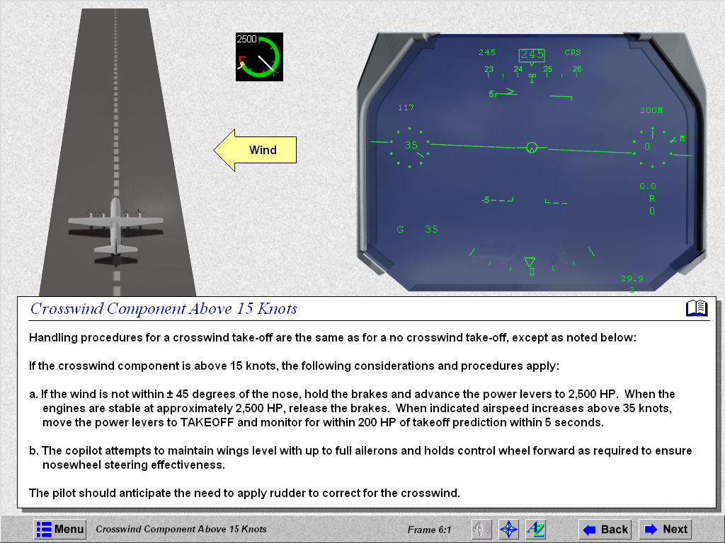
Vmcg
Vcef
Vref
Vrot
Normal Takeoff: Runway available is longer than critical field length

Max Effort Procedures: critical field length exceeds runway available. MFLMETO within available runway.
Vmcg
Vref
Vrot (max)

Vmcg
Vref =Vcef
Vrot
Normal Takeoff (CFL=Runway Available)

Vmcg
Vref
Vrot
No Takeoff Options. Vmcg exceeds runway available.

