Low Level

- Why do we fly low levels? Why in formation?
  - Avoid threats, detection, drop cargo, men, and supplies
  - Mutual support
- What is Dead Reckoning?
  - Flying a precise heading and airspeed for a determined time, also using determined AOB turns
- Difference b/t T.O.T. and T.O.A.?
  - T.O.T. – time over target, at DZ altitude over DZ
  - T.O.A. – time of arrival, on LZ upon touchdown
- First priority during a low level emergency?
  - Climb to MSA, if needed climb to ESA, then head to nearest suitable airfield
- What should be said if DH light illuminates?
  - “Climb”
- How do you CHUM a chart?
  - Get the CHUM or ECHUM from the database, plot the longitude and latitude, write the elevation nearby; repeat for all obstacles within 22 nm of route centerline
- What are the weather mins / requirements for the different low level routes?
  - IR – technically IMC {FTI says 3000’ AGL / 5 sm}(can be IMC, but not advisable by FAA / contact FSS 255.4 / squawk 4000 / need ATC clearance / avoid airports by 1500’ / 3 sm)
  - VR – 3000’ / 5 sm (avoid airports by 1500’ / 3 sm)
  - SR – 1500’ / 5 sm (route at or below 1500’ and 250 kias or less)
  - Local route (non-published) – 1500/3 [night LL mins, highest leg +500’]
- Why do we use TPC and JOG charts?
  - TPC – for flying legs of routes, ideal scale for our speed, altitude and landmark recognition needs
  - JOG – for flying the run-in, more detail for locating DZ or LZ
- Difference between rectangular and circular DZs (run-in, block letter)?
  - Rectangular – set run-in course, example an ‘H’
  - Circular – no set run-in course, ‘example an ‘O’
- How do you select good turn points (think tactical)?
  - Mountainous terrain – gorges, large bridges over gorges, large mountain passes
  - Coastal areas – marker buoys, channels, peninsulas, perpendicular river crossing
  - Seasonal areas – dry lake beds, dead forests
  - Forested areas – clearings, open valleys, prominent patches of woods
  - Items to normally avoid – water (people nearby); cities (people); lookout towers (people); highways (people); railroad tracks (people)
- How is radius of turn used and for what points?
  - For an accurate timing and distance incorporate turn radius. TAS and AOB determine a turn’s radius. Compute in nm and add to leg distances.
  - Plot radius of turn at most all turn point with tactical airlift plotter (150 KIAS/20° AOB)

- What are the symbols for turn points, IP, DZ, alternate and emergency airfields, MSA’s, and ESA’s?
DZ
Alternate Airfield
Advisory Box
Controlling Obstacle (ESA)
Emergency Airfield
Turn/Check Point
Initial Point
Controlling Obstacle (MSA)
- What is the minimum altitude for flight for day VMC? Night VMC?
  - Day VMC – 500’ above highest obstacle within 5nm of course centerline
  - Night VMC – 1000’ above highest obstacle within 5nm of course centerline
- Difference between MSA and ESA?
  - MSA – 500’ above highest obstacle within 5 nm of course centerline
  - ESA – 1099’ > 1000’ above highest obstacle within 22 nm of course centerline (2000’ above in mountainous terrain)
- Describe tick marks on the low level chart, both time and distance?
  - Time – count up on legs in minute increments
  - Distance – count down on legs in nm/min increments
- How compute continuation fuel?
  - Compute continuation fuel by starting at the destination and working backwards; include approach, alternate/reserve at the end of the route; continue to work backwards adding each leg’s required fuel back until initial takeoff
- Describe clock to chart to ground.
  - Reference timing from the clock(s), then note where you should be on the chart, finally look outside for the corresponding landmarks on the ground
- When should timing corrections be made in relation to the IP?
  - All timing corrections should be made prior to the IP.
- How are timing corrections used from slowdown to the DZ?
  - No timing corrections shall be made from the slowdown to the DZ/LZ.
- What are the 3 methods of airspeed time corrections? Describe one.
  - 10% method
  - Proportional method
  - Incremental method
  - Proportional method – for every second off of your planned ETA, change your IAS by 1 knot accordingly and hold this new airspeed for the number of minutes equal to your GS in miles per minute. (Ex. GS = 240 knots, 6 seconds behind; fly 246 KIAS for 4 min)
- Why and when do we do use off course maneuvering?
  - Timing corrections, threat avoidance
- Why do we monitor 255.4?
  - Be aware of other traffic, warn other traffic of our intentions, deconflict with other traffic, monitor FSS
- Describe an ascending slow down? Descending slow-down?
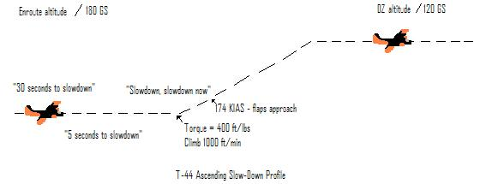

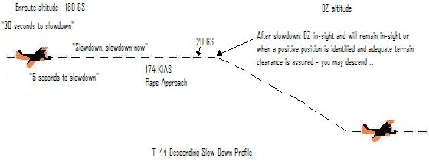
- When can you descend at night enroute? After slow down?
  - Night enroute – do not descend until over the turn point
  - After slowdown - when the DZ is in sight and will remain in sight or when a positive position is identified and adequate terrain clearance is assured
- When should you ascend at night enroute?
  - Night enroute climb – the climb should be completed prior to the turn point
- What are 2 required advisories prior to “green light”?
  - “One minute advisory”; “5 seconds”
- What is a PI, RAM, and block letter?
  - PI – Point of Impact, where the load should impact
  - RAM – Raised Angle Marker
  - Block Letter – alphabetic letter placed in the DZ/LZ
- What do you do if you get lost on a low level route?
  - Stay on original heading, establish max endurance A/S, and climb to appropriate VFR altitude that will give you terrain clearance, Contact an FSS or nearest ARTCC (Climb, Conserve, Confess)

Formation

- Difference between Mission Commander / Formation Lead?
  - Mission Commander – doesn’t change during mission, not matter what formation position, responsible for decisions regarding weather, departure/recovery, fuel requirements, operating areas
  - Formation Lead – PIC of the lead aircraft in the formation, responsible for conducting briefed flight sequence, maintain VMC, stay on assigned route, stable platform, initiate climbs, descents, turns, slowdowns, and recoveries
- What are leads max/min power settings, AOB?
  - 1200 ft/lbs. MAX 400 ft/lbs.
  - 30 degrees AOB, doesn’t prevent lead from using 45 degrees
- Difference between “push” / “go”?
  - Push – no response needed
  - Go – response needed, and check-in on next frequency
- Difference between “terminate” / “knock it off”?
  - Terminate – discontinue maneuver but continue mission
  - Knock It Off – training is finished, formation will return home, term discontinues training evolution (breakoff any aggressive maneuvering and return to enroute position)
- What radio call is transmitted during formation EPs?
  - Knock It Off
- Describe inadvertent weather procedures? (Assume in-trail position)
  - Wing will advise Lead if visual is deteriorating or lost due to weather and give his last position from Lead
  - Lead will transmit “Execute Inadvertent Weather Penetration” then give a base heading and base altitude (base alt will normally ESA – duh)
  - Lead climbs at enroute airspeed 1000’ above the base alt on base heading
  - Two will turn 45 degree away from Lead for two minutes and base heading while climbing 500’ above base alt. After two minutes return to base heading.
  - Three will turn 45 degrees away from Lead for two minutes and base heading and remain on the base alt. After two minutes return to base heading.
  - If VMC is regained, Lead will coordinate rendezvous. If VMC not regained, Lead will coordinate separate IFR clearances for a recovery to base.
- What is IMC breakup?
  - Procedure used to transition from VMC formation flight to IMC single-ship flight for recovery in less than VMC. Lead will coordinate with ATC for individual IFR clearances starting with the last plane in the formation. All will recover independently.
- Describe lead lost communication procedures? Wing?
  - Lead lost comm. – turns beacon and strobe off and “tail wag”. Two should acknowledge by assuming line abreast position. Lead will signal lost comm and clear Two to take the lead. Former Lead then turns beacon and strobes back on to signal completion of lead change, he exits formation safest direction and rejoins at the end of formation
  - Wing lost comm – Wing will turn beacon and strobes off and assume loose line abreast position. Lead will “tail wag” to let Wing know he is lost comm and it is the direction to rejoin formation. Lead will attempt to call Wing on interplane freq, if no response then inform ATC and RTB. Wing full stop while others will wave off to preclude being on rollout with no communications.
- Why do NORDO aircraft full stop and others wave off?
  - Preclude having any other aircraft on rollout with the NORDO aircraft
- Describe procedures for an engine failure in formation? Mid-air collision?
  - Engine failure – Aviate (vector away/boldface), Navigate (off lead), Communicate (Knock it Off),
  - Mid-Air collision - Aviate (vector away/regain control/boldface), Navigate (off lead), Communicate (Knock it Off), Controllability check IAW NATOPS, BDA (Battle Damage Assessment) if feasible
- After a mid-air what are benefits of recovering as a formation vs. single ship?
  - Formation – have wingman for BDA
  - Single ship – no mutual support, no BDA on areas not visible from cockpit,
- Describe comm’s during formation aborted takeoffs.
  - Copilot immediately transmits on tower frequency using formation position number (e.g. “Montana XXX, Two’s aborting, Two’s aborting, Two’s aborting”)
- What is an over-run?
  - Non-lead aircraft breaks abeam of lead or 3-to-9 line
- Procedures for encountering wake turbulence?
  - Climb slightly above aircraft in front, hold power setting
- What is the minimum taxi interval for T-44s?
  - Two aircraft lengths, spacing is Wing’s responsibility
- Who squawks in the formation?
  - Formation Lead

- Describe formation takeoff procedures?
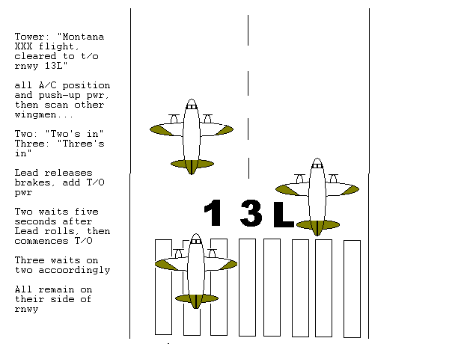

- What is lead’s airspeed prior to formation assembly?
  - 150 KIAS
- Describe the in-trail position prior to formation assembly.
  - VMC – Lead fly’s @ 150 kias, Wing climbs at 180 kias to reach in-trail position, Two will remain below and slight to the right of Lead until in position. Three will remain below and left of both Lead and Two. Once level at assembly altitude, Wing may accelerate to 200 kias
  - IMC – Lead and Wing fly separate instrument departures. Departure flown at pre-briefed airspeed and power setting. Lead directs a rejoin once all A/C are VMC and Wing has reported visual. Lead will terminate with ATC prior to rejoin.
  - Rejoin – Wing will contact Lead and rejoin as briefed,
- Describe the in-trail position for #2 and #3.
  - Two is 500’ behind Lead on right side, not in prop wash with wingtip overlap
  - Three is 1000’ behind Lead on left side, not in prop wash with wingtip overlap
- Describe the fluid-trail position for #2 and #3.
  - Two’s position is a cone 500-1500’ from left to right abeam
  - Three’s position is a cone 2000-3000’ from left to right abeam
  - Two or Three can be anywhere in their cone

- What are the benefits of flying fluid trail vs. in-trail?
  - Fluid trail – better maneuverability than In-trail, tactical formation, more flexible for Wingmen
  - In-trail – better for worse weather, drops, departures, and recoveries
- When is line abreast used?
  - Crossing lines of communication, coastal penetrations
- Describe lead change procedures
  - Briefed at turn point – Lead may continue straight ahead allowing formation to turn at the point and then turn to rejoin at the end or initiate the turn to the next course and continue the turn until approximately 45 degrees beyond the course and allow the formation to pass. Once Two is abeam Lead he will transmit “Two has the Lead” and takes the squawk, then old Lead rejoins in the back
  - Midpoint of a leg – Lead transmits “stand by for lead change”. Lead turns 45 degrees left and allows formation to pass. When Two is abeam Lead, Two transmits “two has the lead” and takes the squawk. Old Lead then rejoins in the back of the formation
- Describe comm’s outside of the aircraft during slowdown.
  - At the slowdown point Lead transmits “Montana XXX flight slowdown, now” over inter-plane freq
- How is drop altitude calculated?
  - Adding 1000’ to the highest object in the DZ
- Describe procedures for a DZ escape.
  - Lead - IP calls “load clear”, retracts flaps, turns to escape heading, accelerates to enroute airspeed, and climbs or descend as req’d
  - Wing – watch Lead’s flaps retraction, wait for IP to call “load clear”, initiates escape by retracting flaps and accelerating back into formation
- What is a racetrack? Why would we use it?
  - Planned pattern allowing multiple passes over same DZ
  - Dropping large number of jumpers on small DZ
- Describe a formation overhead maneuver. Describe downwind maneuver.
  - Overhead
    - Initial – 1000’ AGL or pattern altitude whichever is higher, 200 kias, Wing stacks slightly up, Lead breaks using 45 degrees AOB, retard power to idle, Wing delays break for 5 seconds, both make level turn to downwind, configure, complete landing checklist, succeeding A/C commence final turn to give 20 second (15 second min) space for 1500’ b/t A/C at touchdown
  - Downwind
    - Enter downwind, 200 kias, 800’ AGL or pattern altitude whichever is higher, Wing stacks slightly up, Lead breaks approx. ½ nm past approach end in 45 degrees AOB, retard power to idle, Wing breaks 7-9 seconds after Lead, make level turn until 120 kias, configure and complete landing checklist
  - Landing – land on centerline, approach flaps, power idle, beta range as briefed, clear runway ASAP, if 1500’ min interval not obtained go-around
- What is the purpose of a tactical arrival?
  - Minimum exposure to threats

Tidbits:

- MISSION PLANNING IS NOT PART OF CREW REST in the Navy, if need be plan the flight, present your planning, then ORM the flight for sleep. Don’t get a pink slip!
- Be prepared with Falconview charts well in advance
- Split up chart making w/ friends who know what they’re doing in Falconview
- Must overlay MTRs, airspaces, and ADIZ if using Falconview
- Leg Timing goes on the right side of route centerline
- Have one line abreast transition on a route leg, try a highway
- Make a copy of the Low-Level briefing guide, no folding the book open (page D-18)
- Have 2 significant timing updates per leg

