T-44A Briefing Guides

EVENT: I4102

SYLLABUS NOTES:

Emphasis for I4102 is PAR, ASR, ILS approaches.

c. Minimum of 4 approaches per event and include at least 2 procedure turn approaches. Normal two-engine approaches should be emphasized in this block, but may introduce minor malfunctions.

d. Each event shall include a minimum of one approach with the FD and one without.

e. Holding should be accomplished and graded on at least two evetns, one of which should be GPS holding.

f. All events shall include a missed approach and should include at least two circling missed approaches in the block.

g. One approach per evetn with IP as PF and SMA as PM, emphasizing CRM callouts and radio communications.

h. SMAs shall bring one DD 175 flight plan per SMA and one DD 175-1 per aircraft for their planned profile to every brief. SMAs shall draft a flight plan that will execute the required maneuvers for the events.

SPECIAL SYLLABUS REQUIREMENTS: None for I4102.

DISCUSS ITEMS: Holding, GCA approach, PAR/ILS/ASR configuration point, PAR vs ASR descent point, ASR Recommended Altitudes, NAVIAD Characteristics (ILS), Holding in Lieu Of (HILO) PT approach.

Holding –
FTI Information – Consideration should be given to extended leg lengths if the delay exceeds 20 minutes. This will result in an easier time. Less turns. Use of TACAN station passage is not acceptable for holding fixes. Do not hold directly over a TACAN. Slow down 3 minutes prior to holding fix.

Altitude (MSL) | Max Holding Airspeed (KIAS)
MHA – 6,000 | 200
6,001 – 14,000 | 230
14,001 and above | 265
USAF Fields ONLY | 310
Navy Fields ONLY | 230

Leg lengths: At or below 14k is 1 min. Above 14k standard is 1.5 mins.

Timing Outbound: Start timing outbound abeam the fix. If you can’t determine that, outbound wings level.

Inbound Timing: Begin timing wings level inbound.

Descending in holding: If you are holding above the minimum holding altitude published, once cleared for the approach you can descend to the minimum holding altitude. If no published altitude, the pilot must maintain last assigned altitude until established on a segment of the approach.

AFI 11-217 Info -

10.2.2. Non-charted Holding Patterns. If ATC clears you to hold in a non-charted holding pattern, they will provide you with the following information:

10.2.2.1. Direction. Direction of holding from the fix.

10.2.2.2. Holding fix. The holding fix.

10.2.2.3. Holding course. Radial, course, bearing, airway, or route on which the aircraft is to hold.

10.2.2.4. Leg length. Outbound leg length in miles, if DME or RNAV is to be used.

10.2.2.4.1. Direction of turn. Left turns, if nonstandard.

10.2.2.5. Expect Further Clearance. Time to expect further clearance and any pertinent additional delay information.

10.2.2.5.1. Example: Hold Northeast of the 106 radial, 40 DME fix, 10-mile legs, left turns. Expect further clearance at 1725Z, time now 1710Z.

10.3.5 When a specific DME or RNAV distance is specified, commence the inbound turn at that distance. ATC expects pilots to fly the complete holding pattern as published. Therefore, do not shorten the holding pattern without clearance from ATC.

NOTE: The “holding technique” discussed here encompasses both the “racetrack pattern” and “teardrop
procedure turn” mentioned in the AIM, Para.5-4-8.

(b). Holding Technique. The holding technique is another method you may use to accomplish a
procedure turn course reversal on any approach designed using US TERPs. Enter the procedure turn
according to the holding entry procedures described in section 404 with the following exceptions:

• If your heading is within 90° of the outbound procedure turn course, you may use normal lead
points to intercept the procedure turn course outbound. (This includes all of the teardrop entry
sector and most of the parallel entry sector.)

• If you are properly aligned and elect a teardrop entry, your teardrop course must be within 30°
of the procedure turn course. Use course guidance if it is available.

• If you intercept the procedure turn course outbound, maintain the course for the remainder of
the outbound leg, then turn toward the maneuvering side to reverse course.

Holding – Holding airspeed for the T-44 is 150 kias. When crossing the holding fix, execute the 6 T’s.

GCA Approach –

FTI Info – When shooting a PAR, students shall brief that they will use the most precise approach available for the runway in use as a backup.

The transition to final segment of the approach includes all the maneuvering up to a point where the aircraft is inbound and approx. 8 miles from touchdown. Configure the aircraft on base or dogleg to final.

11-217 Information - 14.3.3. Voice Procedures. The radar approach is predicated entirely upon voice instructions from the approach control or radar controller. Repeat all headings, altitudes (departing and assigned), and altimeter settings until the final controller advises "do not acknowledge further transmissions."

14.3.4.3. Weather. Weather information issued by the radar controller will include altimeter setting, ceiling, and visibility. The controller is required to issue ceiling and visibility only when the ceiling is below 1,500 feet (1,000 feet at civil airports) or below the highest circling minimum, whichever is greater, or if the visibility is less than 3 miles.

PAR - Descend when the controller states “on glidepath”.

To prevent overshooting, AOB should approximate the number of degrees to be turned not to exceed ½ SRT.

DA is MSL altitude and DH is AGL height. Determined by reading on altimeter or advisory call by controller, whichever occurs first.

Two NATOPS qualified pilots are required to be at the controls to utilize minimums below 200 ft. Then can only descend to 100 ft.

AIM PAR Information - This service is provided only when the PAR Final Approach Course coincides with the final approach of the navigational aid and only during the operational hours of the PAR. The radar advisories serve only as a secondary aid since the pilot has selected the navigational aid as the primary aid for the approach.

11-217 PAR Information -

14.3.5.2.6 The controller will continue to provide advisory course and glide path information until the aircraft passes over the landing threshold at which time the controller will advise "over landing threshold."

14.3.5.2.7. Approach Guidance Termination. The controller will cease providing course and glide path guidance when:

14.3.5.2.7.1. The pilot reports the runway/approach lights in sight, and

14.3.5.2.7.2. The pilot requests to or advises that he/she will proceed visually (E.g. “TRACK 32, runway in sight, taking over visual.”).

14.3.5.2.7.2.1. NOTE: A pilot’s report of “runway in sight” OR “visual” alone does not constitute a request/advisement to proceed visually and the controller will continue to provide course and glide path guidance.
ASR –

11-217ASR Information -

14.3.5.1.1. Controller. The controller will inform the pilot of the runway to which the approach will be made, the straight-in MDA (if a straight-in approach is being made), and the MAP location, and will issue advance notice of where the descent to MDA will begin. When the approach will terminate in a circling approach, furnish the controller with your aircraft category. The controller will then issue the circling MDA. Circling MDA for ASR approaches are found in the FLIP Terminal Book (the circling MDA found on the individual IAP refers only to non-radar approaches).
PAR/ILS/ASR configuration point –

 | Precision | Non-Precision | Radar PAR | Radar ASR
NORMAL | 1 ½ dots below GS at GS intercept altitude or 3 NM prior to FAF | 3 NM prior to FAF | Base or Dog-leg to Final | Base or Dog-leg to Final
EMERGENCY (SSE) | ½ dot below GS at GS intercept alt. | In safe position to land | 10 Sec gear warning | - 10 sec gear warning  - Safe position to land

PAR vs ASR descent point –

PAR - When controller advises on glide slope.

ASR - begin decent what the controller advises “begin descent to MDA”. If there is an alt. restriction, the controller will specify the prescribed restriction altitude. When you are past, controller will tell you to continue to MDA.

ASR Recommended Altitudes –

14.3.1 Upon request, the controller will provide recommended altitudes on final to the last whole mile that is at or above the published MDA. Recommended altitudes are computed from the start descent point to the runway threshold. (At the MAP, the straight-in surveillance system approach error may be as much as 500 feet from the runway edges.)

14.3.5.1.3.1. NOTE: Upon request, the controller will provide recommended altitudes on final to the last whole mile that is at or above the published MDA. Due to the possible different locations of the MAP, recommended altitudes may position you at MDA at or slightly prior to the MAP. Consider this in relation to the normal VDP required for your aircraft.
NAVIAD Characteristics (ILS) –
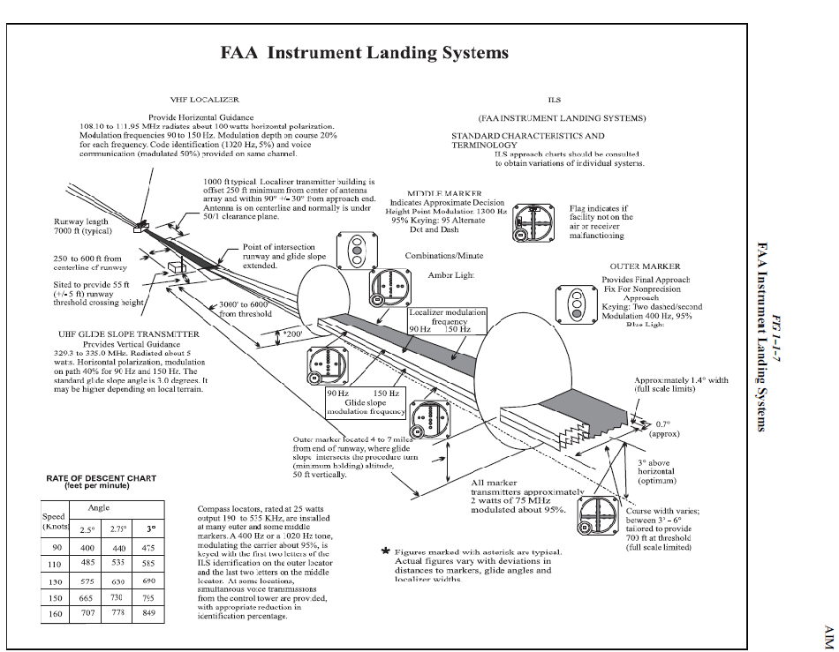

11-217 Info –

14.2.2.1.1. Required Components. In the United States, the glide slope, the localizer, and the outer marker are required components for an ILS. If the outer marker is inoperative or not installed, it may be replaced by DME, another NAVAID, a crossing radial, or radar provided these substitutes are depicted on the approach plate or identified by NOTAM. If the glide slope fails or is unavailable, the approach reverts to an approach without glide path guidance. If the localizer fails, the procedure is not authorized. If the OM (or at least one of its substitutes) is not available, then the procedure is not authorized.

14.2.2.1.2.2.1. NOTE: If using a flight director system or flight management system, the switches should be positioned in accordance with instructions in the aircraft flight manual for intercept and final approach modes of operation. Normally, manual selection of the final approach mode would be delayed until the aircraft heading is within 15 ° of the localizer course and the CDI is within one dot of center.

14.2.2.1.3.6.1. CAUTION: The ILS/LOC approach must be discontinued if the localizer course becomes unreliable, or any time full-scale deflection of the CDI occurs on final approach. Do not descend below localizer minimums if the aircraft is more than one dot (half scale) below or two dots (full scale) above the glide slope. If the glide slope is recaptured to within the above tolerance, descent may be continued to DH.

14.2.2.1.3.6.2. NOTE: If making an autopilot coupled approach or landing, use the aircraft flight manual procedures for the category of ILS approach being conducted. When the weather is below 800 foot ceiling and/or 2 miles visibility, vehicles and aircraft are not authorized in or over the ILS critical area when an arriving aircraft is between the ILS final approach fix and the airport (except for aircraft that land, exit a runway, depart or miss approach). However, when autopilot coupled or auto land operations are to be conducted, and the weather is above ceiling 800 feet and/or visibility 2 miles, advise the ATC approach or tower controller as soon as practical but not later than the FAF. This will allow time for the appropriate ILS critical area to be cleared or an advisory issued. The advisory used by controllers will be: "Localizer/glide slope signal not protected." In this case be alert for unstable or fluctuating ILS indications that may prevent an autopilot-coupled approach. When aircraft equipment and crew qualification permit, the localizer and glide slope may be used for autopilot operations to the points specified in FLIP for each category of ILS approach, unless a restriction is published on the approach procedure.

AIM Info –

a. General
1. The ILS is designed to provide an approach path for exact alignment and descent of an aircraft on final approach to a runway.
2. The ground equipment consists of two highly directional transmitting systems and, along the approach, three (or fewer) marker beacons. The directional transmitters are known as the localizer and glide slope transmitters.

3. The system may be divided functionally into three parts:
(a) Guidance information: localizer, glide slope;
(b) Range information: marker beacon, DME; and
(c) Visual information: approach lights, touchdown and centerline lights, runway lights.
b. Localizer
1. The localizer transmitter operates on one of 40 ILS channels within the frequency range of 108.10 to 111.95 MHz. Signals provide the pilot with course guidance to the runway centerline.
2. The approach course of the localizer is called the front course and is used with other functional parts, e.g., glide slope, marker beacons, etc. The localizer signal is transmitted at the far end of the runway. It is adjusted for a course width of (full scale fly−left to a full scale fly−right) of 700 feet at the runway threshold.
3. The course line along the extended centerline of a runway, in the opposite direction to the front course is called the back course.
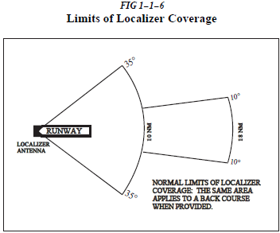

d. Glide Slope/Glide Path
1. The UHF glide slope transmitter, operating on one of the 40 ILS channels within the frequency range 329.15 MHz, to 335.00 MHz radiates its signals in the direction of the localizer front course. The term “glide path” means that portion of the glide slope that intersects the localizer.
CAUTION−
False glide slope signals may exist in the area of the localizer back course approach which can cause the glide slope flag alarm to disappear and present unreliable glide slope information. Disregard all glide slope signal indications when making a localizer back course approach unless a glide slope is specified on the approach and landing chart.
2. The glide slope transmitter is located between 750 feet and 1,250 feet from the approach end of the runway (down the runway) and offset 250 to 650 feet from the runway centerline. It transmits a glide path beam 1.4 degrees wide (vertically). The signal provides descent information for navigation down to the lowest authorized decision height (DH) specified in the approved ILS approach procedure. The glidepath may not be suitable for navigation below the lowest authorized DH and any reference to glidepath indications below that height must be supplemented by visual reference to the runway environment. Glidepaths with no published DH are usable to runway threshold.

3. The glide path projection angle is normally adjusted to 3 degrees above horizontal so that it intersects the MM at about 200 feet and the OM at 2/11/10 AIM Navigation Aids 1−1−9 about 1,400 feet above the runway elevation. The glide slope is normally usable to the distance of 10 NM. However, at some locations, the glide slope has been certified for an extended service volume which exceeds 10 NM.
4. Pilots must be alert when approaching the glidepath interception. False courses and reverse sensing will occur at angles considerably greater than the published path.
5. Make every effort to remain on the indicated glide path.
CAUTION−
Avoid flying below the glide path to assure obstacle/terrain clearance is maintained.
6. The published glide slope threshold crossing height (TCH) DOES NOT represent the height of the actual glide path on−course indication above the runway threshold. It is used as a reference for planning purposes which represents the height above the runway threshold that an aircraft’s glide slope antenna should be, if that aircraft remains on a trajectory formed by the four−mile−to−middle marker glidepath segment.
7. Pilots must be aware of the vertical height between the aircraft’s glide slope antenna and the main gear in the landing configuration and, at the DH, plan to adjust the descent angle accordingly if the published TCH indicates the wheel crossing height over the runway threshold may not be satisfactory. Tests indicate a comfortable wheel crossing height is approximately 20 to 30 feet, depending on the type of aircraft.
NOTE−
The TCH for a runway is established based on several factors including the largest aircraft category that
normally uses the runway, how airport layout effects the glide slope antenna placement, and terrain. A higher than optimum TCH, with the same glide path angle, may cause the aircraft to touch down further from the threshold if the trajectory of the approach is maintained until the flare. Pilots should consider the effect of a high TCH on the runway available for stopping the aircraft.

Holding in Lieu Of (HILO) PT approach –

Depicted just like any other holding pattern except the holding pattern track is printed with a heavy black like (bold) in the plan view. If cleared for the approach, descent may be made to the minimum holding altitude when established in holding (initial passage of the holding fix). May be depicted in two ways: descent at the holding fix or descent on the inbound leg. If depicted on the inbound leg, must be established (within 1 dot or half-scale deflection) of the approach before beginning the descent.

