T-44A Briefing Guides
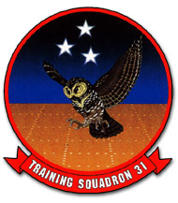

EVENT: C4502

DISCUSS ITEMS: Right hand pattern, CRM

Right hand pattern – In right traffic, utilize a similar position on the wing to maintain desired position on downwind. The right-hand pattern is nearly identical in other respects to the left-hand pattern. Use the CP to clear turns and call approaching the 180° position.

CRM –
  - Decision-making – ability to use logical and sound judgment based on the information available
  - Assertiveness – willingness to actively participate and the ability to state and maintain your position, until convinced by the facts (not the authority or personality of another) that your position is wrong
  - Mission analysis – ability to make long-term and contingency plans and to coordinate, allocate, and monitor crew and aircraft resources
  - Communication – ability to clearly and accurately send and acknowledge information, instructions, or commands and provide useful feedback
  - Leadership – ability to direct and coordinate the activities of other crewmembers and to encourage the crew to act together as a team
  - Adaptability/Flexibility – ability to alter a course of action to meet situational demands, to maintain constructive behavior under pressure, and to interact constructively with other crew members
  - Situation awareness – cognizance of what is happening in the cockpit and in the mission, and knowledge of how that compares with what is supposed to be happening

