T-44A Briefing Guides


EVENT: C4206

DISCUSS ITEMS: Inadvertent IMC, right seat positioning, copilot/right seat responsibilities, and propeller system.

Inadvertent IMC – IMC must be avoided while flying VFR. Occasionally, IMC may be flown into inadvertently even with the best intentions to avoid it. Flying VFR on dark nights is one time to be particularly careful.

No set procedures will cover inadvertent IMC in all situations. Good headwork and situational awareness must be used to meet the objectives: fly out of IMC, rely on instrument scan until in VMC again, fly safe altitudes for terrain and obstacle avoidance and get ATC assistance.

Right seat positioning – a two-position fore and aft adjustment of the pedals is provided through control levers on each pedal. The pilot compartment seats are adjustable fore and aft with the inboard handle on each pilot seat and vertically with the outboard handle.

Copilot/right seat responsibilities – The copilot shall assist the pilot in command in the safe and successful accomplishment of the assigned flight. Examples of this include challenging the pilot with the checklists, monitoring the right side of the aircraft, monitoring engine and performance instruments and aircraft configuration, maintain a lookout, monitoring and challenging deviations from procedures or instructions, communicating with controlling agencies, raising and lowering the gear and/or flaps, and resetting trim and flaps during touch and go’s.

Propeller system –
2.8 Propellers
A three-bladed aluminum propeller is installed on each engine. These propellers are hydraulically controlled, constant-speed, full-feathering, and reversible. Each propeller is controlled by engine oil acting through an engine-driven propeller governor (Fig 2-4). Feathering is accomplished by the feathering springs assisted by centrifugal force applied to the blade shank counterweights. Governor-boosted engine oil pressure moves the propeller blades to the high rpm (low-pitch) hydraulic stop and into reverse pitch. Low pitch propellers position is determined by a mechanically actuated hydraulic stop.

2.8.1 Feathering provisions
The aircraft is equipped with both manual and automatic propeller feathering. Manual feathering is accomplished by pulling the corresponding propeller lever aft past a friction detent. To unfeather, the propeller lever is pushed forward into the governing range. Feather springs and counterweights will normally feather the propeller anytime there is a loss of boosted propeller governor oil pressure, including engine shutdowns on the ground and during any situation in which the propeller is not turning. An automatic feathering system, if armed, will sense loss of torque oil pressure and will feather an unpowered propeller. Automatic feathering can occur only when the propeller AUTOFEATHER switch is in the ARM position, both power levers are at a position that would normally correspond to 90±2 percent N1 or greater, and the torque valve of one engine drops below 260±50 ft/lb. The autofeather system has a cross-interlocking safety feature designed into the control circuit to prevent automatic feathering of both propellers. Before a propeller feathers automatically, the interlock disarms the autofeather circuit of the opposite propeller. After feathering has occurred for one propeller, the opposite propeller can be feathered only by the manual control.
Note
Right propeller may not fully feather with propeller sync on.
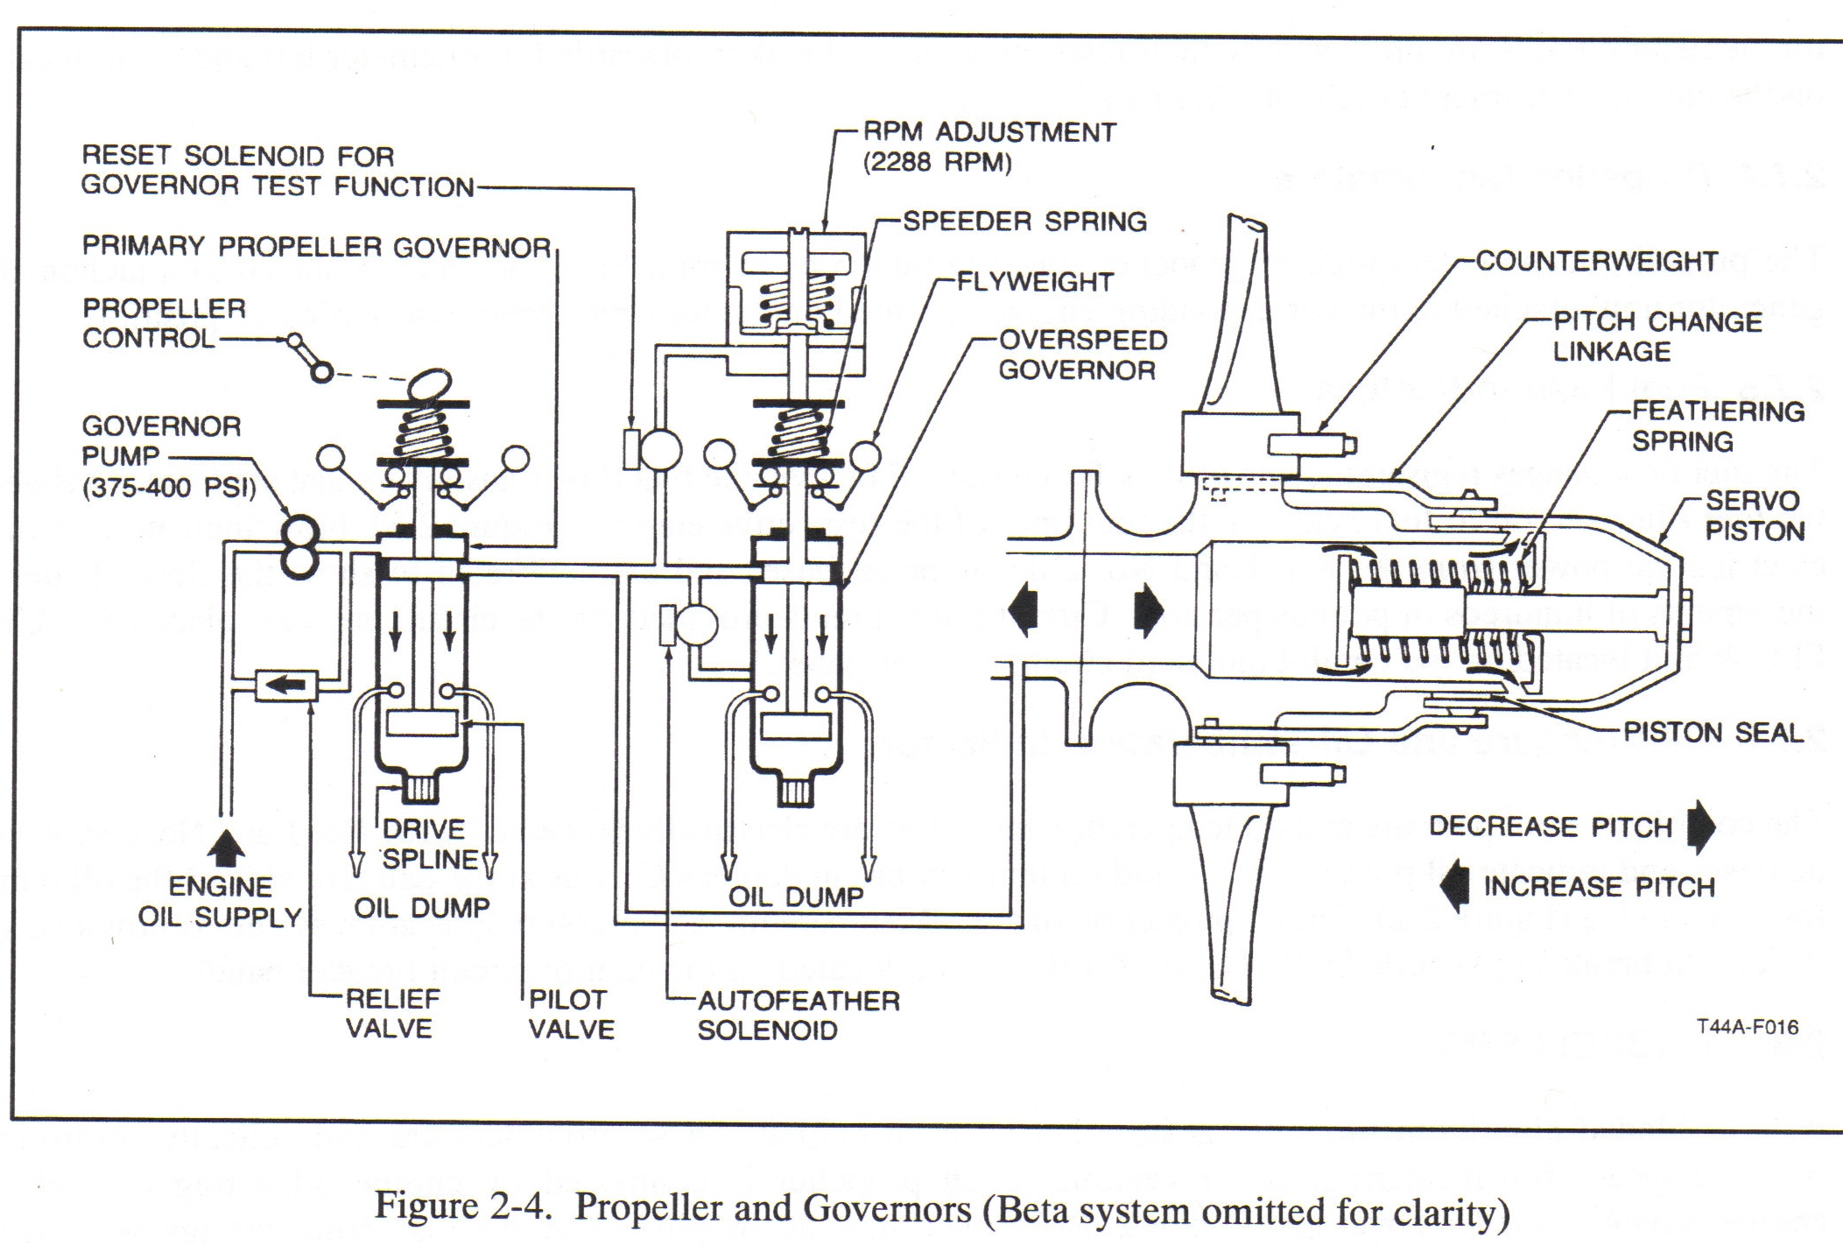

2.8.1 Propeller Autofeather Switch
Autofeathering is controlled by a propeller AUTOFEATHER switch on the left subpanel. The three-position switch is placarded ARM, OFF, and TEST and is spring loaded from the TEST to OFF. The ARM position is used only during takeoff and landing. If an engine loses power with the system armed and the power levers at or above a position corresponding to 90±2 percent N1, two torque-sensing switches 410±50 ft/lb and 260±50 ft/lb of the affected engine are actuated by a loss of torque pressure. Switch actuation applies current through an autofeather relay to a corresponding dump valve, causing the release of oil pressure that holds an established pitch angle on the blades of the affected propeller. Following the release of oil pressure, feathering movement is accomplished by the feathering springs assisted by centrifugal force applied to the blade shank counterweights. The TEST position of the switch enables the pilot to check readiness of the autofeather systems below 90±2 percent N1 and is for grounded purposes only.

2.8.1.2 Autofeather lights
Two green lights on the annunciator panel, placarded LH or RH AUTOFEATHER ARMED, when illuminated indicate that the autofeather system is armed. Complete arming of the system is accomplished when power levers are advanced to or above a position corresponding to 90±2 percent N1 and the autofeather switch is in the ARMED position. Both lights will illuminate indicating a fully armed system. Both lights will be extinguished if either propeller has been autofeathered or if the system is disarmed by retarding the power lever.

2.8.2 Propeller Synchrophaser
The propeller syncrophaser system is designed for in-flight use only. When in use, the system will automatically “slave” the right propeller rpm to the left “master” propeller. This is accomplished via a magnetic speed pickup mounted in each propeller overspeed governor and magnetic phase pickups mounted on each propeller deice slip ring that transmits electronic pulses to a control unit. The control unit then converts any pulse rate differences into correction commands and these correction commands are then transmitted to an actuator motor mounted on the right engine. The actuator motor then “trims” the right propeller governor assembly to exactly match the left propeller rpm while leaving the propeller control lever position constant. If the synchrophaser system is unable to adjust the right propeller to the left, the actuator has reached its travel limit. To recenter the actuator, use the following procedure.
- PROP SYNC switch - - OFF.
- Synchronize the propellers manually.
- PROP SYNC switch - - ON.
Note
The recentering process will take approximately 6 seconds.

To prevent the right propeller from losing excessive rpm if the left propeller is feathered while the synchrophaser is in use, the system is limited to ±30 rpm from the governor setting. Adjustment of rpm with both propeller levers at the same time will retain the right propeller governor setting within the ±30 rpm range of the left propeller.

2.8.2.1 Propeller Synchronization Switch
One two-position switch located on the control quadrant is placarded PROP SYNC ON — OFF and completes the circuit for propeller synchronization. When the switch is placed in the OFF position, the actuator will automatically run to the center range before stopping. This assures the control will function normally when the ON position is next selected. System operation requires synchronization of the propellers in the normal manner and then selecting ON position of the PROP SYNC switch.

2.8.2.2 PROP SYNC on Light (Annunciator)
The propeller synchronization system is designed for in-flight use only; therefore, if the system is in use and the landing gear is extended (as in an approach for landing), a yellow annunciator light placarded PROP SYNC ON will illuminate.

2.8.3 Propeller Governors
Each propeller system utilizes two governors, one "primary" and one "backup," to control propeller rpm. Each propeller lever establishes rpm for the respective propeller by altering the setting of a primary governor (Figure 2-4) attached to the propeller gear reduction housing. It is the primary governor that controls rpm through the entire range. Should a primary governor malfunction (exceeding 2,200 rpm by more than 4 percent), an overspeed governor cuts in (2,288 ±40 rpm), dumping oil from the propeller to prevent rpm from exceeding safe limits. If a propeller should stick or move too slowly during a transient condition, the corresponding governor would be unable to prevent an overspeed condition. To provide for this contingency, the pneumatic section of the primary governor acts as a fuel topping governor when the propeller rpm exceeds 2,332 rpm (2,200 rpm + 6 percent). This limits the fuel flow into the engine, thereby reducing the power driving the propeller. During propeller operation in the reverse range, the pneumatic section of the primary governor will be reset to allow a maximum of 2,100 rpm.

2.8.3.1 Propeller Governor Test (PROP GOV TEST) Switch
One two-position switch on the left subpanel (Figure 1-4) is provided for operational test of the propeller systems. The switch is placarded PROP GOV TEST. A solenoid actuated by the PROP GOV TEST switch enables the overspeed governor to be reset for test purposes (1,900 to 2,100 rpm.) The propeller governor test circuit(s) are protected by a circuit breaker placarded PROP GOV located in the ENGINE group on the copilot outboard subpanel.

2.8.3.2 Propeller Levers
Two propeller levers on the control pedestal (Figure 1-5) placarded PROP are used to regulate propeller speeds. Each lever controls a primary governor that acts to regulate propeller speeds within the normal operating range of 1,800 to 2,200 rpm. The full forward position is placarded TAKEOFF, LANDING AND REVERSE, and also HIGH RPM. Full aft position is placarded FEATHER. When a lever is placed at HIGH RPM, the propeller may attain a static rpm of 2,200, depending upon power lever position. With the power levers at idle and the condition levers at low idle, propeller rpm should read between 900 and 1,100 rpm. As a lever is moved aft, passing through the propeller governing range but stopping at the feathering detent, propeller rpm will correspondingly decrease to the lowest limit. Moving a propeller lever aft past the detent into FEATHER will feather the propeller.

Note
If propeller rpm does not read between 900 and 1,100 rpm with the power levers at idle and condition levers at low idle, perform a low pitch torque check (checkflight item 19 in paragraph 10.6) to ensure propeller flight idle stops are correctly adjusted.

2.8.4 Propeller Reversing
CAUTION
- Moving the power levers aft of IDLE without the engine running will result
in damage to the reverse linkage mechanism.
  - To prevent damage to reversing linkage, propeller levers must be in HIGH
RPM position prior to propeller reversing.

The propeller blade angle may be reversed to shorten landing roll. To reverse, propeller levers are positioned at HIGH RPM (full forward) and the power levers are lifted up to pass over the IDLE detent, then pulled aft into REVERSE setting.
2.8.4.1 Propeller Reverse Not-Ready Annunciator Light
One yellow caution light, placarded REV NOT READY, on the annunciator panel alerts the pilot not to reverse the propellers. It illuminates when the landing gear selector handle is down and the propeller levers are not at the HIGH RPM (full forward) position.

Primary Governor Failure (memory item): feather or overspeed (outside normal limits). * Certain failures can cause beta valve to be inop, causing overspeed. Control w/ overspeeding prop very difficult at lower power settings and airspeeds, highly discouraged. If necessary, landing with overspeeding prop carry extra airspeed. Gives more rudder authority, reduces prob of in-flight beta.
If prop rpm out of normal governor range (1800 - 2200RPM):
[1] Propeller RPM -- Adjust to Normal RPM.
By prop lever. If norm restored, continue ops. If norm can't be obtained:
[2] Power Lever - IDLE (concur)
[3] Propeller Lever - FEATHER (concur)
Notes: Prop RPM > 2420 may result in RGB failure and/or N2 turbine damage. Engine with disabled prop can provide electric power. Right prop may not full feather with prop sync ON. Fully feathered prop will still be running at about 200 rpm.
[4] Alt Prop Feather Checklist - AS REQ

Prop Linkage Failure: prop gov ctl linkage fails, prop goes to 2200 or maintains last rpm setting.
[1] Manipulate prop lever to determine if cockpit control lost
[2] If cockpit control lost and RPM in safe limits, match opposite prop speed with uncontrollable prop and land as soon as practicable.
CAUTION: Reverse w/o high RPM can damage prop.

Alternate Prop Feathering: Linkage or gov fails and prop doesn't feather by itself or normal feathering procedures don't work, use autofeather.
[1] Power Lever - IDLE (failed propeller) (concur)
[2] Condition Lever - FUEL CUTOFF (concur)
[3] Autofeather - ARM
[4] Power Levers -- > 90% N1 *Don't pull power lever to IDLE during autofeather, may disarm system.
[5] Emergency Shutdown Checklist - EXECUTE

