T-44A Briefing Guides


EVENT: C4205

DISCUSS ITEMS: Engine system and electrical system.

Engine system –
System
- Engines
  - Two PT6A-34B turboprop engines rated at 550SHP
  - Reverse flow, free turbine type, three-stage axial, single-stage centrifugal
  - Accessory gearbox driven by the compressor shaft
  - Outside air enters the cowling air intake, flows through a plenum chamber into the three-stage axial compressor and centrifugal compressor, forced through diffuser vanes, and turned 90° into the combustion chamber.
  - Air is mixed with fuel and ignited by two igniters initially, then self-sustaining.
  - Burning gases reverse in direction, pass through nozzle guide vanes to the compressor turbine and then to the power turbine.
  - A two-stage planetary reduction gearing provides a 15:1 reduction and imparts torque from the power turbine to the prop shaft.
  - After passing through the power turbine, gases are discharged as exhaust.
  - Axial compressor most effective at low rpm, centrifugal at high rpm.
- Engine cooling
  - Forward engine compartment cooled by air entering the exhaust stack cutouts and exiting through louvers behind the cutouts
  - Accessory section cooled by air entering from the forward engine compartment and exiting through a flush vent on the left side of the cowling.
- Ice protection
  - Ice vanes can be lowered that provide a sudden turn in airflow prior to entering the plenum chamber. Snow and ice are removed by virtue of their inertia.
- Engine fuel control
  - Engine driven pump, FCU SCU, a common manifold, and 14 fuel spray nozzles. A drain valve bleeds off residual fuel to the collector tank after engine shutdown or aborted start.
  - An electrically operated collector pump returns fuel to the tanks when the internal float switch is activated. Protected by FUEL DRAIN COLLECT PUMP CB.
  - FCU is a hydromechanical computing and metering device. Controls power by adjusting N1 speed, which in turn is controlled by varying the amount of fuel injected. The condition lever to FUEL CUTOFF closes off fuel from the start control unit.
  - Oil-to-fuel heater maintains fuel temp between 70°F and 90°F.
  - Purge solenoid valve opens during the starting cycle to send trapped fuel vapor through a vent line back to the nacelle tank. The valve is electrically connected to the ignition system.
  - Engine-driven fuel pump mounted on the accessory section. Depends on fuel for lubrication and cooling so limited to 10hrs TBO when not boosted by electric boost pump.
  - At less than 3500’ PA, N1 idle is a constant. Above, N1 idle can be as high as 83%.
  - In the flight idle range, power levers control N1 speed. In beta (15 to -5), power control blade angle. In reverse (-5 to -11) power controls N1 speed and blade angle.
- Starting System
  - Generators provide 250amp/28VDC output.
  - Starters draw 700 amps initially, then drop to 300 amps as the engines reach 20% N1.
  - STARTER ONLY switch motors the starter, while IGN&ENG START rotates the starter, energizes the igniter plugs, and activates the IGN IND lights.
  - Compressor progressive bleed valve bleeds off compressor pressure to prevent compressor stall or overtemp. Open at low rpm, starts to close at 62% N1 and fully closed at 75% N1.
  - Autoignition when armed actuates at 410 +/- 50 ft-lbs.
- Oil Supply
  - 14 U.S. quarts (9 quarts in the tank)
  - 1 gear-type oil pump and 4 scavenger return pumps.
  - Oil pressure regulated by a pressure relief valve that returns excess oil to the oil tank.
  - Engine torquemeters indicate torque from a movable ring gear in the RGB that meters an oil orifice. As torque increases, oil pressure across the orifice increases proportionately, which is measured by a 26 VAC signal.

15.1 ENGINE FAILURE
The T-44 exhibits no unusual handling characteristics at speeds above vmc- Refer to Part XI for the climb or cruise performance that can be expected in an engine-out situation. Directional control is a function of airspeed and power, varying directly with airspeed and inversely with power. An increase in asymmetrical power at any given airspeed results in mild yaw, accompanied by a more pronounced proverse roll into the dead engine. The rate of roll and yaw varies directly with the rate of power increase on the operative engine. These can be easily controlled with aileron and rudder. Rudder trim is sufficient to maintain balanced flight at airspeeds above approximately 100 KIAS. At speeds below 100 KIAS, full rudder trim must be supplemented by constant rudder pressure. At full rudder trim, only a few inches of rudder travel remain. The use of flaps will not significantly affect directional control, but will adversely affect performance. Figure 27-5 shows that a positive climb rate cannot be obtained with full flaps (100 percent) and gear down at any gross weight while single engine.

WARNING
If full flaps are used during a single-engine approach, the waveoff procedure described in paragraph 7.18 will result in a loss of approximately 200 feet before a positive rate of climb can be established.

An indication of impending engine failure or flameout usually is preceded by unstable engine operation. One or a combination of symptoms may prevail, such as fluctuating turbine rpm, torque and interstage turbine temperature, illumination of fuel system warning lights, dropping oil pressure, loss of thrust, etc. In the event engine failure or unexpected flameout occurs, an emergency shutdown should be performed. An airstart may be performed if the engine failure cannot be attributed to a mechanical malfunction or was not accompanied by an explosion, overheating condition, vibration, strong fuel fumes, fire, or zero ni tachometer rpm. A flameout condition is indicated by a drop in ITT, torque, and turbine rpm.

15.2 EMERGENCY SHUTDOWN CHECKLIST
*l. Power lever — IDLE.

WARNING
If the autofeather system is being used, do not retard the failed engine power lever until the feathering sequence is completed. To do so will deactivate the autofeather circuit and prevent automatic feathering.
*2. Prop lever — FEATHER.
*3. Condition lever — FUEL CUTOFF.

In case of confirmed/suspected fire or fuel leak, continue checklist. If not, proceed to DEAD ENGINE CHECKLIST in paragraph 15.3.
*4. Firewall valve — CLOSED.
*5. Fire extinguisher — As Required.
*6. Bleed air — CLOSED.

WARNING
If the bleed air valve is left open, smoke or fumes may enter through the pressurization system.
7. Dead Engine Checklist — As Required (P).
;15.3 DEAD ENGINE CHECKLIST
The Dead Engine Checklist should be completed as time permits following the completion of the Emergency Shutdown Checklist.
- Cabin temperature mode — OFF (CP).
- Vent blower — As Required (CP).
- Crossfeed — CLOSED (P).
- Boost pump (failed engine) — OFF (P).
- Transfer pump (failed engine) — OFF (P).
- Fuel control heat (failed engine) — OFF (P).
- Autofeather — OFF (P).
- Propeller sync — OFF (P).
- Autoignition (failed engine) — OFF (CP).
- Generator (failed engine) — OFF (CP).
- Electrical load — Monitor (P).
- Current limiters — Check (P).
WARNING
The landing gear warning system will not function if the power lever for the failed engine is placed forward of a position corresponding to 79 ±2 percent N₁ rpm.

15.4 JAMMED POWER LEVER
There have been occasions when power levers have jammed in the T-44 in flight, leaving the pilot with no capability to change the corresponding engine power setting. Should this occur, check all engine instruments and the nacelle for abnormal indications. If no abnormal secondary indications are detected, consideration should be given to keeping the engine running unless controllability is or becomes a factor. Land as soon as practicable.

Prior to landing, the engine should be secured as follows:
*l. Condition lever (affected engine) — FUEL CUTOFF.
*2. Emergency Shutdown Checklist — Execute (P).

WARNING
The landing gear warning system will not function if the power lever remains jammed forward of a position corresponding to 79 ±2 percent ni rpm.

Electrical system –
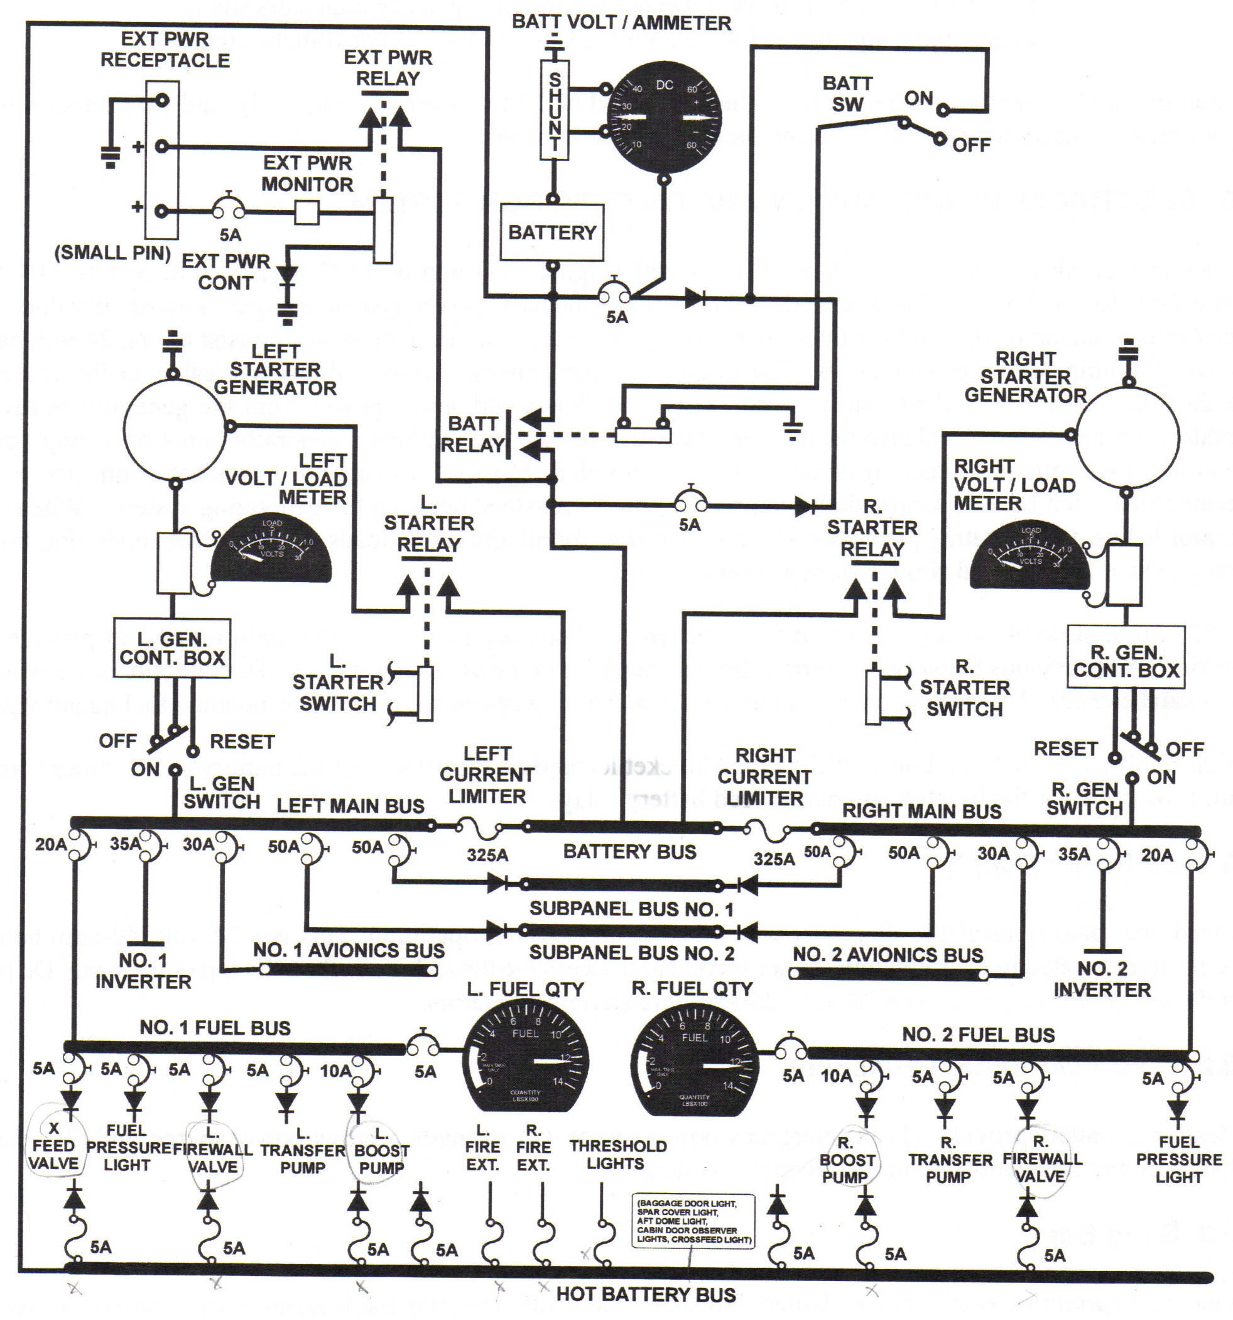
2.10 Electrical Power Supply and Distribution System
This aircraft employs both DC (28.25 ± 0.8 VDC) and AC (114 ± 7 VAC, 400 ± 6 Hz) electrical power. The DC electrical supply forms the basic power system, energizing most aircraft circuits. AC power is obtained from DC power through inverters. The three sources of DC power consist of one 24-volt battery and two 250-amp starter-generators. The output of each generator passes through a cable to the respective generator bus. Other buses distribute power to aircraft dc loads and derive power from the generator buses. The current and overvoltage protection is automatically provided. Most DC distribution buses are connected to both generator buses, but have isolation diodes to prevent power crossfeed between the generating systems,. When either generator is lost, the operating generator will supply power for all aircraft DC loads. Two inverters operating from DC power produce the required single-phase ac power.

Two 325-amp slow-blow fuses, referred to as current limiters, are used to tie the main buses and provide fault protection. A battery bus between the current limiters supplies DC power to the starters. The integrity of each current limiter can be checked by turning on the battery switch and noting operation of the corresponding fuel quantity gauge.

Four circuit breakers mounted on an “L” shaped bracket located on the aft side of the battery compartment provide circuit protection for the bus-fed and battery-fed battery relays.

2.10.1 DC Power Supply
One lead-acid battery furnishes DC power when the engines are not operating. This is a 24-volt, 42-amp hour battery located in the right wing center section and accessible through a panel on the top of the wing. DC power is produced by two engine-driven 28-volt, 250-amp starter-generators.

2.10.2 Lead-Acid Battery Functions
The lead-acid battery provides 1) an emergency power source, 2) an engine starting power source, and 3) a damper to absorb power transients within the electrical system.

2.10.3 Gang Bar
All electrical current except for the hot battery bus may be shutoff. The gang bar is raised when a battery or generator switch is turned on. Placed down, the bar forces all switches to the OFF position.

2.10.3.1 Battery (BATT) Switch
A switch placarded BATT is located on the control pedestal and, when placed to the ON position, permits the battery to supply DC power to the aircraft bus system through the battery relay. Isolation diodes permit the battery relay to be energized by external power or the generators in the event the battery charge is insufficient to activate the relay.

2.10.3.2 Generator Switches
These are three-position switches placarded OFF and ON with a spring loaded “reset” position forward of ON. When a generator is removed from the system for failure of placing the switch to OFF, the affected unit cannot have its output restored to the aircraft until the GEN switch is moved to “reset”, then ON.

The generator control panel is located under the cabin center aisle aft of the main spar and provides overvoltage, undervoltage, reverse current protection, and automatic paralleling. If one or more of these conditions is sensed, the respective generator will be disabled and the associated LH or RH generator out light will illuminate.

2.10.4 Load Voltmeters
Each meter normally shows output amperage shown as a percent of rated capacity from the respective generator unless the pushbutton switch is pressed to obtain bus voltage reading. Current consumption is indicated as a percentage of total output amperage capacity for monitored generator.

2.10.4.1 Generator Out Warning Lights
Shows LH GEN OUT and RH GEN OUT lights on the annunciator panel.

2.10.5 DC External Power Source
DC power is supplied through the DC external plug and applied directly to the battery bus after passing through the external power relay. The holding coil circuit of the relay is energized by the external power source.

The auxiliary power unit must not exceed 28 VDC and have the capability of delivering a continuous load of 300 amps with up to 1,000 amps for 0,1 seconds.

2.10.6 AC Power Supply
Aircraft AC electrical power is supplied by two 750 V-A, single-phase inverters that receive operating current from the DC power system. They supply single-phase 26 VAC and 115 VAC power.

2.10.6.1 AC Power Warning Lights
#1, #2 INV OUT lights illuminate as well as INST INV OUT, which indicates a 26 VAC failure to the engine torquemeters.
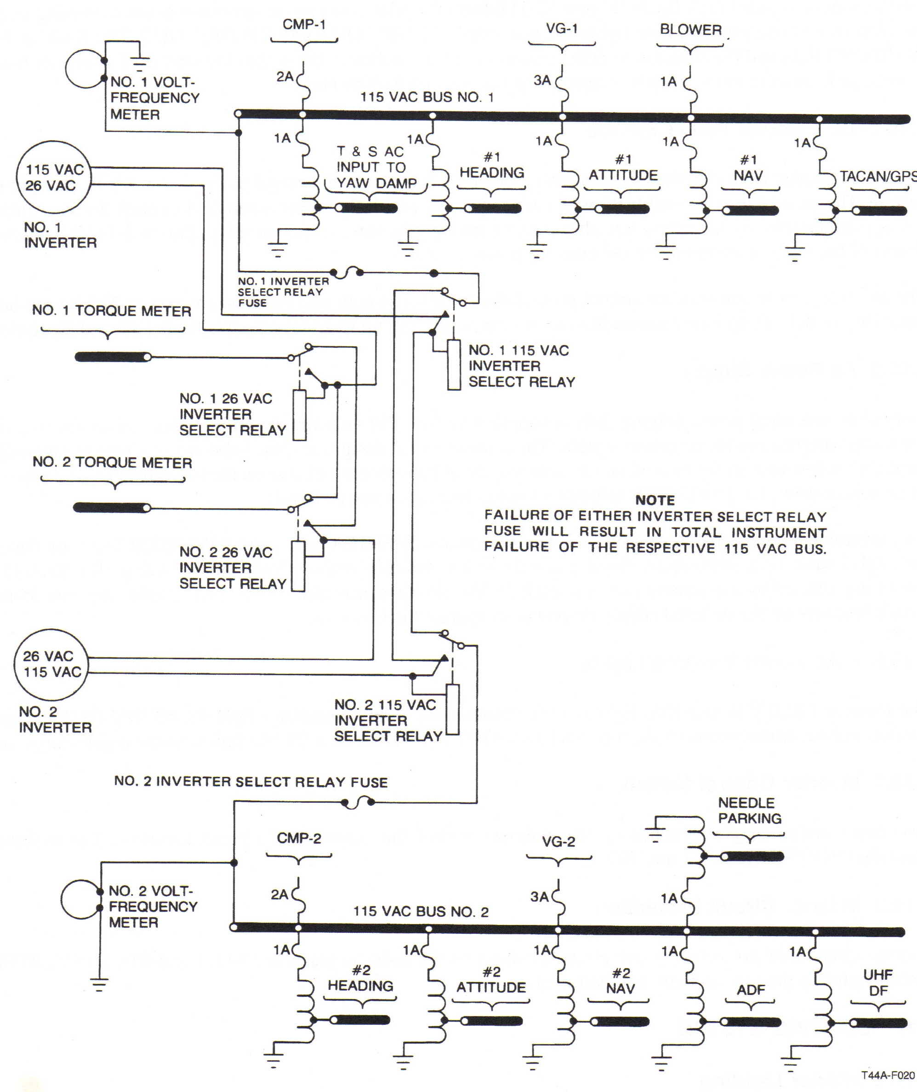

15.14 ELECTRICAL SYSTEM FAILURE
15.14.1 Generator Failure
If a generator fails (indicated by illumination of the respective RH or LH GEN OUT annunciator), all nonessential electrical equipment should be used with caution to avoid overloading the remaining generator. Loads in excess of single-generator output will drain the battery. If a generator fails and will not reset, current limiter status information is necessary because it relates to battery condition/duration. Three basic possibilities exist: (1) If the battery volt ammeter is not showing a discharge and no other equipment failures are noted, the current limiters are intact and the operating generator is providing all the DC power requirements. If the load is 1.0, turn off unnecessary equipment. (2) If the battery is showing a discharge and no other equipment failures are noted, the current limiter opposite the inoperative generator has failed. The battery is powering the equipment/busses on the inoperative generator's main bus. Consideration should be given to securing the battery to conserve it for later use in the terminal area (lowering gear and flaps, etc.). If the battery is secured, the singly powered items on the inoperative generator's main bus will be lost. The boost pump on that side will still be operating, since it is dual powered, and the battery will still show a discharge. For maximum battery conservation, consider securing that boost pump. If the boost pump is secured, the pressure light on that side will not illuminate since it is singly powered. The crossfeed valve will still operate manually. (3) If the battery is not showing a discharge and other equipment failures are noted, (a fuel quantity gauge, a VOR, a VHF or UHF radio, a flight director and a compass system) the current limiter has failed on the same side as the inoperative generator and this equipment will remain inoperative. The battery is not being discharged. Therefore, the operating generator is powering the hot battery bus. Monitor the operating generator's load.
When generator failure is indicated, proceed as follows:

Note
Ensure starter switch is off.

*1. Generator — OFF, Reset Momentarily, Then ON.
Note
- Release the generator switch slowly from the spring-loaded reset position
to the ON position to prevent tripping the opposite generator off.
- Normal voltage in the reset position indicates a failure of the generator
control rather than the generator.

If generator will not reset:
*2. Generator — OFF.
*3. Current limiter (Battery Ammeter) --- Checked.

WARNING
The combination of a failed generator, failed opposite side current limiter and a drained battery results in no power available to the hot battery bus. In this situation no fire extinguishing capability exists.
Note
If the battery is supplying power to busses due to either a failed generator and opposite side current limiter or due to a failed generator and excessive load on the operating generator, battery power may be available for as little as 10 minutes if electrical load is not reduced.

- Operating generator — Do Not Exceed 1.0 Load.
- Land as soon as practicable.

WARNING
Should smoke and/or fumes be detected immediately following a generator failure, the origin could be in the generator control or an internal generator malfunction. Intermittent utilization of the corresponding engine bleed air valve may help confirm an internal malfunction. If smoke and fumes persist for an internal malfunction, consideration should be given to securing the corresponding engine to stop generator rotation and eliminate the fire hazard.

15.14.2 Dual-Generator Failure
If both generators are inoperative, consideration should be given to the following steps as a method of ensuring maximum duration of the battery.

1. Cabin temperature mode, electric heater, anti-ice/deice, autoignition, lights and radar — OFF.
2. Emergency voice report — Completed.
3. (V_{MC}) Gang bar — OFF; (I_{MC}) Generators — OFF.

WARNING
With a total loss of electrical power, the cabin will depressurize as the bleed air valves are spring loaded closed. If cabin altitude exceeds 10,000 feet, supplemental oxygen for all occupants of the aircraft should be considered.

- Boost pumps — OFF.
- (vmc) Both inverters — OFF; (I_{MC}) #2 inverter — OFF.
- Pull the following circuit breakers:
a. Left and right feeder bus circuit breaker for No. 2 subpanel bus.
b. Left and right fuel panel bus circuit breaker.
c. LH fuel flow, LH oil temperature circuit breakers.
d. RH bleed air control, propeller sync, annunciator power, flap motor, and flap indicator circuit breakers.

Note
With dual-generator failure, a no-flap landing and manual gear extension should be anticipated in all cases.

- If vmc: Avionics master — OFF, Battery — ON. The pilot turn and slip indicator and landing gear annunciator lights will be powered to ensure the gear are safely down and locked after a manual extension.
- If imc: If GCA approach is available pull the following circuit breakers: #1 AVIONICS, VOR #2, RMI #1, and radar. The copilot will be able to fly a GCA approach using UHF. No electric trim will be available. Select transponder to the manual mode. The copilot should select the SPKR/phone switch to SPKR so the pilot can hear the radio.
- If imc: If a VOR/ILS or TACAN approach are the only approaches available, pull the following circuit breakers: #2 AVIONICS, ADF, RADIO ALTM, RMI #2, OPR AUDINTPH., ELEC TRIM. The pilot can fly a VOR/ILS approach. No transponder will be available. The copilot should select the SPKR/phone switch to SPKR so the pilot can hear the radio. If a TACAN approach is flown pull the NCS and the VOR #1 circuit breakers.

The battery life will be significantly reduced when steps 8 or 9 are used.

15.14.3 Excessive Loadmeter Indications (Over 1.0)
Excessive loadmeter indications are generally caused by an excessive battery charge rate or an electrical system ground fault.
1. Battery/ammeter — Check.

If a charge rate in excess of 30 amps is indicated:
- Battery —OFF.
- Battery/ammeter — Check.
If battery charge rate is still in excess of 30 amps the battery relay has failed, land as soon as possible. If battery charge rate drops after securing the battery switch, proceed as follows:
- Recheck loadmeters.

, i If loadmeters are normal, the problem was excessive battery charge rate. Land as soon as practicable. If loadmeter indications are still excessive, an electrical ground fault exists. Be alert for electrical fire, secure malfunctioning electrical equipment and land as soon as possible.
Note
Loadmeter splits of greater than 0.1 are indicative of abnormal generator paralleling. With the air-conditioner or electric heater activated, an excessive loadmeter indication for the left generator may be indicative of a current limiter failure.

15.14.4 Inverter Failure
Either inverter is capable of supplying the full amount of normally required single phase alternating current (ac)
power. The failure of an inverter will be indicated by illumination of the respective failed INVERTER OUT (#l/#2) annunciator light.
- Fail inverter — OFF.
- Check for ac bus switchover.
- Land as soon as practicable.
Note
,After a total AC power failure, both compass systems, attitude gyros, VOR, TACAN, and ADF azimuth/bearing, torque indication and GPS will be unavailable.

15.14.5 Instrument Inverter Failure
Illumination of the INST INV annunciator light indicates a loss of both 26-Vac stepdown transformers. Torquemeter indications will be erroneous. Utilize ITT and ni RPM for making power changes.

15.14.6 Circuit Breaker Tripped
- Nonessential circuit — Do Not Reset in Flight.
- Essential circuit
a. Circuit breaker — Push to Reset.
b. If circuit breaker trips again — Do Not Reset.

15.14.7 Avionics Failure
If all avionics power is lost, the avionics master switch has possibly failed. Pulling the avionics MASTER POWER circuit breaker on the CP subpanel may restore avionics power.

15.14.8 Subpanel Feeder Circuit Breaker Tripped
A short is indicated: DO NOT RESET IN FLIGHT

