T-44A Briefing Guides


EVENT: C4204

DISCUSS ITEMS: Aircraft operating limits, forced landing, fuel system, and environmental/pressurization system.

Aircraft operating limits – See the VT-31 website

Forced landing – If sufficient altitude remains after reaching a suitable landing area, a circular pattern will provide the best observation of surface conditions, windspeed, and direction. When the condition of the terrain has been noted and the landing area selected, set up a normal pattern and extend the gear when the landing is assured. Fly the base leg as necessary to control point of touchdown. Plan to overshoot rather than undershoot using flaps as necessary. Keep in mind that with both propellers feathered, the normal tendency is to overshoot because of less drag. In the event of a positive gear down and locked indication cannot be determined, prepare for a gear up landing.

Note
Night emergency egress procedures may be facilitated by pre-positioning the threshold and spar lighting switch to on and turning on the aft compartment lighting.

- Configuration
  - Do not extend full flaps until the landing is assured
  - A gear up landing should be considered based on the type of touchdown surface
- Selecting a landing area
  - Select a landing area of adequate size to accommodate the aircraft, preferably free of obstacles and smooth. Cultivated fields are most desirable. Swamps, boggy ground, shallow lakes, and forest should be avoided if possible.
  - Land the aircraft into the wind as near as possible
- Landing the aircraft
  - The landing should be made at the slowest speed commensurate with complete control
  - If landing into trees, fly into them. Do not attempt to land on the tops.

To assist the pilot in making a forced landing, a pattern describing optimum altitudes at selected positions is provided for information purposes only and is not an objective for qualification.
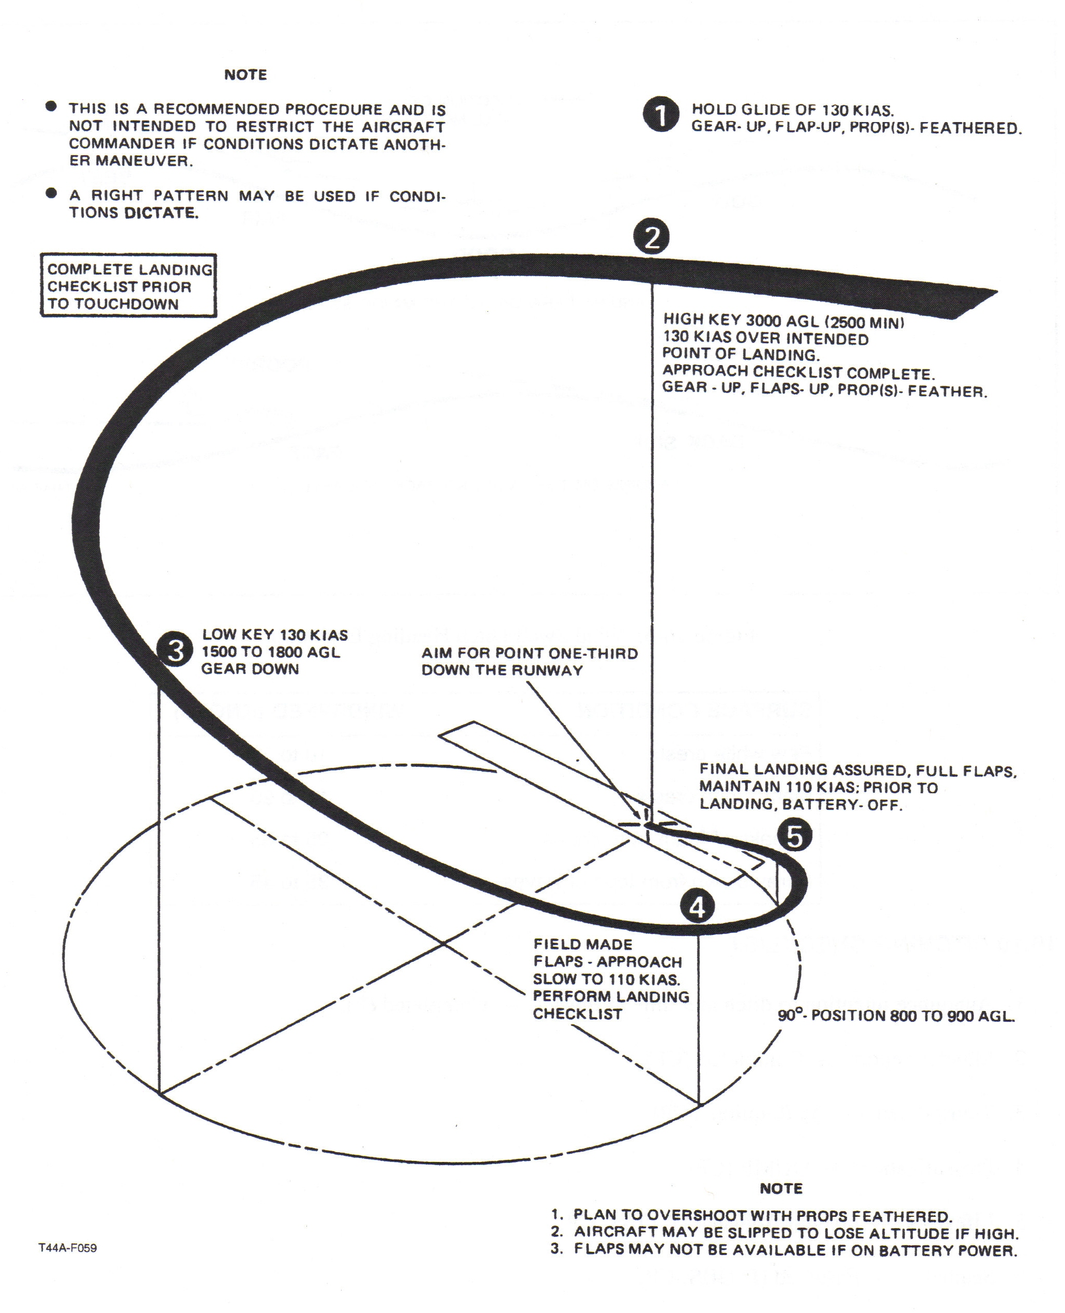

During the NATOPS briefing, forced landing is briefed as:
“In the event of forced landing / ditching, the pilot not at the controls will back up the pilot both on the controls and with verbal altitude updates. Landing / Ditching on parameters is most important. The IP can be expected to perform any actual forced landing / ditch.”
Fuel System –
- Total fuel capacity is 387.6 gallons, of which 384 are usable
- Transfer pumps are energized by 42-gallon (ON), 51-gallon (OFF), and 59-gallon (upper level) float switches in the nacelle tank.
- When all wing tank fuel has been used, a pressure sensing switch will sense the drop in fuel pressure in the transfer line and, after a 30-second delay, will terminate transfer pump operation, and a red NO FUEL TRANSFER annunciator light will illuminate.
- Boost pump failure will show a flashing fault light, a FUEL CROSSFEED light if the crossfeed switch is in auto, and a LH or RH FUEL PRESSURE light.
- Unboosted engine operation is limited to 10 hours throughout the TBO period.
- When AUTO is selected with the crossfeed switch, the crossfeed valve remains closed until fuel boost pressure (LH, RH, or both) drops from a nominal 30 psi value to 5 psi.
- The LH RH firewall valves, LH RH boost pumps, and crossfeed valve (not the crossfeed light!) are dually powered by the hot battery bus.

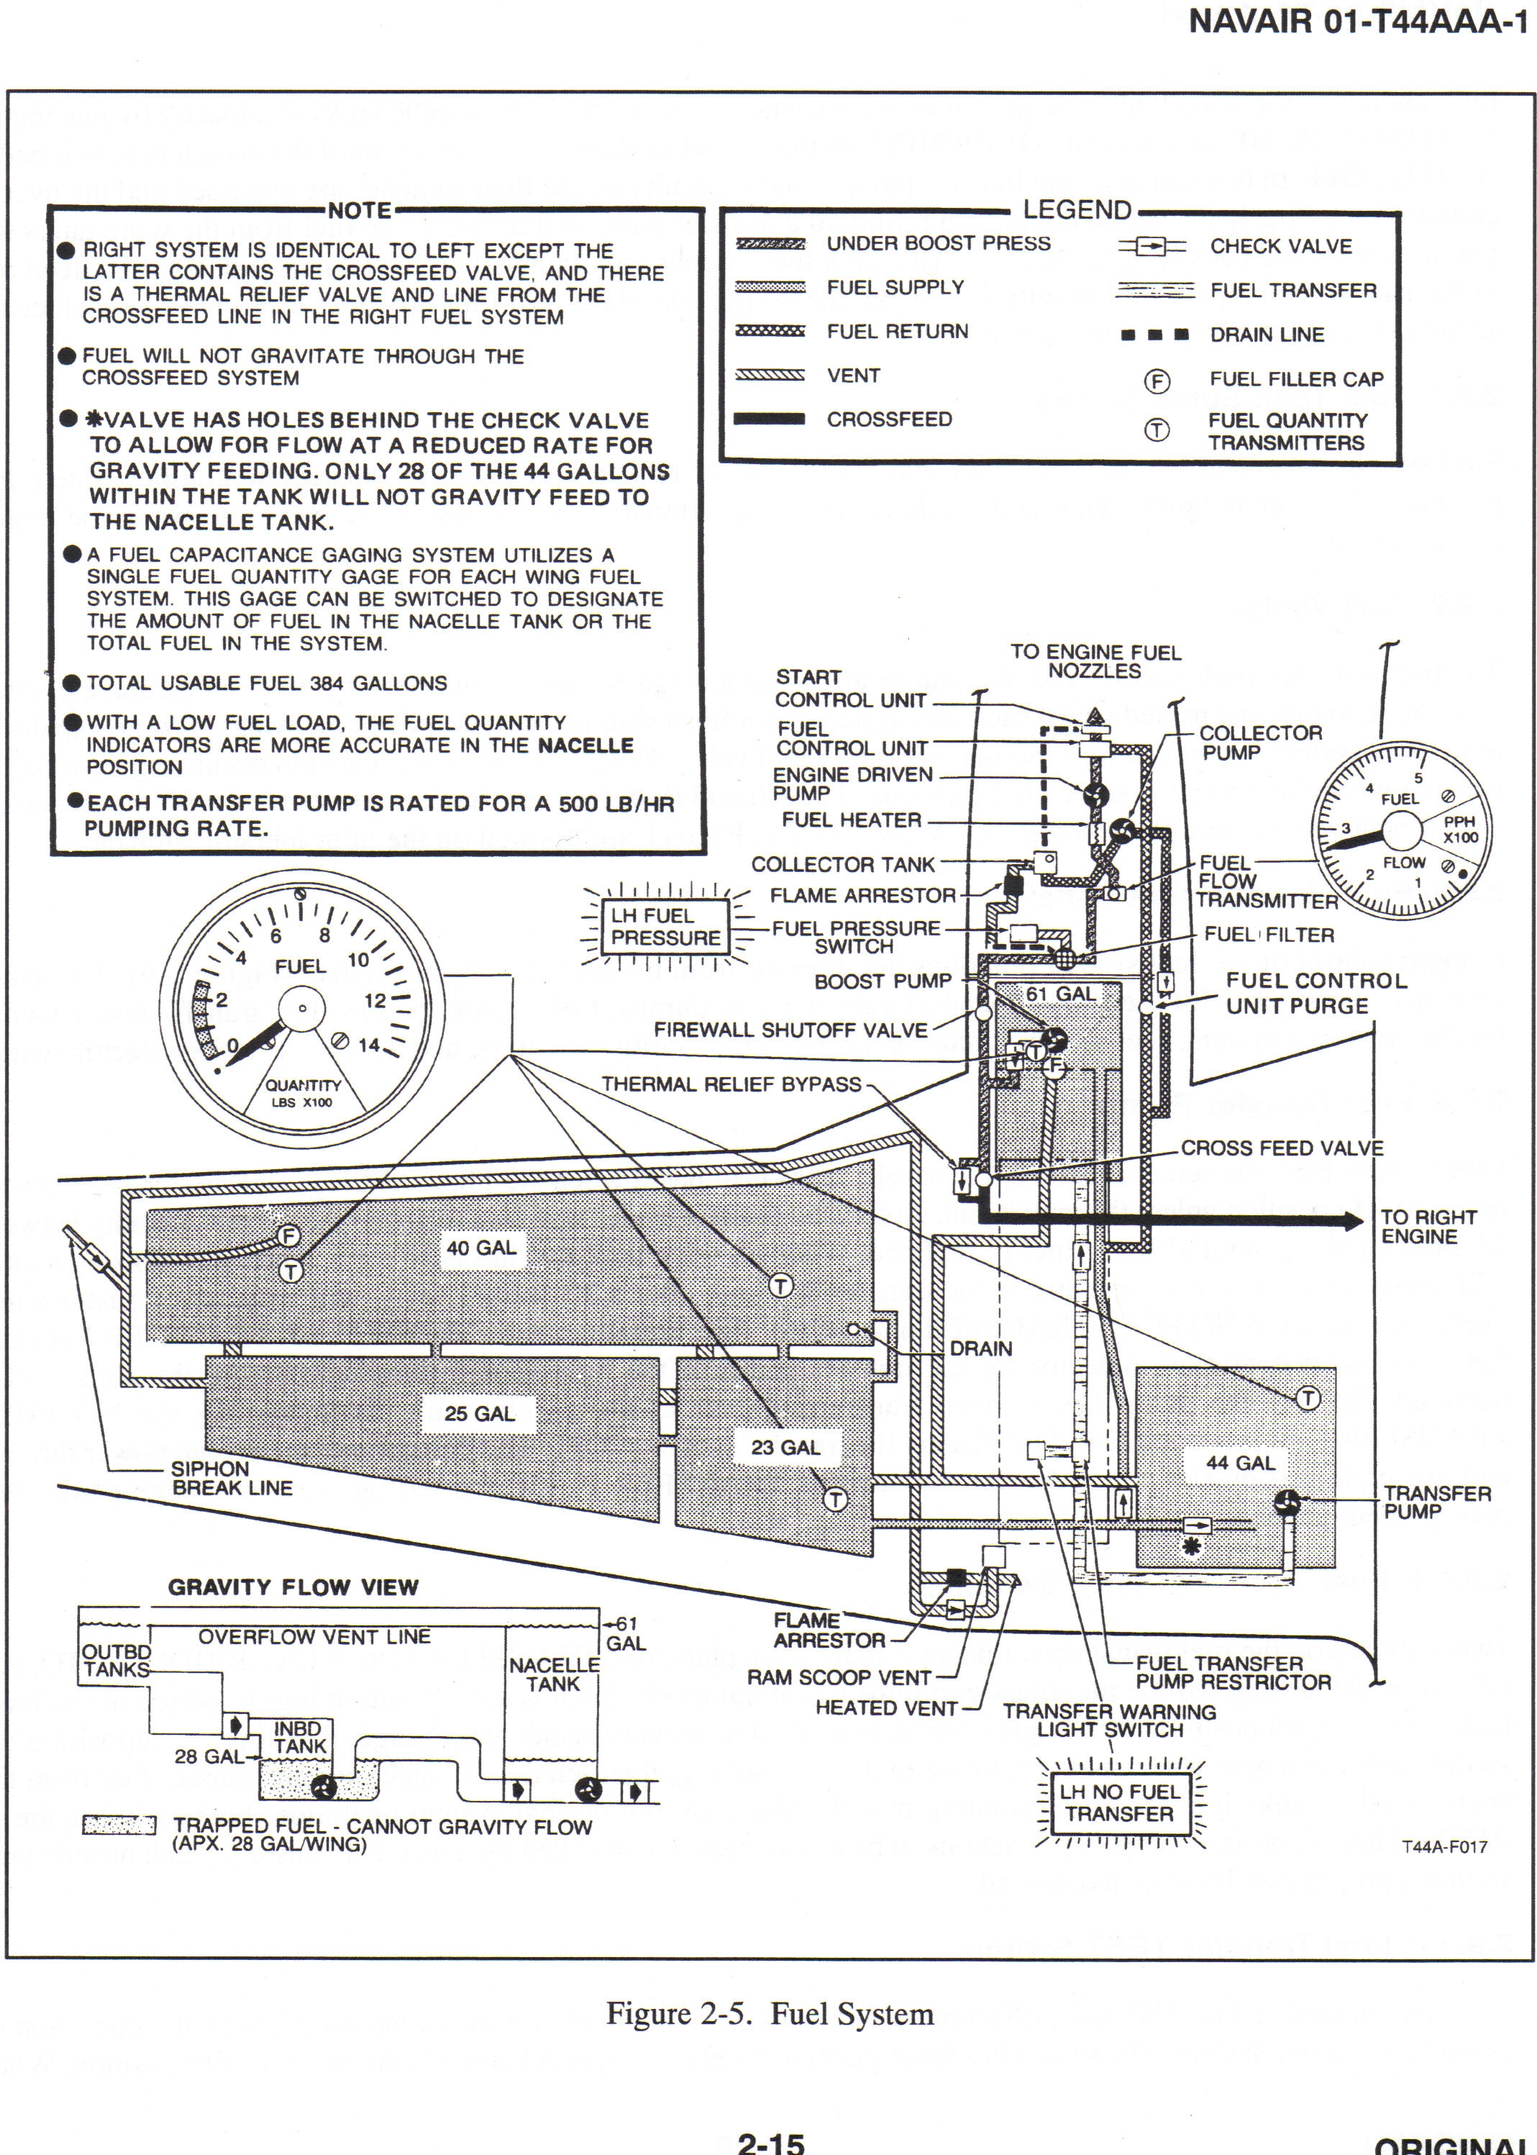

Fuel system failure –
15.11.1 Engine-Driven Fuel Pump Failure
The engine-driven fuel pump will sustain engine operation after failure of the electric boost pump; however, failure of the engine-driven fuel pump will result in flameout. Perform the EMERGENCY SHUTDOWN CHECKLIST in paragraph 15.2

15.11.2 Transfer Pump Failure
Illumination of the LH or RH NO FUEL TRANSFER light indicates a possible failure of the corresponding transfer pump.

- Check total and nacelle fuel quantity.
If no fuel remains in the wing tanks:
- Transfer pump — OFF.

If fuel remains in the wing tanks and it is deemed necessary to utilize the 28 gallons of fuel that would otherwise remain trapped:
- Transfer pump — OVERRIDE.
If light remains on:
- Transfer pump — OFF.

Note
Consider alteration of the flight plan because of unavailable fuel trapped in the wing (approximately 28 gallons).
- Land as soon as practicable.

15.11.3 Boost Pump Failure
A boost pump failure with crossfeed in AUTO will be noted by illumination of the yellow FUEL CROSSFEED annunciator light. The failed boost pump is identified by momentarily placing the crossfeed switch in the CLOSED position. The red LH or RH FUEL PRESSURE light will illuminate indicating the failed boost pump.
- Failed boost pump — OFF.
- Crossfeed — OPEN.

Note
Determination of range without resorting to suction lift is dependent upon fu el load remaining on the side opposite the failed boost pump.
3. Land as soon as practicable.

Note
If range because of crossfeed operation is critical, suction lift may be utilized at all cruise altitudes but should be discontinued in favor of crossfeed (boosted pressure) when initiating descent for landing in the event of a missed approach.

Boost pump failure during rapid climbout will cause a gradual power loss on the affected engine beginning at approximately 13,000 feet. This altitude will vary with the prevailing fuel temperature in the tank (the higher the fuel temperature, the lower the altitude at which the gradual power loss will occur). Complete power loss will occur if the climb is continued under these circumstances. This condition results from the highly aerated condition of the fuel caused by rapidly decreasing tank pressure during climb, allowing entrapped air in the fuel to expand. Once the pressure has stabilized and excess air has escaped from the fuel, loss of a boost pump has less effect on engine operation with maximum power settings available at altitudes up to 31,000 feet. The time required to stabilize the fuel from this highly aerated condition cannot be determined exactly since it is a function of both rate of climb and fuel temperature. Fuel stabilization should occur after a few minutes of stabilized cruising operation. Descents from a from a high altitude with the boost pump inoperative do not affect engine operation.

If engine power loss is experienced during the climb-out or initial phase or cruise because of an inoperative boost pump and a condition of aerated fuel, satisfactory engine operation may be regained by initiating crossfeed, reducing power, and/or descending to a lower altitude. If the crossfeeding is continued for a prolonged period, a major unbalancing of fuel load will occur and a range loss will be encountered because the surplus fuel in the tank with the inoperative boost pump cannot be crossfed to the other engine.

CAUTION
Engine-driven fuel pump operation without boost pump fuel pressure is limited to 10 hours. This time shall be recorded.

15.12 FUEL LEAKS
A fuel leak may be evidenced by the smell of fuel in the cockpit, a rapid drop in fuel quantity, or sighted visually. The first concern of the crew must be to guard against the outbreak of an engine fire. Consideration should be given to securing electrical systems that may contribute to the outbreak of a wing fire. Outboard wing electrical items in each wing that may be individually secured from the cockpit are the navigation and strobe lights and the fuel vent heaters. In addition, the left wing contains the AOA sensor and the sensor heater circuits. Inboard wing systems may be secured using the gang bar. If a wing or nacelle fuel leak is evidenced and power is not necessary to sustain flight or reach a safe destination, consideration should be given to securing the engine as follows:

*1. Condition lever — FUEL CUTOFF.
*2. Emergency Shutdown Checklist --Execute.

15.13 FUEL SIPHONING
If fuel filler cap siphoning occurs, proceed as follows:
- Airspeed — 140 KIAS.
- Land as soon as practicable.
Note
Extreme nose-low attitudes will aggravate the fuel siphoning condition.

Environmental/pressurization system –
2.18.1 Bleed Air Valve Switches
Bleed air valve switches of the two-position, lever-lock type actuate electric solenoids in the flow control units of the engines to bring warm, compressed air (bleed air) from the compressor section of the engine to the cabin. The bleed air valves are electrically opened and spring loaded to closed.

2.18.2 Vent Blower Switch
The vent blower switch controls vent blower fan speed. In the AUTO position, the blower will run at low speed and with this position selected may be secured by selecting OFF with the cabin temp mode switch.

2.18.3 Manual Temp Control Switch
The spring loaded switch placarded MANUAL TEMP – INCR – DECR controls the motor-driven heat exchanger bypass valves in the wing center sections. In the automatic mode, the motors are driven to the proper valve opening automatically as regulated by the temperature control located in the ceiling at the forward end of the cabin. Since the valves operate sequentially, it may take as long as 1 minute to drive the valves from one extreme to the other.

2.18.4 Electric Heat Switch
This switch is solenoid held in GRD MAX position when on the ground and will drop down to the NORM position at lift-off when the landing gear safety switch is opened. If all eight of the electrical heating elements are not desired for initial warmup as in the GRD MAX position, the switch may be placed in the NORM position for warmup in which only four elements will be used. In this position, the operation of the heater is automatic in conjunction with the temperature controller when the CABIN TEMP MODE is in AUTO and will operate continuously in the MAN HEAT position to supplement bleed air heating. Protection of the ducting is provided through heat limiters installed in the system. The OFF position turns off all electric heat and leaves the cabin heating to be provided by bleed air.

If windshield anti-ice, propeller deice, and/or LH or RH lip boot heaters are operating (individually or in combination), all electric heater operation will be locked out to protect against possible electrical overload.

2.18.5 Cabin Temperature Control Rheostat
Temperature sensing units in the cabin in conjunction with the control setting initiates a heat or cool command to the temperature controller for desired cabin environment.

2.18.6 Cabin Temperature Mode Switch
In the AUTO mode, cabin temp is controlled by the temperature controller in conjunction with the cabin temp control rheostat. With the selector in the MAN HEAT or MAN COOL position, temperature regulation is accomplished manually with the MANUAL TEMP control switch.

2.18.7 Flow Control Unit
A flow control unit forward of the firewall in each nacelle controls third-state compressor bleed air from the engine for pressurization, heating, and ventilation. This unit is fully pneumatic except for an electrical solenoid operated by the bleed air switches and a normally open electric ambient air shutoff valve solenoid operated by the LH landing gear safety squat switch.

The flow of bleed air through the flow control unit is controlled by a pressure regulator that uses atmospheric pressure and temperature to maintain a constant pressure through the flow control unit at all altitudes and temperatures.

Ambient air flow is controlled only as a function of temperature. While bleed air is at lower temperatures on the ground, the LH landing gear squat switch closes the ambient air shutoff valve blocking the flow of ambient air into the flow control unit. This exclusion of ambient air on the deck allows for faster warmup in cold weather. Once airborne, ambient air is allowed into the flow control unit where it mixes with bleed air as regulated by a pneumatic thermostat. As temperatures lower, the pneumatic thermostat begins to close, which in turn closes the ambient modulator valve, shutting off the flow of ambient air. Thus, the pneumatic thermostat governs the temperature of the hot air available to the cabin by regulating the amount of cold ambient air that mixes with the warm bleed air. The mixed air is then forced into the bleed air line through the heat exchanger in the wing center section and into the cabin.

The flow control unit contains a firewall shutoff valve in the bleed air line that is held in the open position by pressure directly from the pressure regulator. When the bleed air valve is closed or when bleed air diminishes on engine shutdown, the firewall valve closes because of a loss of pressure to the firewall shutoff valve.

2.18.8 Air Circulation
The vent blower, installed forward of and beneath the pilot rudder pedals, provides the motive force for airflow circulation in the cabin. The vent blower pumps air from the cabin through a flapper door in the forward pressure bulkhead into the air-conditioner plenum. In the plenum, the air passes through the evaporator that, if the air-conditioner is running, refrigerates the air. The air then crosses over to the right side of the nose section where part of the air is tapped off by a cold air duct prior to reaching the heater. Air from the cold air duct is sent to the overhead outlets throughout the cabin. The rest of the air passes through the electric heater, which may or may not be operating, and into the heater plenum forward of and beneath the copilot rudder pedals. In the heater plenum, air mixes with incoming bleed air and is ducted aft under the floor to outlets on the sidewalls of the cabin and baggage compartment vent. This air is also available to the cockpit via push-pull controls for foot air and windshield defrosting.

2.18.9.1 Cooling
There are two types of cooling on the mode selector switch: AUTO and MAN COOL. In AUTO, the temp controller closes the right bypass valve in proportion to the desired temperature decrease. Once the right bypass is closed, the left bypass valve begins to close routing all bleed air through the heat exchanger. An air intake on the leading edge of the wing brings ram air into the heat exchanger to cool the bleed air that is being ducted into the cabin. This ram air, upon leaving the exchanger, is dumped overboard through louvers on the bottom side of the wing. If additional cooling is then required, a signal is sent to the air-conditioner to begin operating. The air-conditioner evaporator is mounted in the lower part of the nose forward of the pressure bulkhead. Cool air is supplied to the air-conditioner condenser through a louvered intake in the right side of the nose and exhausted through louvers in the left side. The unit is electrically driven, has a rated capacity of 16,000 BTUs and uses refrigerant gas.

In the MAN COOL mode, operation of the air conditioner is continuous and all bleed air may be sent through heat exchangers by holding the manual temp control switch in the DECR position.

On a hot day, max cooling is obtained by 1) closing the bleed air valves if on the ground, 2) setting the vent blower to HI, and 3) opening all overhead air nozzles.

2.18.9.2 Heating
There are two modes of heating: MAN HEAT and AUTO. Selection of MAN HEAT imposes continuous operation in that mode with regulation of the bleed air temperature provided through the MANUAL TEMP control switch. With the electric heat in the NORM position, operation of the heater continues in MAN HEAT. In the automatic mode, the temp control may be regulated with the CABIN TEMP control rheostat. The temp control begins to open the left bypass valve in proportion to the amount of heat demanded. Once the left bypass valve is open completely, the right bypass valve begins to open routing all bleed air around the heat exchangers. If further heating is needed, the electric heater begins operating assuming the electric heat switch is in the NORM of GND MAX position.

On a very cold day, max heating is obtained by 1) positioning electric heating to GND MAX, 2) setting the vent blower to HI, 3) closing the overhead nozzles, and 4) opening the bleed air valves after engine start.

If the air conditioner or electric heater operates, the loadmeter will read significant load and the operator should take care not to exceed generator load vs. N1 limits or the low idle ITT limit.

2.18.10 Unpressurized Ventilation
Fresh air ventilation is provided by two sources: 1) the bleed air heating system and 2) outside air obtained from a ram air scoop on the left side of the nose. The ram air enters the evaporator plenum through a flapper door. The flapper door is open during the unpressurized mode. (In the pressurized mode, the flapper door is held closed by a solenoid lock).

Cabin air forced into the evaporator plenum by a blower mixes with ram air from outside and is ducted throughout the cabin.

2.18.11 Pressurization Control System
Bleed air is available to the cabin for pressurization. The pressurization control system controls only the outflow of air from the pressure vessel to achieve control of the pressure differential.

2.18.11.1 Cabin Pressure Control Switch
This switch has three positions: TEST, PRESS, and DUMP.

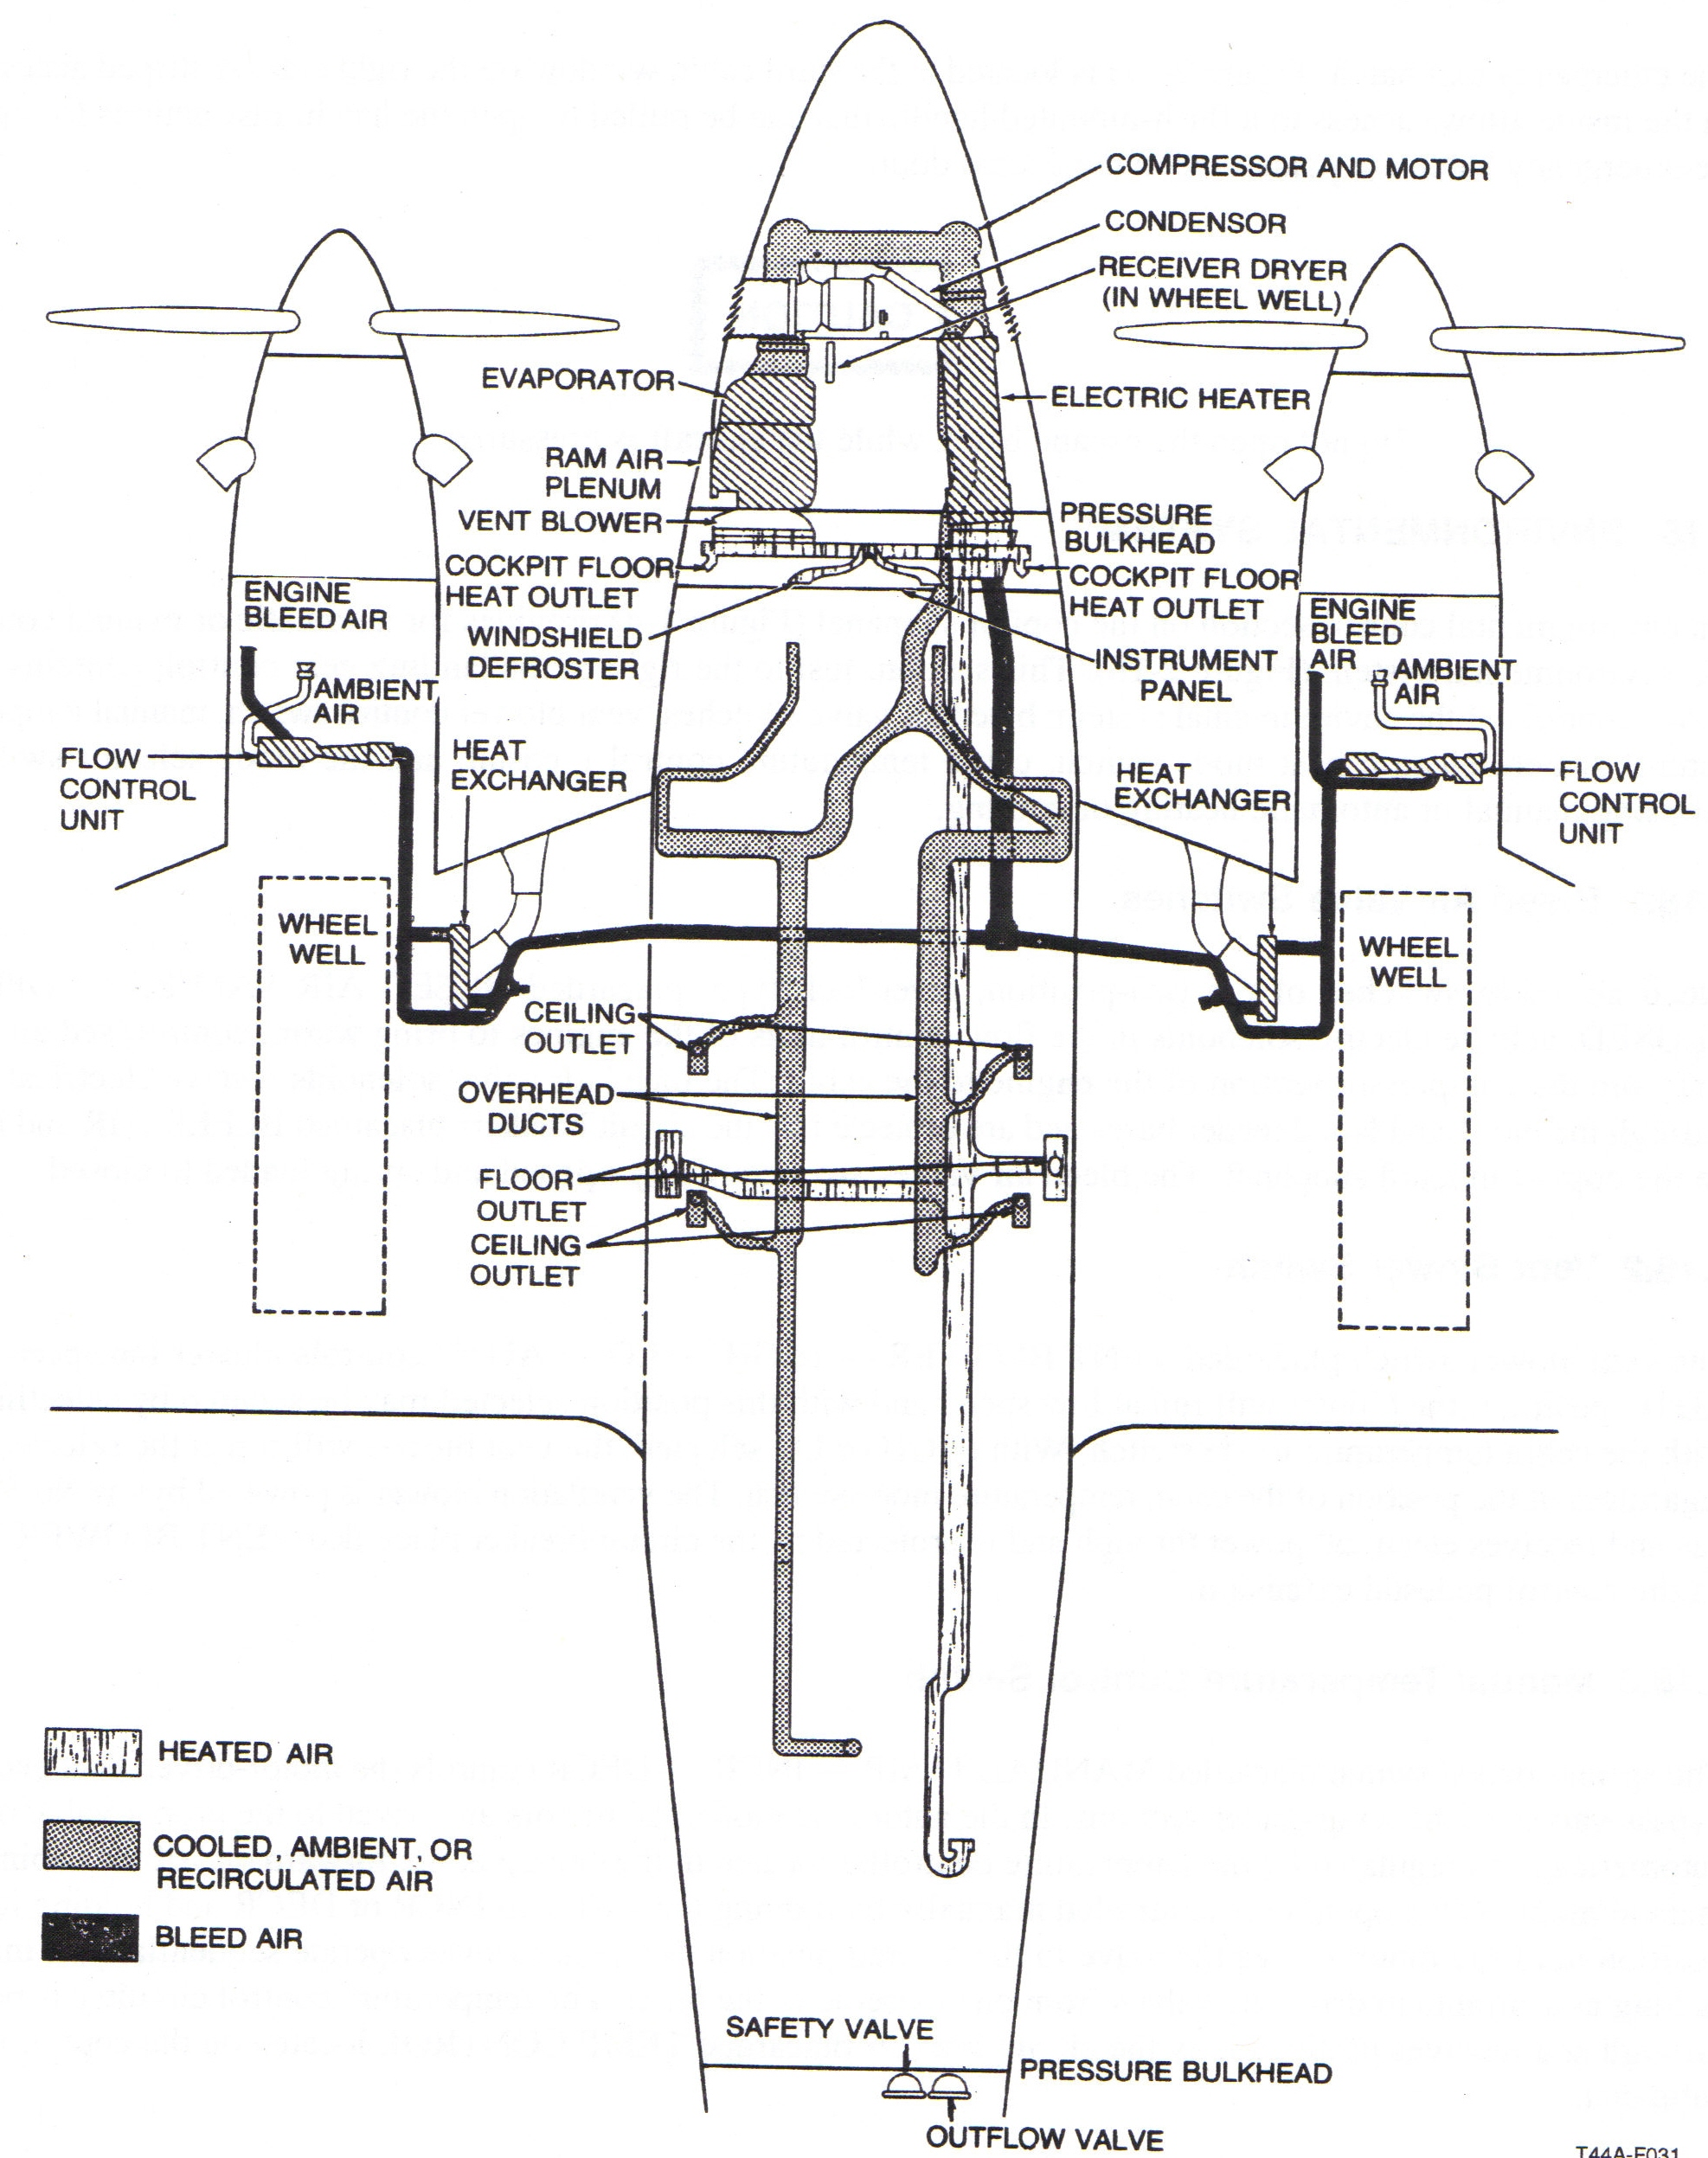
2.18.11.2 Controller
This device controls the opening of the outflow valve by varying the amount of vacuum applied to the valve. The controller contains the rate knob and the altitude knob. With the rate knob the operator can select a desired cabin rate of climb and descent from a minimum of about 50 fpm to a max of about 2000 fpm, and the middle setting approximates 500-700 fpm. The altitude knob allows selection of the desired cabin pressure altitude from 1,000’ below sea level to 10,000’MSL. On the ground, the LH squat switch closes to apply power to a normally open PRESET solenoid, which in turn closes to block off the source of vacuum to the controller. With no vacuum applied, the outflow valve goes to its spring-loaded closed position. Thus, at lift-off, the cabin immediately begins to pressurize at the rate preset on the controller.

2.18.11.3 Outflow Valve
The outflow valve meters the outflow of cabin air and also contains a preadjusted relief valve set to ensure that the cabin does not exceed 4.7 psid. Third, it incorporates a negative-pressure differential relief diaphragm (the cabin altitude cannot be higher than the aircraft).

2.18.11.4 Safety Valve
The safety valve serves as the “dump valve” that opens completely to relieve all pressure differential whenever the pressure control switch is placed in DUMP or when the switch is in PRESS and the aircraft is on the ground. The LH squat switch activates this valve to open when on the ground. A second function of the safety valve is that it contains a preadjusted relief valve to ensure cabin pressure differential does not exceed 4.9 psid. Thirdly, like the outflow valve, it contains a negative pressure differential relief diaphragm.

2.18.11.5 System Operation
On the ground before takeoff, the LH squat switch in series with the cabin pressure control switch in PRESS supplies power to the safety valve (dump) solenoid and the preset solenoid. The safety valve solenoid opens to supply vacuum to the safety valve that holds it in the OPEN or DUMP position. The preset solenoid closes to prevent vacuum from entering the controller and consequently the outflow valve stays closed. Moving the control switch to TEST opens the circuit to those solenoids, allowing the safety valve to close and control of the outflow valve to the controller. Thus, if bleed air is entering the pressure vessel and if a cabin altitude below field elevation has been set, the cabin VSI will show a descent.

NOTE
Because of the small amount of bleed air coming into the cabin at idle engine power, this descent will be a rather small, slow indication.

After lift-off, the left landing gear squat switch opens, which 1) removes electric power from the preset and safety valve solenoids and 2) actuates a time delay that allows the left engine to commence pressurization sequencing 6 seconds before the right engine. This delay sequencing prevents excessive pressure bump when activating the ambient air solenoids of the pressurization system.

As the ambient air sequencing commences, the safety valve goes to its spring-loaded closed position as the outflow valve begins modulating outflow in accord with the controller setting. As the aircraft climbs, the controller modulates outflow until the max cabin differential is reached.

After this point, the cabin altitude begins to climb at approximately the same rate as the aircraft. At a cabin altitude of 9,500’ to 10,000’, a pressure switch illuminates the ALT WARN annunciator light. At this point the poppet valve within the outflow valve will open to maintain a 4.7 psid.

When descending, the negative pressure differential diaphragm in the outflow valve will open to maintain a 0 psid descent. To avoid landing with the cabin pressurized, the controller should be set above the field pressure altitude.
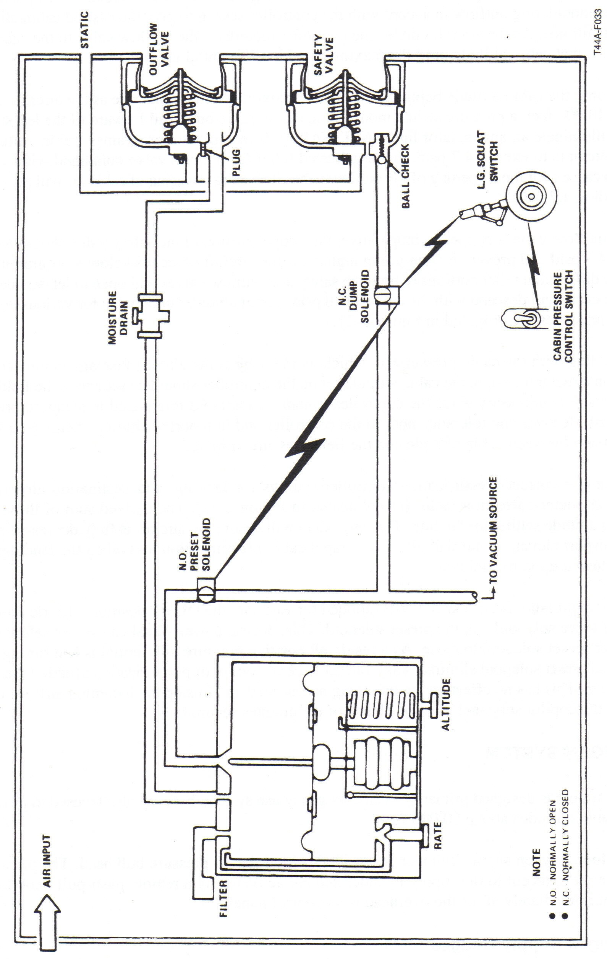

15.19 LOSS OF PRESSURIZATION
Note
Approximately 75-percent ni (single engine 85-percent ni) is required to maintain the pressurization schedule during descent.

If gradual pressurization loss is experienced:
- Cabin altitude — Checked (P).
- Pressurization controller — Checked (CP).
- Bleed air — Checked (CP).
- Press dump test switch — TEST (CP) (hold 15 seconds).
Note
If activating the test switch restores pressurization, it may be necessary to
hold the switch in TEST until the cabin altitude profile is adjusted to 10,000 feet or less. If pressurization is regained through the test switch, pulling the PRESS CONTROL CB will remove electric power from the system, thereby maintaining pressurization.

If unable to restore pressurization:
- Oxygen masks/MIC switches (100 percent) — As Required (P, OBS, CP).
- Descend — As Required (P).

WARNING
Verify obstacle clearance and altimeter setting.

CAUTION
On descent when cabin altitude matches pressure altitude, ensure the PRESS CONTROL CB is reset to preclude landing pressurized.

15.20 Explosive Decompression
If explosive decompression occurs, the cabin pressure changes to the outside pressure in less than 1 second. Explosive decompression causes a fog that should not be confused with smoke. An explosive decompression affects all crewmembers and can be extremely dangerous if it occurs at high altitude. Some of the effects accompanying explosive decompression are rush of air from lungs, a momentary dazed sensation that passes immediately, possible gas pains, and hypoxia if oxygen equipment is not immediately available. Maintaining a safe pressure differential and having oxygen equipment immediately available are precautions that should be observed in pressurized compartments. If explosive decompression occurs, proceed as follows:

- Oxygen masks / MIC switches (100 percent) – As Required.
- Descend – As Required.

Cracked windshield
External Panel: Heating elements inop, don’t use wipers.
Internal panel: descend/depressurize to 2.5 psi in 10 mins. Lose some vis.
Cracked cabin window
Depressurize/Descend

