T-44A Briefing Guides


EVENT: C4202

DISCUSS ITEMS: Simulated dual engine failure, ditching—power off, windmilling airstart, and propeller system/malfunctions.

Simulated dual engine failure – A simulated dual engine failure allows practice of restart procedures and may be followed by a simulated ditch. Simulated ditches shall not be practiced with an engine actually secured or a prop feathered.

The maneuver may be initiated in any configuration above 91 KIAS by the IP reducing both power levers to idle. It may be commenced following a simulated engine shutdown by reducing the remaining power lever to idle. “Sea level” shall be assumed to be the bottom of the block. You will select an appropriate ditch heading unless instructed otherwise.

The size of the Seagull blocks (i.e. 2000’) generally do not allow sufficient time to complete a successful Starter-Assisted Airstart. Unless NATOPS recommends not a attempting a restart (fire, etc.), or insufficient battery voltage exists, a simulated restart attempt should be made on both engines simultaneously. The following procedures should be utilized:

- Clean up if required and commence a turn toward the coastline, a desired heading, or IP assigned heading while transitioning to 130 KIAS. 102 KIAS will allow you more time for restart if altitude is minimal.
- Simultaneously commence the Windmilling Airstart Checklist. Simulate both condition levers at fuel cutoff by pointing at both power levers. The autoignition may be armed, or the starters may be simulated on, at the student’s discretion. The IP will state “no lightoff” or “lightoff on the left/right/both.” If a restart is successful, add power and complete the checklist. If the restart fails, complete the Emergency Engine Shutdown Checklist (appropriate items as time permits) and follow ditching procedures. The IP shall reduce RPM to 1900 when the props are (simulated) feathered and may add power to 100 ft-lbs.
- Stop engine restart attempts at some point during the engine out ditch. The engines should be secured by doing at least the first three items of the Emergency Shutdown Checklist. Place emphasis on flying a proper ditch. Attempting engine relights all the way to the water is likely to deplete all battery power if using the starters. This would eliminate the possibility of a successful IFR ditch.

15.5.3 Engine Failure (Second Engine)
In the event of a dual-engine failure, proceed to the appropriate Airstart Checklist. Do not feather both propellers if a windmilling airstart is intended. Should all attempts to restart either engine fail, transition to the maximum glide range, airspeed (130 KIAS, gear up, flaps up, and propellers feathered) or maximum glide endurance airspeed (102 KIAS, gear up, flaps up, and propellers feathered) as necessary.
WARNING
In the event of a dual failure at low altitude and airspeed, there may be insufficient airflow to maintain propeller and engine N1 speeds to drive the engine for the light-off. In this case consideration should be given to engaging both starter switches vice utilizing the autoignitions for the attempted light-off. With electric heat or air-conditioner motor operating, battery power to the starter motors is significantly reduced. The fact that neither propeller is feathered will significantly reduce glide range and endurance during the relight attempt.
Note
- No wind glide range is approximately 2 nm/1,000 feet. Subtract 0.2 nm per 10 knots of headwind.
- With a dual-engine failure, only battery power is available. Should battery conservation be a consideration, refer to dual-generator failure procedure.

Ditching—power off – Simulated ditching allows practice of procedures required to successfully complete a water landing. Waveoffs following a simulated ditch shall be initiated no lower than 4000’ AGL utilizing both engines. The instructor shall fly ditch recoveries. The maneuver is complete upon simulated water impact. “Sea level” will be designated by the instructor (usually the bottom of the block). NATOPS discusses how to select an appropriate ditch heading. The weather information packets for operational flights usually contain recommended ditch headings for use when the crew can not see the water surface. You should use all information available to select a ditch heading, but due to the limitations imposed by the Seagull blocks, the IP may have to give you a ditch heading that will allow sufficient airspace to complete the maneuver. Ditching is most likely to be caused by an uncontrollable fire, fuel starvation, or dual engine failure. If ditching due to a low fuel state, complete the maneuver while power is still available on both engines. The following must be carefully managed for a successful ditch:

NOTE: NATOPS provides an excellent discussion on ditching technique. The Ditching Checklist does not need to be memorized. General quizzing by instructors is encouraged, but students are not expected to memorize these items.

- Wings Level/Heading – It does not do any good to fly a perfect ditch if the airplane hits a wave head-on. Ensure wings level prior to impact. A couple of degrees off heading will not make much difference, but cartwheeling on impact could prove fatal.
- Rate of descent – The airframe will absorb much of the impact, but not all of it. Excessive rates of descent greatly reduce the survivability of the ditch. The vertical deceleration will be almost instant on water impact. The greater the rate of descent, the higher the instantaneous G-load experienced by the crew.
- Airspeed – Do not get slow. The recommended airspeed provides a safety margin to ensure controllability of the aircraft. Since the aircraft decelerates in the horizontal over a longer period of time, slightly higher airspeeds are still survivable.

The first priority after a dual engine failure is to attempt to regain the use of one or both engines. The altitude/airspeed at the time of the power loss will determine if this is an option. There are two airspeeds of concern to power off glide. Maximum range glide is 130 KIAS. Maximum endurance glide is 102 KIAS. Use nose attitude to slow to the appropriate airspeed. At low altitude you may have to slow to 102 KIAS (an overtemp may occur on the restart if N2 falls below 2200 rpm. Attempt a restart with the appropriate checklist. If the restart is unsuccessful, use your nose attitude to transition to max range glide (130 KIAS) as you complete the Emergency Shutdown (minimum first three items as altitude permits) and Ditching Checklists. Follow the NATOPS ditching technique. The idea is to trade airspeed for rate of descent.

16.11.3 No Power Available
- Gear - - UP.
- Flaps - - UP.
- Rate of descent should be such that airspeed be maintained at 130 knots (maximum glide KIAS) until approximately 200 feet AGL. At this time, transition should be made to approach flaps allowing airspeed to bleed off with a slight noseup attitude prior to impact by using radar altimeter or any visual reference to the water surface. Water entry should be at a minimum airspeed of 90 knots with a maximum rate of descent of 500 fpm.

Note
- Flaps and/or radar altimeter may be inoperative because of no generators
and low battery voltage.
- If a no-flap ditch is performed, adjust airspeed to enter the water at
approximately 100 KIAS with a maximum rate of descent of 500 feet per
minute.

It is essential that an attempt be made to control the attitude of the aircraft throughout the ditching until all motion stops.
WARNING
Do not unstrap from the seat until all motion stops. The possibility of injury and disorientation requires that evacuation not be attempted until the aircraft comes to a complete stop. Evacuate the aircraft through the emergency exit or airstair door. Take the liferaft and first-aid kit. See paragraph 16.13 for information on raft inflation.
WARNING
Do not remove the raft from its carrying case inside the aircraft. Do not inflate raft before launching. Pull inflation ring to inflate the raft.

CAUTION
Keep liferaft away from any damaged surfaces which might tear it. Tie down first-aid kit in the center of the raft to prevent it from being lost in case the raft capsizes. After all personnel have been evacuated, move raft out from under any part of the aircraft which might strike them as it sinks. Remain in the vicinity of the aircraft as long as it remains afloat.

Windmilling airstart –
15.5 AIRSTARTS
Airstarts accomplished with the assistance of an operating generator (cross-generator start) or with the battery only should be successful at all altitudes and airspeeds. A starter-assisted airstart should normally be attempted regardless of generator availability unless conditions warrant a windmilling airstart.

CAUTION
- Unless a greater emergency exists, the cause for engine failure should be
determined before attempting an airstart.
- Above 20,000 feet, starts tend to be hotter. During engine acceleration to
idle speed, it may be necessary to periodically cycle the condition lever to
FUEL CUTOFF to avoid an overtemperature.
- Electrical loads not consistent with flight conditions should be reduced.

15.5.2 Windmilling Airstart
The windmilling airstart procedure is an emergency relight for use when an engine has been inadvertently secured. This procedure will result in a loss of airspeed and/or altitude because of the windmilling propeller and, therefore, requires immediate action for a successful restart.
- Power lever (failed engine) — IDLE. (DC)
- Propeller lever (failed engine) — Full Forward. (DC)
- Condition lever (failed engine) — FUEL CUTOFF. (DC)
- Firewall valve — OPEN.
- Autoignition — ARM.

CAUTION
Windmilling airstarts above 20,000 feet or below 2,200 propeller rpm may exceed ITT limitations.
- Condition lever — LOW IDLE.

WARNING
If engine was shut down by closing the firewall valve, time to light-off during restart may exceed 10 seconds.
- Power — As Required.
- Generator — Reset/ON (CP).
- Condition lever — HIGH IDLE (P).
- Propeller levers — Match As Required (P).

Propeller system/malfunctions –
2.8 Propellers
A three-bladed aluminum propeller is installed on each engine. These propellers are hydraulically controlled, constant-speed, full-feathering, and reversible. Each propeller is controlled by engine oil acting through an engine-driven propeller governor (Fig 2-4). Feathering is accomplished by the feathering springs assisted by centrifugal force applied to the blade shank counterweights. Governor-boosted engine oil pressure moves the propeller blades to the high rpm (low-pitch) hydraulic stop and into reverse pitch. Low pitch propellers position is determined by a mechanically actuated hydraulic stop.

2.8.1 Feathering provisions
The aircraft is equipped with both manual and automatic propeller feathering. Manual feathering is accomplished by pulling the corresponding propeller lever aft past a friction detent. To unfeather, the propeller lever is pushed forward into the governing range. Feather springs and counterweights will normally feather the propeller anytime there is a loss of boosted propeller governor oil pressure, including engine shutdowns on the ground and during any situation in which the propeller is not turning. An automatic feathering system, if armed, will sense loss of torque oil pressure and will feather an unpowered propeller. Automatic feathering can occur only when the propeller AUTOFEATHER switch is in the ARM position, both power levers are at a position that would normally correspond to 90±2 percent N1 or greater, and the torque valve of one engine drops below 260±50 ft/lb. The autofeather system has a cross-interlocking safety feature designed into the control circuit to prevent automatic feathering of both propellers. Before a propeller feathers automatically, the interlock disarms the autofeather circuit of the opposite propeller. After feathering has occurred for one propeller, the opposite propeller can be feathered only by the manual control.
Note
Right propeller may not fully feather with propeller sync on.
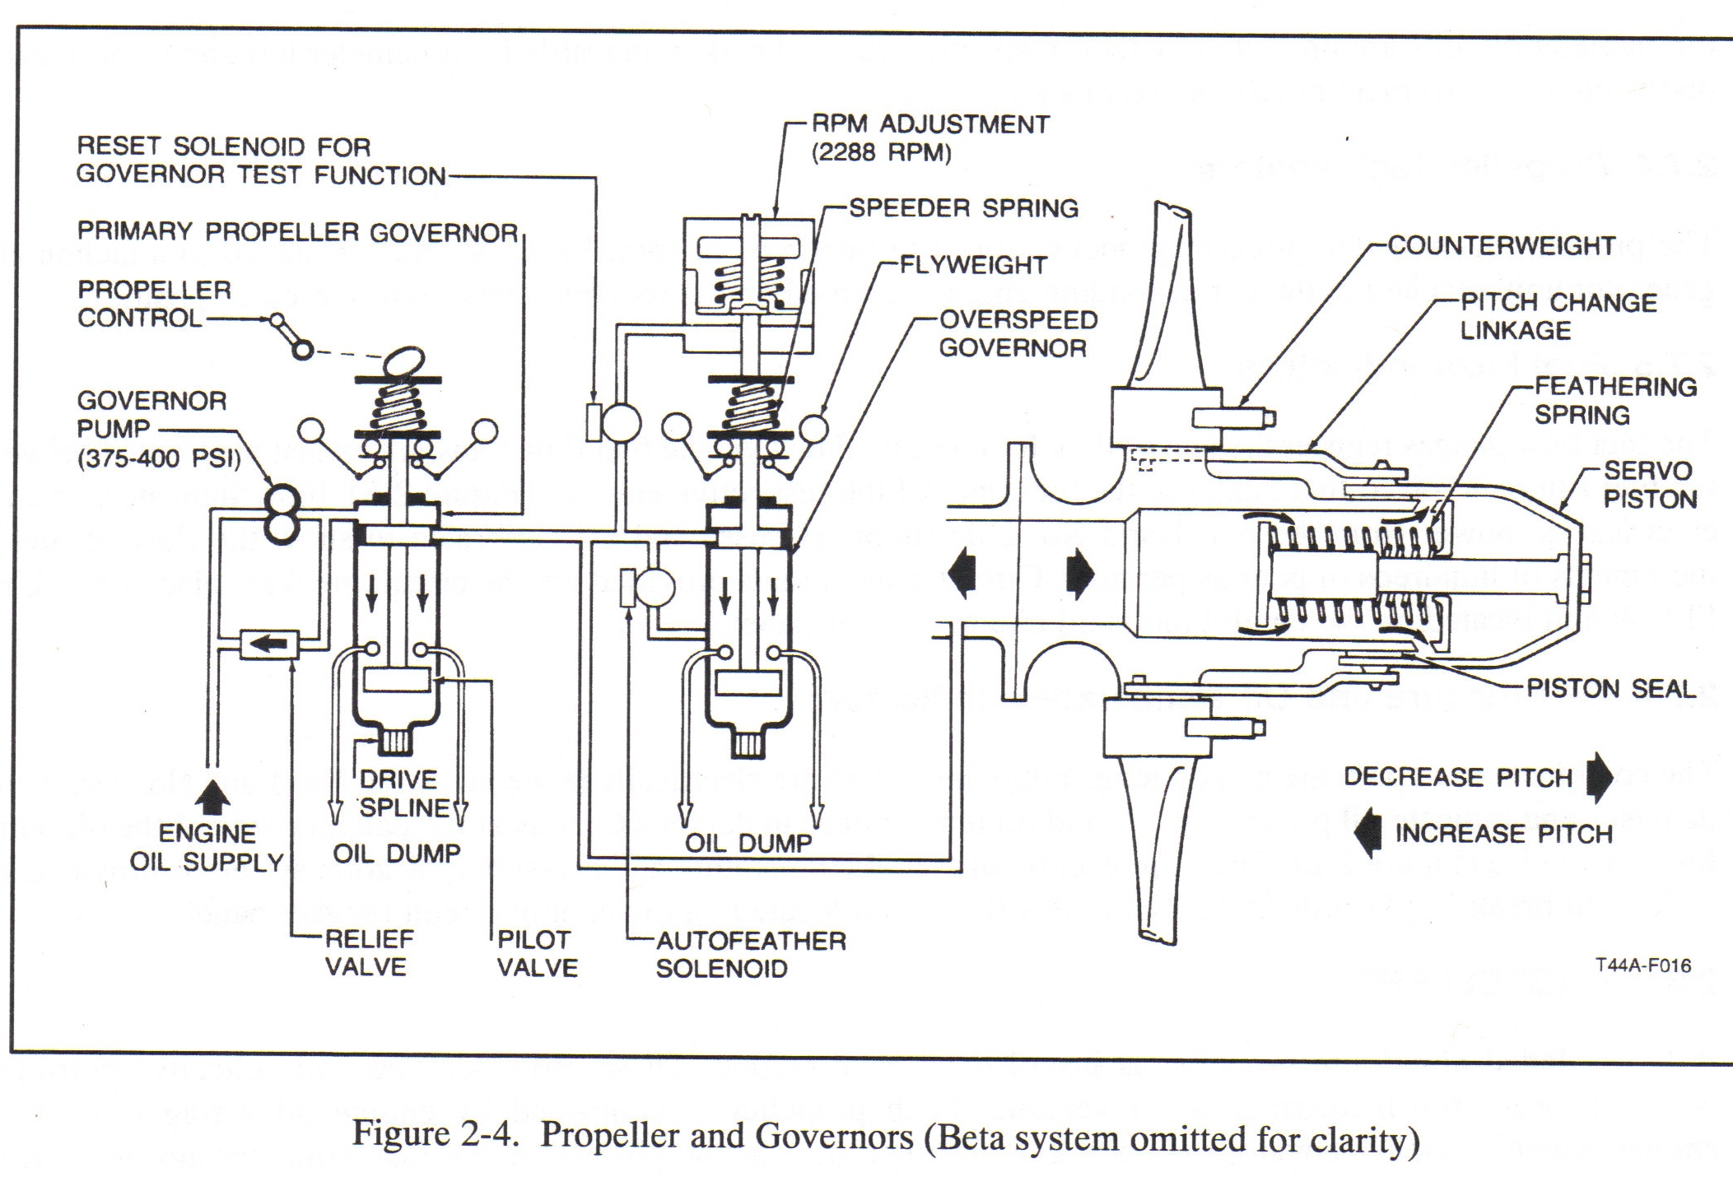
2.8.1 Propeller Autofeather Switch
Autofeathering is controlled by a propeller AUTOFEATHER switch on the left subpanel. The three-position switch is placarded ARM, OFF, and TEST and is spring loaded from the TEST to OFF. The ARM position is used only during takeoff and landing. If an engine loses power with the system armed and the power levers at or above a position corresponding to 90±2 percent N1, two torque-sensing switches 410±50 ft/lb and 260±50 ft/lb of the affected engine are actuated by a loss of torque pressure. Switch actuation applies current through an autofeather relay to a corresponding dump valve, causing the release of oil pressure that holds an established pitch angle on the blades of the affected propeller. Following the release of oil pressure, feathering movement is accomplished by the feathering springs assisted by centrifugal force applied to the blade shank counterweights. The TEST position of the switch enables the pilot to check readiness of the autofeather systems below 90±2 percent N1 and is for grounded purposes only.

2.8.1.2 Autofeather lights
Two green lights on the annunciator panel, placarded LH or RH AUTOFEATHER ARMED, when illuminated indicate that the autofeather system is armed. Complete arming of the system is accomplished when power levers are advanced to or above a position corresponding to 90±2 percent N1 and the autofeather switch is in the ARMED position. Both lights will illuminate indicating a fully armed system. Both lights will be extinguished if either propeller has been autofeathered or if the system is disarmed by retarding the power lever.

2.8.2 Propeller Synchrophaser
The propeller syncrophaser system is designed for in-flight use only. When in use, the system will automatically “slave” the right propeller rpm to the left “master” propeller. This is accomplished via a magnetic speed pickup mounted in each propeller overspeed governor and magnetic phase pickups mounted on each propeller deice slip ring that transmits electronic pulses to a control unit. The control unit then converts any pulse rate differences into correction commands and these correction commands are then transmitted to an actuator motor mounted on the right engine. The actuator motor then “trims” the right propeller governor assembly to exactly match the left propeller rpm while leaving the propeller control lever position constant. If the synchrophaser system is unable to adjust the right propeller to the left, the actuator has reached its travel limit. To recenter the actuator, use the following procedure.
- PROP SYNC switch - - OFF.
- Synchronize the propellers manually.
- PROP SYNC switch - - ON.
Note
The recentering process will take approximately 6 seconds.

To prevent the right propeller from losing excessive rpm if the left propeller is feathered while the synchrophaser is in use, the system is limited to ±30 rpm from the governor setting. Adjustment of rpm with both propeller levers at the same time will retain the right propeller governor setting within the ±30 rpm range of the left propeller.

2.8.2.1 Propeller Synchronization Switch
One two-position switch located on the control quadrant is placarded PROP SYNC ON — OFF and completes the circuit for propeller synchronization. When the switch is placed in the OFF position, the actuator will automatically run to the center range before stopping. This assures the control will function normally when the ON position is next selected. System operation requires synchronization of the propellers in the normal manner and then selecting ON position of the PROP SYNC switch.
2.8.2.2 PROP SYNC on Light (Annunciator)
The propeller synchronization system is designed for in-flight use only; therefore, if the system is in use and the landing gear is extended (as in an approach for landing), a yellow annunciator light placarded PROP SYNC ON will illuminate.

2.8.3 Propeller Governors
Each propeller system utilizes two governors, one "primary" and one "backup," to control propeller rpm. Each propeller lever establishes rpm for the respective propeller by altering the setting of a primary governor (Figure 2-4) attached to the propeller gear reduction housing. It is the primary governor that controls rpm through the entire range. Should a primary governor malfunction (exceeding 2,200 rpm by more than 4 percent), an overspeed governor cuts in (2,288 ±40 rpm), dumping oil from the propeller to prevent rpm from exceeding safe limits. If a propeller should stick or move too slowly during a transient condition, the corresponding governor would be unable to prevent an overspeed condition. To provide for this contingency, the pneumatic section of the primary governor acts as a fuel topping governor when the propeller rpm exceeds 2,332 rpm (2,200 rpm + 6 percent). This limits the fuel flow into the engine, thereby reducing the power driving the propeller. During propeller operation in the reverse range, the pneumatic section of the primary governor will be reset to allow a maximum of 2,100 rpm.

2.8.3.1 Propeller Governor Test (PROP GOV TEST) Switch
One two-position switch on the left subpanel (Figure 1-4) is provided for operational test of the propeller systems. The switch is placarded PROP GOV TEST. A solenoid actuated by the PROP GOV TEST switch enables the overspeed governor to be reset for test purposes (1,900 to 2,100 rpm.) The propeller governor test circuit(s) are protected by a circuit breaker placarded PROP GOV located in the ENGINE group on the copilot outboard subpanel.

2.8.3.2 Propeller Levers
Two propeller levers on the control pedestal (Figure 1-5) placarded PROP are used to regulate propeller speeds. Each lever controls a primary governor that acts to regulate propeller speeds within the normal operating range of 1,800 to 2,200 rpm. The full forward position is placarded TAKEOFF, LANDING AND REVERSE, and also HIGH RPM. Full aft position is placarded FEATHER. When a lever is placed at HIGH RPM, the propeller may attain a static rpm of 2,200, depending upon power lever position. With the power levers at idle and the condition levers at low idle, propeller rpm should read between 900 and 1,100 rpm. As a lever is moved aft, passing through the propeller governing range but stopping at the feathering detent, propeller rpm will correspondingly decrease to the lowest limit. Moving a propeller lever aft past the detent into FEATHER will feather the propeller.

Note
If propeller rpm does not read between 900 and 1,100 rpm with the power levers at idle and condition levers at low idle, perform a low pitch torque check (checkflight item 19 in paragraph 10.6) to ensure propeller flight idle stops are correctly adjusted.

2.8.4 Propeller Reversing
CAUTION
- Moving the power levers aft of IDLE without the engine running will result
in damage to the reverse linkage mechanism.
  - To prevent damage to reversing linkage, propeller levers must be in HIGH
RPM position prior to propeller reversing.

The propeller blade angle may be reversed to shorten landing roll. To reverse, propeller levers are positioned at HIGH RPM (full forward) and the power levers are lifted up to pass over the IDLE detent, then pulled aft into REVERSE setting.
2.8.4.1 Propeller Reverse Not-Ready Annunciator Light
One yellow caution light, placarded REV NOT READY, on the annunciator panel alerts the pilot not to reverse the propellers. It illuminates when the landing gear selector handle is down and the propeller levers are not at the HIGH RPM (full forward) position.

Primary Governor Failure (memory item): feather or overspeed (outside normal limits). * Certain failures can cause beta valve to be inop, causing overspeed. Control w/ overspeeding prop very difficult at lower power settings and airspeeds, highly discouraged. If necessary, landing with overspeeding prop carry extra airspeed. Gives more rudder authority, reduces prob of in-flight beta.
If prop rpm out of normal governor range (1800 - 2200RPM):
[1] Propeller RPM -- Adjust to Normal RPM.
By prop lever. If norm restored, continue ops. If norm can't be obtained:
[2] Power Lever - IDLE (concur)
[3] Propeller Lever - FEATHER (concur)
Notes: Prop RPM > 2420 may result in RGB failure and/or N2 turbine damage. Engine with disabled prop can provide electric power. Right prop may not full feather with prop sync ON. Fully feathered prop will still be running at about 200 rpm.
[4] Alt Prop Feather Checklist - AS REQ

Prop Linkage Failure: prop gov ctl linkage fails, prop goes to 2200 or maintains last rpm setting.
[1] Manipulate prop lever to determine if cockpit control lost
[2] If cockpit control lost and RPM in safe limits, match opposite prop speed with uncontrollable prop and land as soon as practicable.
CAUTION: Reverse w/o high RPM can damage prop.

Alternate Prop Feathering: Linkage or gov fails and prop doesn't feather by itself or normal feathering procedures don't work, use autofeather.
[1] Power Lever - IDLE (failed propeller) (concur)
[2] Condition Lever - FUEL CUTOFF (concur)
[3] Autofeather - ARM
[4] Power Levers -- > 90% N1 *Don't pull power lever to IDLE during autofeather, may disarm system.
[5] Emergency Shutdown Checklist - EXECUTE

