T-44A Briefing Guides
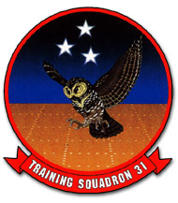

EVENT: C4201

DISCUSS ITEMS: Actual versus simulated engine shutdown, PIC/crew resource management during SSE, P-factor, VMC (air/ground), V_{MCA} maneuver, starter-assisted airstart, SSE pattern work, SSE landings/waveoffs/touch and go, SSE full stop, landing gear manual extension, and landing gear system/malfunctions.

Actual versus simulated engine shutdown – Only difference is that simulated brings prop to feather, actual (training-only) is accomplished by bringing the condition lever to FUEL CUTOFF. Both shutdowns must be accomplished above V_{SSE} and 4000’ AGL.

PIC/crew resource management during SSE – Previously briefed.

P-factor –
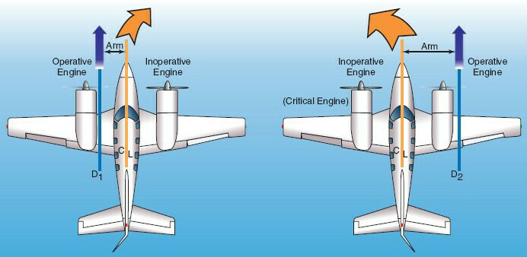

The left engine is the critical engine due to P-factor. With a clockwise-turning prop, the down-going blade (the right side of the prop) has a larger angle of attack with the relative wind then the up-going blade. Translated, the right side is taking a larger bite and thus creating more thrust then the left side. These uneven forces cause a yawing tendency. Looking at the diagram above, the right-yawing tendency is greater on the right engine than the left engine because the right side of the prop on the right engine is farthest from the axis of yaw, creating a greater torquing effect.

V_{MC} (air/ground) – V_{MC} is the airspeed below which it is not possible to maintain heading despite maximum rudder deflection and 5° AOB into the operating engine. The FAA certifies V_{MCA} under the following conditions:

- Takeoff power set on the operating engine
- Critical engine windmilling (left engine in the T44)
- Flaps at takeoff setting
- Gear up
- 5° into the operating engine
- Maximum allowable aft CG
- Full rudder deflection

V_{SSE} (91 KIAS) is single-engine safety speed; the speed above both VMCA and stall speed. Intentional failing of one engine below this speed (airborne) is prohibited.

V_{MCG} (63 KIAS) is minimum controllable speed on the ground; the minimum speed at which the aircraft can maintain runway centerline (using maximum rudder) with the critical engine windmilling, and the opposite engine at full power. At speeds below 63 KIAS insufficient airflow exists to directionally control the aircraft.

V_{MCA} maneuver – Flown only by the instructor. Begin on a numbered heading at 150 KIAS with prop sync off. The following procedures will be utilized to demonstrate VMCA after it has been thoroughly briefed:
- Altitude Min 8000’ AGL
- Power 400 ft-lbs
- Flaps Approach
- Gear Up
- Props Full forward
- Airspeed Approx. 110 KIAS
- Power Set idle on the left (critical) engine and smoothly apply max power on the right
- Attitude Raise the nose so airspeed bleeds off at approx. 1 knot / sec, keep the ball centered and trim while maintaining directional control with rudder and 5° of bank into the good engine. Observe the rudder is full throw with full rudder trim and aileron is required to maintain the 5° of bank. Note when the nose begins to yaw into the dead engine (visually or by turn needle and RMI). This will occur at approximately 86 KIAS. Also note the position of the rudder and ailerons.

NOTE: Some AOB may need to be taken out in order to simulate VMC air due to the high density altitude. VMC air decreases with altitude.

- Recovery Slowly reduce power on the operating engine and decrease AOA. As airspeed accelerates above V_{MCA}, smoothly reapply power on the operating engine. At 102 KIAS, execute a single-engine waveoff. The maneuver is complete when established in a climb, clean, with 102 KIAS or greater.

NOTE: During this maneuver, the T-44 has been inadvertently spun in a clean configuration following rapid power application. Use approach flaps to ensure stall speed is below V_{MCA}. Single-engine power-on flight below 86 KIAS is prohibited.

Starter-assisted airstart – Airstarts accomplished with the assistance of an operating generator (cross-generator start) or with the battery only should be successful at all altitudes and airspeeds. A starter-assisted airstart should normally be attempted regardless of generator availability unless conditions warrant a windmilling airstart.

CAUTION
- Unless a greater emergency exists, the cause for engine failure should be determine before attempting an airstart (i.e MOVEOFF).
- Above 20,000 feet, starts tend to be hotter. During engine acceleration to idle speed, it may be necessary to periodically cycle the condition lever to FUEL CUTOFF to avoid an overtemperature.
- Electrical loads not consistent with flight conditions should be reduced.

15.5.1 Starter-Assisted Airstart Checklist
Starter-assisted airstarts may be achieved at all altitudes and airspeeds, precluding mechanical malfunctions.
†1. Power lever (failed engine) – IDLE
†2. Propeller lever (failed engine) – FEATHER
†3. Condition lever (failed engine) – FUEL CUTOFF
4. Cabin temperature mode – OFF (CP)
5. Vent blower – AUTO (CP)
6. Radar – OFF/STBY (CP)
7. Anti-ice/deice – As required (P)
8. Firewall valve – OPEN (P)
9. Transfer pump – AUTO (P)
10. Boost pump – ON (P)
11. Crossfeed – AUTO (P)
12. Generator (failed engine) – OFF (CP)
†13. Starter (failed engine) – IGN & ENG START (check ignition indicator light on)

WARNING
If engine was shut down by closing the firewall valve, time to light-off during restart may exceed 10 seconds.
CAUTION
Operating engine ITT may increase approximately 50°C because of generator loading. If conditions permit, retard operating engine to reduce the possibility of exceeding ITT limits.

14. Condition lever – LOW IDLE (P)
15. Starter (N1 above 50%) – OFF (P)
16. Propeller – Unfeather (P)
17. Power – As required (P)
18. Generator – Reset/ON (CP)
19. Fuel control heat – ON (P)
20. Bleed air – OPEN (CP)
21. Electrical equipment – As required (CP) (i.e. AUTOIGNITION switch)
22. Condition lever – HIGH IDLE (P)
23. Instruments/nacelles – Checked (P,CP)

SSE pattern work –
The SSE landing pattern acquaints the student with procedures required to land safely following the loss of an engine. The SSE pattern is very similar to a normal pattern except considerations are made for decreased performance and reduced directional control margins are maintained. Trim the aircraft throughout the entire pattern. You may use the CP to check the position, but not to center it for you. Never sacrifice control of aircraft to complete a checklist. The “power up, rudder up, clean up” method is a good technique to remember whenever experiencing power loss.

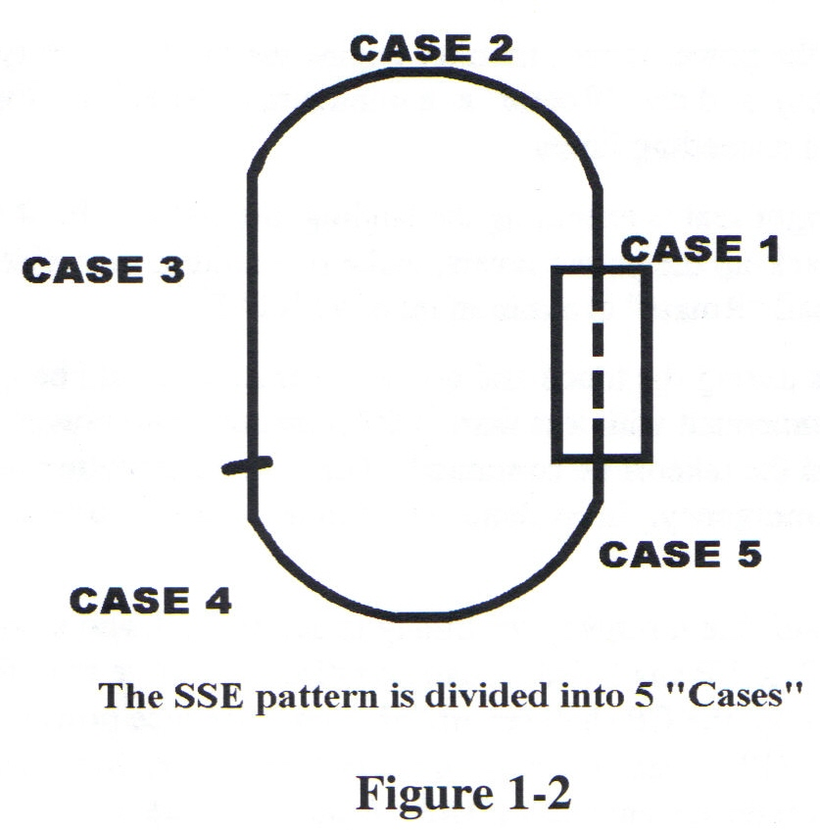

Case 1. Takeoff to Crosswind. If an engine fails during the takeoff roll, execute Aborting Takeoff procedures. If airborne, and sufficient runway remains, close the power levers and land. If airborne, and insufficient runway remains, execute Engine Failure After Takeoff procedures as practiced during dynamic engine cuts:
- Power As required. Set max allowable on the operating engine.
- Gear Up. Ensure flaps are up also.
- Airspeed As required. At 102 KIAS raise the nose to stop any altitude loss and accelerate to 110 KIAS if possible.

Identify the failed engine utilizing engine instruments (torque, ITT, N1, fuel flow) and rudder pressure.

- Execute the memory items of the Emergency Shutdown Checklist. Determine if malfunction is fuel or fire related while simultaneously pulling props back to 1900 RPM. Reset maximum power. Continue the checklist if malfunction is fuel or fire related.

NOTES:
- If an engine fire is experienced in the traffic pattern, continuation of the Emergency Shutdown Checklist is required in order to activate the fire extinguisher. Complete the checklist as soon as possible after a fire indication is noted. Have the CP declare an emergency and request crash crew response. Execute the Emergency Engine Shutdown On-Deck Checklist after landing.
- If the autofeather system is activated, retarding either power lever before the feathering sequence is complete will deactivate the circuit and prevent automatic feathering.

WARNING
A positive rate of climb cannot be maintained in any configuration with a windmilling prop. Banking 5° into the operating engine, while maintaining the ball nearly centered (¼ to ½ out towards the operating engine), is critical to optimizing single-engine climb performance at low airspeed and high AOA.

- Maintain 110 KIAS (minimum of 102 KIAS).
- Initiate the crosswind turn at 300’ or above, and continue climbing to 800’. Complete the Emergency Shutdown Checklist.
- Transfer communications to the CP, declare an emergency and address the Dead Engine Checklist. Under simulated emergency conditions, inform the IP you would now advise the Tower of your emergency and intentions.

Case 2. Crosswind Turn. Loss of an engine in a high AOB turn requires immediate action, especially if the inside engine fails. Proceed as follows:
- Add power while simultaneously leveling the wings momentarily, nearly center the ball, and clean up. Roll wings level regardless of the malfunction. Rolling out allows proper analysis, better control of the aircraft, and ensures proper rudder input. Maintain a minimum of 102 KIAS. After regaining control, continue the crosswind turn. An immediate resumption of the turn is desired at Cabaniss to prevent extending the pattern.
- Perform the memory items of the Emergency Shutdown Checklist. Transfer communications to the CP, declare an emergency and address the Dead Engine Checklist.
- Climb to pattern altitude, and then accelerate to 120 KIAS. Max allowable power may be required initially, but should be reduced as soon as practicable.

Case 3. Downwind. Fly a normal pattern.
- Add power, nearly center the ball, and clean up if required to maintain 120 KIAS and 800’. The gear and/or flaps may be raised. Do not clean up if airspeed and 800’ can be maintained at 120 KIAS until the 180.
- Perform the memory items of the Emergency Shutdown Checklist. Transfer communications to the CP, declare an emergency and address the Dead Engine Checklist.
- Just prior to the 180, if attitude and airspeed permit, select approach flaps, gear down, and complete the Landing Checklist (if not previously completed). The CP is responsible for making the radio call once communications are transferred.

NOTES:
- If altitude and/or airspeed do not permit lowering of the flaps and landing gear, inform the CP and Tower you are holding the gear until reaching the pattern profile.
- The Landing Checklist must never be held. However, if it was interrupted for any reason, it shall be reinitiated.

- Maintain 120 KIAS (minimum of 110 KIAS) to the 90. The gear must be down and Landing Checklist complete no later than the 90.

Case 4. Approach Turn. The approach turn is defined as any point after commencing a turn off the 180 until the 90. Power loss in a descent is normally easy to control with only slight additional power.
- Add power to maintain 110 KIAS minimum/120 KIAS maximum and nearly center the ball. Do not raise the gear unless committed to a waveoff. Maintain a minimum of 110 KIAS.
- Continue the approach turn.
- Perform the memory items of the Emergency Shutdown Checklist. Transfer communications to the CP, declare an emergency and address the Dead Engine Checklist.

When a fire is first discovered past the 180 position, only the first 3 memory items of the Emergency Shutdown Checklist are required. You are allowed to complete the checklist if able, but not at the expense of maintaining solid BAW. Generally, once established on final, checklist items should not be executed.

“Not required” or “first two items of the Dead Engine Checklist” is an appropriate response to the Dead Engine Checklist challenge during the emergency shutdown checklist in the pattern; it is time dependent. Addressing the first “two items” is good headwork since it will reduce the load on the remaining generator. Should a waveoff be required, the pilot can then call for the remainder of the Dead Engine Checklist as appropriate.

Case 5. After the 90. The steep G/S maintained in the VFR traffic pattern usually requires little power on final. Therefore, power loss should pose no particular problem. Only slight additional power is normally required. The need for power is usually most noticeable nearing the runway since a minimum of 110 KIAS must be maintained over the threshold. Some power is usually required all the way to touchdown in order to maintain speed. Loss of an engine on final may not allow time to complete checklists. Concentrate on flying the aircraft to a smooth touchdown, on centerline, in the first third of the runway.

NOTE: Use of full flaps is left to the discretion of the P, but is not recommended due to the aircraft’s limited waveoff capability. Students will not practice full flap SSE landings.

- Maintain directional control and crosswind corrections, ensuring sufficient power to sustain 110 KIAS to the threshold. Accomplish the first three memory items (optional/recommended).
- Smoothly place the props full forward and visually check three green lights. Call “Props full forward, three down and locked, review me complete, you have the comms, declare an emergency once safely-on-deck.” The CP will check the props full forward, three green lights, and respond “Review complete.”

NOTE: For actual engine failures, except for a Case 5 failure, the failed engine would have been feathered during the Emergency Shutdown Checklist. If a prop has been feathered, only the operative prop would be placed full forward. In a Case 5 failure, land with both props full forward unless the failed engine has autofeathered. It is unlikely the prop would autofeather since the power levers would probably not be above the 90% position. If a waveoff is required under actual single-engine conditions, placing both power levers to maximum allowable should result in an autofeather.

- Maintain a minimum speed of 110 KIAS until over the threshold, then slowly reduce power toward idle and land the aircraft. Maintain alignment and centerline. The aircraft has a tendency to float with one engine feathered.
- Utilize SSE full stop procedures described below.

SSE landings/waveoffs/touch and go – Procedures are exactly the same as normal touch-and-go procedures because both power levers are already at idle upon touchdown.

SSE waveoffs –
- Power Maximum allowable. Simultaneously transition to a climb attitude. Anticipate significant rudder with power. Keep the ball nearly centered (¼ to ½ out towards the operating engine) while using up to 5° AOB into the operating engine. Maintain a minimum of V_{xse} (102 KIAS), a maximum of V_{yse} (110 kias), preferably V_{yse}. Level off or descend if required to maintain flying speed. Under no circumstances allow speed to approach V_{sse} (91 KIAS).
- Flaps Approach (unless already up). Immediately select flaps to approach.
- Gear Up. The gear is raised when the descent has been stopped or there is no possibility of touchdown on a prepared surface. Do not delay in raising the gear.
- Flaps Up. Immediately after selecting gear up, raise the flaps. Anticipate a slight attitude adjustment to prevent settling.
- Props Reduce to 1900 RPM after CP reports “Gear up.” In an actual situation, one prop would be feathered. A positive single-engine climb is not possible in any configuration with a windmilling prop.

Direct the CP to make a waveoff call. The maneuver is complete at the IP’s discretion, when established in a clean climb, minimum of 102 KIAS (preferably 110 KIAS), with the aircraft trimmed and in balanced flight.

SSE full stop –The SSE full stop landing present no particular control difficulties as long as the following procedures are adhered to exactly. After landing, reduce power lever to idle. Lift both power levers over the detent and slowly ease the operating engine into reverse. Counteract the yaw with rudder while braking and scanning toward the end of the runway for alignment. If yaw becomes excessive, reduce or discontinue reversing and stop with brakes. Do not lock the brakes. The maneuver is complete when the aircraft has come to a slow taxi on the runway. Following an actual single-engine landing, clear the runway if practicable, then perform shutdown. Do not attempt to taxi on one engine. Make single-engine landings on the most favorable runway. Placing the dead engine into the wind may facilitate aircraft control during the landing rollout. Placing the good engine into the wind may help the aircraft control and reduce rudder requirement while airborne.

SSE Full stop landings shall only be performed if the SSE full stop brief was completed. See SSE full stop brief in Appendix A. All SSE full stop landings shall be initiated from a Case One or Two scenario and only when specifically required in the syllabus.

SSE full stop landing brief:
“This will be a simulated single engine full stop landing. Once safely on the deck, I will pull both power levers over the detent, smoothly apply reverse on the operating engine, countering any swerve with rudder and aileron as necessary to maintain directional control. As rudder effectiveness is lost, I will return both power levers toward flight idle until directional control can be regained.

Landing gear manual extension –
16.5.3 Landing Gear Emergency Extension
CAUTION
If a mechanical malfunction is known or suspected, do not attempt a manual gear extension.
The landing gear may be extended manually if the electrical portion of the extension mechanism should fail; however, the gear cannot be retracted manually, and no provision is made for gear extension with mechanical linkage failure. As airspeed is reduced, it is correspondingly easier to manually actuate the alternate extension handle.
The propeller reverse not ready light will not be illuminated with the landing gear relay circuit breaker pulled. The landing gear motor down limit switches may not be sufficiently activated; therefore, the angle-of-attack indicator light may not be available. When making an emergency extension, proceed as follows:
- Airspeed — 120 KIAS Recommended (155 KIAS maximum).
- Autopilot — As Required.
- Landing gear relay circuit breaker (LDG GR) — Pull.
- Landing Gear handle — DN.
- Clutch disengage lever — Lift and Turn Clockwise.
- Manual extension handle — PUMP until three green indicator lights illuminate. Approximately 50 strokes are required to fully extend the landing gear.

CAUTION
- For a PRACTICE manual extension: Reduce handle stroke length when nose gear indicates safe. Do not pump handle after all gear down position lights (three) are illuminated. Further movement of the handle could damage the drive mechanism precluding normal retraction.
- For an EMERGENCY manual extension: Reduce handle stroke length when nose gear indicates safe. After all gear down position lights (three) are illuminated, pump the handle until significant resistance is encountered. Do not stow handle or move any landing gear controls, reset any landing gear controls, switches or circuit breakers until the aircraft is on the ground and the cause of the malfunction has been determined and corrected.

- Gear position (visual) — Check (for Emergency Manual Extension).

16.5.4 Landing Gear Retraction After Practice Manual Extension

After a practice manual extension of the landing gear, the gear may be retracted electrically as follows:
- Emergency engage handle — Rotate Counterclockwise and Push Down.
- Extension lever - - STOW.
- Landing gear relay circuit breaker (LDG GR) — Push In.
- Landing gear handle — UP.

Landing gear system/malfunctions –
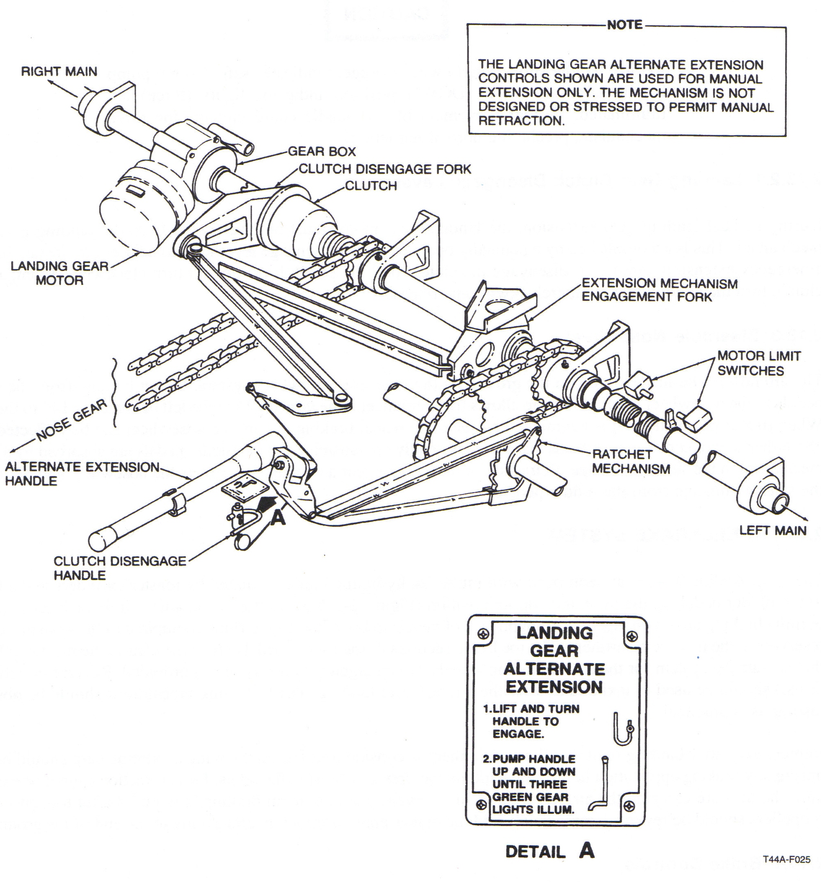* Dynamic braking and limit switches limit gear extension and retraction. Overload clutch prevents damage with a mechanical malf.
* Gear extension should not exceed 8 sec, retraction 10 sec.
* Only PIC can direct horn silencing.
* Cannot override horn during final approach, or in pattern.
* J-hook may not stop gear on ground if rt. Squat switch doesn’t have enough weight on it.
* Shock spring in NWS absorbs vibrations before they get to rudders. Shimmy damper as well.
* On emergencies, get visual confirmation. Is possible to get 3 green with unsafe indications. Wheel falls off, strut still works, etc.
* Don’t taxi with unsafe gear indications.
Emergencies: All Generally Deferred, to your advantage to burn off fuel, decrease weight.
Unsafe Up:
1. Gear Handle - Down
2. Gear position - Check
3. If safe down, land as soon as practibile
4. If not, go to unsafe down procedures
Unsafe Down:
1-3. Check CBs
4. Check lights (press-to-test, check if wheels up warning system works under 79% N1, check AoA indexer lights.
No AoA: motor cutoff, manually extend. Check prop sync lt (rt.), L/T lights (nose), GND MAX ht (hold in pos, won’t lock w/ squat switch) (left) (wont work w/ windshield heat, prop deice, lip boot heat.)
5. Visual gear pos check.
6. If safe, land ASA practibile.
7. If not, determine if electrical. If electrical, emergency extend. If not:
8. Gear handle - up
9. Gear pos visual check.
10. Visually up - gear up landing. If not, unsafe gear landing.
Airborne Gear Inspection
1. Join up with comms
Don’t erratically maneuver
2. Check tire inflation, J-hook, mechanical downlock, condition, gear doors and hydraulic leak.
One Main up Landing
Favor the good wheel, drag in the center, no cables, turn on lights for night emergency egress. Execute checklist, brief, lock harnesses, landing check, kill engines, use rudder and ail to keep bad wing off as long as possible, brakes, emergency shutdown on deck.
Main Down, Nose Up.
Difficult to get out of AC because of nose low, DO NOT USE BRAKES! Hold nose off as long as possible. Same as one bad main, but no brakes, no rudder/ail.
Gear Up
Tends to overshoot, touchdown at 85 kts. Brief, secure seatbelts, disengage clutch, stow manual extension handle, pull LDG GR CB, Flaps - APP, Gang bar off if possible, immediately prior to TD, Cond lev - Fuel C/O, After Touchdown - Power - Idle, Cond Lev - Fuel C/O, Brakes - A/R (can use brakes and rudders for dir control. Finish emergency shutdown, shoot the fire extinguishers.
Main Flat
Put the drag in the center, use opposite brake for directional control.
Nose Flat
Less stable NWS, aerobrake, light wheelbraking only to maintain dir control.
Brake Failure
Dir control w/ rudder + asym power, stop from reversing to aid in decel, do not taxi.

1) Gear: operated by motor (single, split field, 28vdc, under co seat.) Motor limit switches prevent overtravel (under pilot seat) Torque shafts drive main actuators, duplex-chains drive nose gear. Spring loaded locks fix gear in down position, jackscrew in nose fixes it in overcenter down, jackscrews holds all three up. GEAR MOTOR CB on pedestal. Gear retraction time, 5-7 sec., gear extension time 4-6 sec. 2 red bulbs in warning lights, means: unlocked, in transit, HD LT TEST, below 79%+-2 power, below approach flaps, gear not down.

2) Wheels up warning system : warning horn, lights, when gear not down and locked + power below 79%+-2 N1, Flaps beyond approach, can silence horn. DON’T override on traffic pattern or final approach. Silence only works w/ flaps up.

3) Squat switches: Mechanically activated. Rt.: (act.) Gear inop, downlock hook, (de.) Flight hour meter, (de) Indexer for AoA, Stall warning (de), Heat rt. Eng. Lip boot (de.). Left: Heat AoA vane reduce to 14 from 28 (de), Heat electric heater GRD MAX (de from NORMAL), Heat lip boot left engine (de), Ambient air solenoid (de.), Pressurization: preset (de.), dump (act.), door (closes)

4) Downlock and uplock switches: each strut has one (3) of each downlock and uplock. You can check which one is not fully retracted by PROP SYNC; if rt. Uplock closed Propsync won’t turn on. Landing lighs... If nosewheel uplock closed, landing lights won’t come on. Electric heater: checks left. Motor limit switches: up limit deactivates motor, deactivates g-meter when gear is up. Down limit switch deactivates motor, activates AOA indexer lts.

5) Alt gear extension: Can be manually extended, but not retracted through handcrank. Do not do it if a malfunction is suspected. Right side of pilot seat. Must disengage landing gear clutch to pump handle, lift up clutch, turn clockwise, reengage by doing opposite. Airspeed - 120 KIAS recommended (155 max), A/P-A/R, landing gear relay CB - pull, Gear handle - down, Clutch disengage - list, turn clockwise, Manual hnandle - pump until 3 green (50 ish pumps)

6) Brakes: Multidisc hydraulic brakes, Shuttle valve allows changeover from one set of brakes to the other. Dual parking brake valves lock pressure. Fluid from hyd brake system reservoir, NBO emergency brakes, out setting maintains check valves, only Px in not out. Only Pilot, not during flight. With wheelbrake fail: directional control w/ diff power, rudder, NWS. Use reverse or beta to help. Manuver into open area, NO taxi. Shuttle valve sometimes fail. Reset by pulling aft on top of brakes.

7) NWS: Direct: 12L/14R, w/ brakes: 48 deg. Retraction autodisenages.

1. Nosewheel steering actuates nose gear 12 degrees left and 14 degrees right. (48 degrees either side with braking)
2. The function that up and down limit switches share is deactivates landing gear motor and prevents overtravel of gear.
3. The up limit switch also deactivates the g-meter when the landing gear is extended.
4. The down limit switch also activates the AOA indexer lights. On the ground, the right main squat switch deactivates the AOA indexer lights.
5. The three up locks all will turn on the red lights in the gear selector handle, illum the wheels up light, and activate the gear warning horn if the gear don't fully retract.
6. The right up lock also deactivates the prop sync light when the prop sync switch is ON. If the right up lock has gear fully retracted, the prop sync light will not come on when the prop sync switch in ON.
7. The left up lock also keeps the loading for the electric heat in NORM & GND MAX within slight fluctuation or no significant generator load difference. If the left up lock has gear fully retracted, switching the electric heat from NORM to GND MAX will yield only a slight or no significant change in generator loading.
8. The nose up lock also deactivates the landing lights. If up lock has gear fully retracted, no illumination of landing lights and no increase in generator loading when landing lights are turned ON.
9. The right squat switch: [GFISH] on ground
Gear Circuit inop
Flight hour meter inop
Inlet lip heat inop
Stall warning & AOA indexer lights inop
Handle (gear) & hook (downlock) activated
10. The left squat switch: [HHHAP] on ground
Heat for left engine lip boot inop
Heat for AOA sensor - LOW (14V)
Heat - GND MAX
Ambient air solenoid - CLOSED
Pressure control safety valve - OPEN
11. Down lock switches: close when strut fully extends. When all 3 down lock switches activated (all 3 gear down & locked): [1] WHEELS UP light deactivates [2] Gear horn deactivates [3] 3 green down lights illum
12. The red light in the gear handle will illuminate when: [1] the gear is unlocked, in transit, or gear warning horn activated [2] both power levers retarded below 79%N₁ when gear not down and locked [3] pressing the Landing Gear Handle Warning Light Test Button [4] Flaps below APPR & gear is not down and locked.
13. The warning horn silence button and the WHEELS UP light can be turned off in flight (with power retarded, gear up, and flaps up by pressing the WARN HORN SILENCE button. After silencing the horn, it will remain silent until the flaps are extended or at least one power lever is advanced beyond 79%N₁ and then pulled back below 79%N₁. Don't silence the horn in the traffic pattern or during the final segment of an IAP when potential to land exists. Only the PIC will cancel the horn.
14. During manual gear extension, the first green down lock indicator to illum will be the nosegear light.
15. The extension time of the gear is 4-6 seconds. The retraction time of the gear is 5-7 seconds.
16. The prop reverse not ready light will not illum with the landing gear relay CB pulled (during manual emergency extension of gear).
-- The warning horn, wheels up light, and gear handle will all come on when all 3 landing gear struts are not down and locked and: [1] both power levers retarded < 79(+/-2)%N₁ OR [2]Flaps extended beyond approach position (Flaps - FULL)
-- The wheels up light & gear handle light illum when: [1] both power levers retarded < 79(+/-2)%N₁ with Gear UP OR [2]Flaps extended beyond approach position with Gear UP.
17. It is possible to have a safe gear indication and not have safe gear (such as not having 3 complete tire or wheel assemblies).
18. The main gear are held down and locked by spring loaded locks. The nose gear is held down by a jackscrew actuator.
19. The gear are held up by the jackscrew in the actuator.
20. I can tell the difference between an electrical and mechanical malfunction on an unsafe gear by comparing visual indications with cockpit gear indications and gear circuit breaker positions.
Pull the following circuit breakers: [1] Landing gear relay CB [2] Landing gear indicator CB [3] Landing gear motor CB [4] Cockpit gear position indicators. If during pulling any of the following , the gear indicates safely down and is visually confirmed safely down, land as soon as practicable. ***Absence of illuminated AOA indexers could indicate premature landing gear motor cutoff which is indicative of an electrical problem.

