T-44A Briefing Guides


EVENT: C4105

DISCUSS ITEMS: Engine failure after takeoff, engine secure and restart, SSE touch-and-go procedures, SSE waveoff at altitude, SSE ditching, PIC/crew resource management during SSE, SSE pattern work, SSE landings/waveoffs/touch and go, and electrical system/malfunction.

Engine failure after takeoff –
(NATOPS 15-1, 15-4)
At speeds above 100KIAS, rudder trim is sufficient to maintain balanced flight. Below 100KIAS, full rudder trim must be supplemented by constant rudder pressure. At full rudder trim only a few inches of rudder travel remain. The use of flaps won’t significantly affect directional control, but will adversely affect performance (a positive rate of climb can’t be achieved with full flaps (100%) and gear down.

WARNING: If full flaps are used during a single engine approach, the wave off procedure described in par. 7.18 will result in a loss of 200 feet before a positive rate of climb can be established.

An indication of impending eng failure or flameout is usually preceded by unstable engine operation, such as fluctuating N₁, torque, ITT, illumination of fuel system warning lights, dropping oil pressure, loss of thrust, etc. If engine failure or unexpected flameout occurs, an emergency shutdown should be performed.

An airstart is permissible if engine failure is NOT caused by [MOVEOFF]: Mechanical malfunction, Overheat, Vibration, Explosion, 0 N₁, Fire, Fuel Fumes.

A flameout is indicated by a drop in ITT, torque, and turbine RPM.

Engine Failure After Takeoff (NATOPS 14-1, 15-1, 15-4)
If engine fails after takeoff and sufficient runway remains, land and bring aircraft to a stop. If insufficient runway:
“Power – UP, Rudder – UP, Clean – UP, Speed – UP, Checklist”
- Power – as required
- Gear – up
- Airspeed – as required (V_{XSE}) 102KIAS or (V_{YSE}) 110KIAS. If autofeather system is ‘armed,’ retarding either power lever before the feather sequence is completed will deactivate the autofeather circuit and prevent automatic feathering.
- EMERGENCY SHUTDOWN CHECKLIST –
- Power lever – Idle
- Propeller – Feather
- Condition lever – Fuel cutoff.

If fire or fuel leak, continue checklist. If not, proceed to dead engine checklist.
- Firewall valve – closed
- Fire extinguisher – as required
- Bleed air – closed
- Dead engine checklist – as required. (A positive rate of climb can’t be achieved in any configuration with the inoperative engine prop windmilling).
Engine secure and restart –
Normal securing is performed with the Secure Checklist.

During an abnormal start, use the Abnormal Start Procedures:
(for HOT START & NO LIGHT OFF)
If ITT likely to exceed 925C or no rise in ITT within 10 sec after condition levers LOW IDLE:
*1. Condition Lever – FUEL CUTOFF (ITT < 790C)
*2. Starter – OFF

Caution:
Starter time limited to 40 sec ON, 60 sec OFF, 40 sec ON, 60 sec OFF, 40 sec ON, 30 minutes OFF.

Note:
If start attempt discontinued and another start attempted, allow 60 sec delay to drain fuel and cool starter, then motor up starter for 15 sec minimum. Allow engine to completely stop before attempting another start.

During an inadvertent movement of the condition lever to fuel cutoff:
If the condition lever is inadvertently selected to fuel cutoff, the condition lever shall not be moved from fuel cutoff after a shutdown until required by the appropriate checklist.

On the ground:
- Stop the aircraft
- Notify Ground
- Restart the engine with the Engine Start procedures

On takeoff roll:
- Abort the takeoff WARNING: Single engine reversing may be applied if required. Use extreme caution if the surface is not hard or dry

After takeoff:
Power – Max
Gear – Up
Airspeed – As required. At 102 kias raise the nose to stop altitude loss and accelerate to 110 kias if possible.
Emergency Shutdown Checklist
Starter Assisted Airstart Checklist

SSE touch-and-go procedures – Procedures are exactly the same as normal touch-and-go procedures because both power levers are already at idle upon touchdown.

SSE waveoff at altitude – SSE waveoffs allow safe transition from SSE descending flight to maximum power, SSE climbing flight. The maneuver is designed to stop altitude loss as soon as possible while transitioning to a climb at desired climb speed. Practice at altitude prepares the student fro SSE waveoffs in the pattern.

Level off on a 1000’ altitude plus 800 (i.e. 4800, 5800, etc), 120 KIAS, on a numbered heading. One technique is to align the CDI with your heading, tail at the top. This simulates 800’ on the downwind leg of the traffic pattern. The IP will simulate a single-engine by reducing one power lever to idle or simulating an emergency situation requiring an engine to be secured. “Power up, rudder up, clean up.” Complete the Emergency Shutdown Checklist without delay. The IP will call “Approaching the 180.” Lower the flaps and gear and complete the Landing Checklist. Immediately start a descending left turn to arrive at the “90” at 500’ and 120 KIAS (minimum 110 KIAS). Continue the turn to “final,” rolling out on the head of the CDI at 250’ with a minimum of 110 KIAS, maximum of 120 KIAS. Smoothly place the props full forward; when IP calls “Waveoff,” execute the following procedures:

- Power Maximum allowable. Simultaneously transition to a climb attitude. Anticipate significant rudder with power. Keep the ball nearly centered (¼ to ½ out towards the operating engine) while using up to 5° AOB into the operating engine. Maintain a minimum of V_{xse} (102 KIAS), a maximum of V_{yse} (110 kias), preferably V_{yse}. Level off or descend if required to maintain flying speed. Under no circumstances allow speed to approach V_{sse} (91 KIAS).
- Flaps Approach (unless already up). Immediately select flaps to approach.
- Gear Up. The gear is raised when the descent has been stopped or there is no possibility of touchdown on a prepared surface. Do not delay in raising the gear.
- Flaps Up. Immediately after selecting gear up, raise the flaps. Anticipate a slight attitude adjustment to prevent settling.
- Props Reduce to 1900 RPM after CP reports “Gear up.” In an actual situation, one prop would be feathered. A positive single-engine climb is not possible in any configuration with a windmilling prop.

Direct the CP to make a waveoff call. The maneuver is complete at the IP’s discretion, when established in a clean climb, minimum of 102 KIAS (preferably 110 KIAS), with the aircraft trimmed and in balanced flight.

SSE ditching -- Simulated ditching allows practice of procedures required to successfully complete a water landing. Waveoffs following a simulated ditch shall be initiated no lower than 4000’ AGL utilizing both engines. The instructor shall fly ditch recoveries. The maneuver is complete upon simulated water impact. “Sea level” will be designated by the instructor (usually the bottom of the block). NATOPS discusses how to select an appropriate ditch heading. The weather information packets for operational flights usually contain recommended ditch headings for use when the crew can not see the water surface. You should use all information available to select a ditch heading, but due to the limitations imposed by the Seagull blocks, the IP may have to give you a ditch heading that will allow sufficient airspace to complete the maneuver. Ditching is most likely to be caused by an uncontrollable fire, fuel starvation, or dual engine failure. If ditching due to a low fuel state, complete the maneuver while power is still available on both engines. The following must be carefully managed for a successful ditch:

NOTE: NATOPS provides an excellent discussion on ditching technique. The Ditching Checklist does not need to be memorized. General quizzing by instructors is encouraged, but students are not expected to memorize these items.

- Wings Level/Heading – It does not do any good to fly a perfect ditch if the airplane hits a wave head-on. Ensure wings level prior to impact. A couple of degrees off heading will not make much difference, but cartwheeling on impact could prove fatal.
- Rate of descent – The airframe will absorb much of the impact, but not all of it. Excessive rates of descent greatly reduce the survivability of the ditch. The vertical deceleration will be almost instant on water impact. The greater the rate of descent, the higher the instantaneous G-load experienced by the crew.
- Airspeed – Do not get slow. The recommended airspeed provides a safety margin to ensure controllability of the aircraft. Since the aircraft decelerates in the horizontal over a longer period of time, slightly higher airspeeds are still survivable.

Power available (single engine) – May be caused by an uncontrollable fire or other catastrophic engine failure. Time may be more critical since the fire may damage flight control and/or structural integrity. Make an emergency descent as appropriate (if you are already close to the water a full blown emergency descent might increase your workload unnecessarily, but do make an effort to get down quickly). Select a ditch heading and complete the Ditching Checklist. Follow the NATOPS ditching technique. The single-engine ditch is essentially the same as the two-engine ditch. Power still controls rate of descent and nose attitude still controls airspeed. Keep the ball centered.

16.11 DITCHING TECHNIQUE
16.11.2 Power Available (Single-Engine)
- Gear - - UP.
- Flaps — APPROACH.
WARNING
In the event of single-engine full-flap ditchings, abnormally high power requirements resulting from the use of full flaps will result in marginal controllability at all but minimum gross weights. Reconfiguration from full flaps to APPROACH flaps may result in settling and/or stall. The use of APPROACH flaps is strongly recommended in single-engine ditchings.
- Rate of descent, 100 fpm during final stages of approach (last 300 feet utilizing radar altimeter).
- 91 KIAS.
Note
If a no-flap ditch is required, increase airspeed to 100 knots.

It is essential that an attempt be made to control the attitude of the aircraft throughout the ditching until all motion stops.
WARNING
Do not unstrap from the seat until all motion stops. The possibility of injury and disorientation requires that evacuation not be attempted until the aircraft comes to a complete stop. Evacuate the aircraft through the emergency exit or airstair door. Take the liferaft and first-aid kit. See paragraph 16.13 for information on raft inflation.
WARNING
Do not remove the raft from its carrying case inside the aircraft. Do not inflate raft before launching. Pull inflation ring to inflate the raft.

CAUTION
Keep liferaft away from any damaged surfaces which might tear it. Tie down first-aid kit in the center of the raft to prevent it from being lost in case the raft capsizes. After all personnel have been evacuated, move raft out from under any part of the aircraft which might strike them as it sinks. Remain in the vicinity of the aircraft as long as it remains afloat.

PIC/crew resource management during SSE – Apply to the following:
- PIC
  - Responsible for the safe and successful accomplishment of the assigned flight
  - Monitors progression of all tasks assigned to other crewmen
  - Assumes custody of the aircraft upon signing the “A” sheet and shall report all discrepancies
  - Responsible for briefing passengers or emergency procedures and equipment
  - PIC status cannot be passed in flight
- CRM
  - Decision-making – ability to use logical and sound judgment based on the information available
  - Assertiveness – willingness to actively participate and the ability to state and maintain your position, until convinced by the facts (not the authority or personality of another) that your position is wrong
  - Mission analysis – ability to make long-term and contingency plans and to coordinate, allocate, and monitor crew and aircraft resources
  - Communication – ability to clearly and accurately send and acknowledge information, instructions, or commands and provide useful feedback
  - Leadership – ability to direct and coordinate the activities of other crewmembers and to encourage the crew to act together as a team
  - Adaptability/Flexibility – ability to alter a course of action to meet situational demands, to maintain constructive behavior under pressure, and to interact constructively with other crew members
  - Situation awareness – cognizance of what is happening in the cockpit and in the mission, and knowledge of how that compares with what is supposed to be happening

SSE pattern work –The SSE landing pattern acquaints the student with procedures required to land safely following the loss of an engine. The SSE pattern is very similar to a normal pattern except considerations are made for decreased performance and reduced directional control margins are maintained. Trim the aircraft throughout the entire pattern. You may use the CP to check the position, but not to center it for you. Never sacrifice control of aircraft to complete a checklist. The “power up, rudder up, clean up” method is a good technique to remember whenever experiencing power loss.

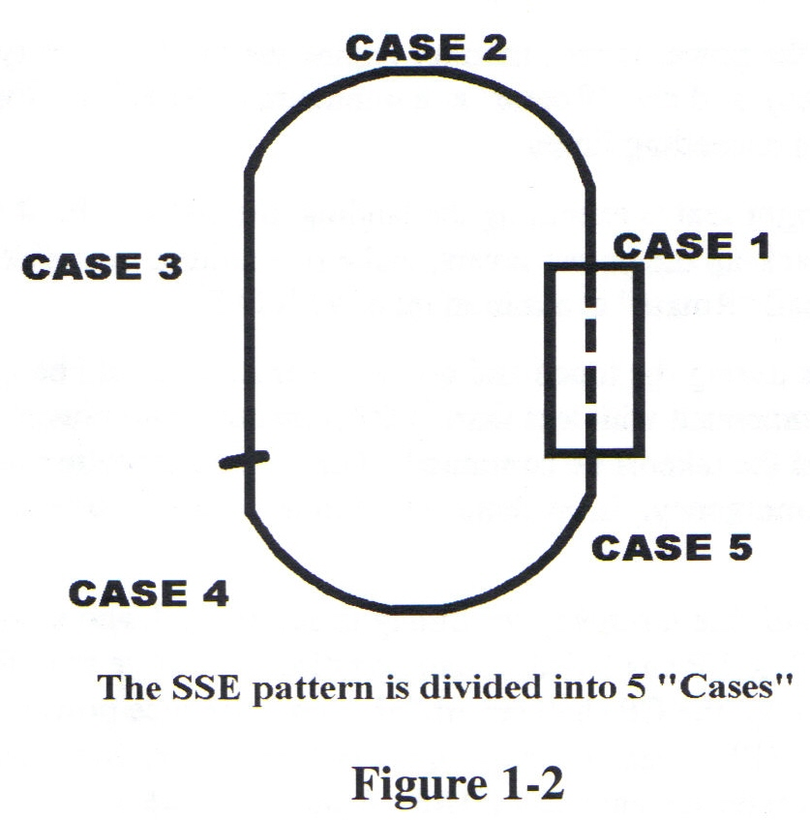

Case 1. Takeoff to Crosswind. If an engine fails during the takeoff roll, execute Aborting Takeoff procedures. If airborne, and sufficient runway remains, close the power levers and land. If airborne, and insufficient runway remains, execute Engine Failure After Takeoff procedures as practiced during dynamic engine cuts:
- Power As required. Set max allowable on the operating engine.
- Gear Up. Ensure flaps are up also.
- Airspeed As required. At 102 KIAS raise the nose to stop any altitude loss and accelerate to 110 KIAS if possible.

Identify the failed engine utilizing engine instruments (torque, ITT, N1, fuel flow) and rudder pressure.

- Execute the memory items of the Emergency Shutdown Checklist. Determine if malfunction is fuel or fire related while simultaneously pulling props back to 1900 RPM. Reset maximum power. Continue the checklist if malfunction is fuel or fire related.

NOTES:
- If an engine fire is experienced in the traffic pattern, continuation of the Emergency Shutdown Checklist is required in order to activate the fire extinguisher. Complete the checklist as soon as possible after a fire indication is noted. Have the CP declare an emergency and request crash crew response. Execute the Emergency Engine Shutdown On-Deck Checklist after landing.
- If the autofeather system is activated, retarding either power lever before the feathering sequence is complete will deactivate the circuit and prevent automatic feathering.

WARNING
A positive rate of climb cannot be maintained in any configuration with a windmilling prop. Banking 5° into the operating engine, while maintaining the ball nearly centered (¼ to ½ out towards the operating engine), is critical to optimizing single-engine climb performance at low airspeed and high AOA.

- Maintain 110 KIAS (minimum of 102 KIAS).
- Initiate the crosswind turn at 300’ or above, and continue climbing to 800’. Complete the Emergency Shutdown Checklist.
- Transfer communications to the CP, declare an emergency and address the Dead Engine Checklist. Under simulated emergency conditions, inform the IP you would now advise the Tower of your emergency and intentions.

Case 2. Crosswind Turn. Loss of an engine in a high AOB turn requires immediate action, especially if the inside engine fails. Proceed as follows:
- Add power while simultaneously leveling the wings momentarily, nearly center the ball, and clean up. Roll wings level regardless of the malfunction. Rolling out allows proper analysis, better control of the aircraft, and ensures proper rudder input. Maintain a minimum of 102 KIAS. After regaining control, continue the crosswind turn. An immediate resumption of the turn is desired at Cabaniss to prevent extending the pattern.
- Perform the memory items of the Emergency Shutdown Checklist. Transfer communications to the CP, declare an emergency and address the Dead Engine Checklist.
- Climb to pattern altitude, and then accelerate to 120 KIAS. Max allowable power may be required initially, but should be reduced as soon as practicable.

Case 3. Downwind. Fly a normal pattern.
- Add power, nearly center the ball, and clean up if required to maintain 120 KIAS and 800’. The gear and/or flaps may be raised. Do not clean up if airspeed and 800’ can be maintained at 120 KIAS until the 180.
- Perform the memory items of the Emergency Shutdown Checklist. Transfer communications to the CP, declare an emergency and address the Dead Engine Checklist.
- Just prior to the 180, if attitude and airspeed permit, select approach flaps, gear down, and complete the Landing Checklist (if not previously completed). The CP is responsible for making the radio call once communications are transferred.

NOTES:
- If altitude and/or airspeed do not permit lowering of the flaps and landing gear, inform the CP and Tower you are holding the gear until reaching the pattern profile.
- The Landing Checklist must never be held. However, if it was interrupted for any reason, it shall be reinitiated.

- Maintain 120 KIAS (minimum of 110 KIAS) to the 90. The gear must be down and Landing Checklist complete no later than the 90.

Case 4. Approach Turn. The approach turn is defined as any point after commencing a turn off the 180 until the 90. Power loss in a descent is normally easy to control with only slight additional power.
- Add power to maintain 110 KIAS minimum/120 KIAS maximum and nearly center the ball. Do not raise the gear unless committed to a waveoff. Maintain a minimum of 110 KIAS.
- Continue the approach turn.
- Perform the memory items of the Emergency Shutdown Checklist. Transfer communications to the CP, declare an emergency and address the Dead Engine Checklist.

When a fire is first discovered past the 180 position, only the first 3 memory items of the Emergency Shutdown Checklist are required. You are allowed to complete the checklist if able, but not at the expense of maintaining solid BAW. Generally, once established on final, checklist items should not be executed.

“Not required” or “first two items of the Dead Engine Checklist” is an appropriate response to the Dead Engine Checklist challenge during the emergency shutdown checklist in the pattern; it is time dependent. Addressing the first “two items” is good headwork since it will reduce the load on the remaining generator. Should a waveoff be required, the pilot can then call for the remainder of the Dead Engine Checklist as appropriate.

Case 5. After the 90. The steep G/S maintained in the VFR traffic pattern usually requires little power on final. Therefore, power loss should pose no particular problem. Only slight additional power is normally required. The need for power is usually most noticeable nearing the runway since a minimum of 110 KIAS must be maintained over the threshold. Some power is usually required all the way to touchdown in order to maintain speed. Loss of an engine on final may not allow time to complete checklists. Concentrate on flying the aircraft to a smooth touchdown, on centerline, in the first third of the runway.

NOTE: Use of full flaps is left to the discretion of the P, but is not recommended due to the aircraft’s limited waveoff capability. Students will not practice full flap SSE landings.

- Maintain directional control and crosswind corrections, ensuring sufficient power to sustain 110 KIAS to the threshold. Accomplish the first three memory items (optional/recommended).
- Smoothly place the props full forward and visually check three green lights. Call “Props full forward, three down and locked, review me complete, you have the comms, declare an emergency once safely-on-deck.” The CP will check the props full forward, three green lights, and respond “Review complete.”

NOTE: For actual engine failures, except for a Case 5 failure, the failed engine would have been feathered during the Emergency Shutdown Checklist. If a prop has been feathered, only the operative prop would be placed full forward. In a Case 5 failure, land with both props full forward unless the failed engine has autofeathered. It is unlikely the prop would autofeather since the power levers would probably not be above the 90% position. If a waveoff is required under actual single-engine conditions, placing both power levers to maximum allowable should result in an autofeather.

- Maintain a minimum speed of 110 KIAS until over the threshold, then slowly reduce power toward idle and land the aircraft. Maintain alignment and centerline. The aircraft has a tendency to float with one engine feathered.
- Utilize SSE full stop procedures described below.

SSE landings/waveoffs/touch and go –
SSE Full Stop Landing – The SSE full stop landing present no particular control difficulties as long as the following procedures are adhered to exactly. After landing, reduce power lever to idle. Lift both power levers over the detent and slowly ease the operating engine into reverse. Counteract the yaw with rudder while braking and scanning toward the end of the runway for alignment. If yaw becomes excessive, reduce or discontinue reversing and stop with brakes. Do not lock the brakes. The maneuver is complete when the aircraft has come to a slow taxi on the runway. Following an actual single-engine landing, clear the runway if practicable, then perform shutdown. Do not attempt to taxi on one engine. Make single-engine landings on the most favorable runway. Placing the dead engine into the wind may facilitate aircraft control during the landout rollout. Placing the good engine into the wind may help the aircraft control and reduce rudder requirement while airborne.

SSE Full stop landings shall only be performed if the SSE full stop brief was completed. See SSE full stop brief in Appendix A. All SSE full stop landings shall be initiated from a Case One or Two scenario and only when specifically required in the syllabus.

SSE full stop landing brief:
“This will be a simulated single engine full stop landing. Once safely on the deck, I will pull both power levers over the detent, smoothly apply reverse on the operating engine, countering any swerve with rudder and aileron as necessary to maintain directional control. As rudder effectiveness is lost, I will return both power levers toward flight idle until directional control can be regained.

SSE Waveoff – SSE waveoffs allow safe transition from SSE descending flight to maximum power SSE climbing flight. NATOPS allows for a power setting “as required”, but the airplane is power limited with one engine inoperative. Maximum power on the remaining engine is a recommended starting point. The maneuver is designed to stop altitude loss as soon as possible, while transitioning to a climb at the desired climb speed. Minimum altitude for the IP to initiate a practice SSE waveoff is 200’. The IP shall take the controls, utilize both engines, and execute any waveoff required below 200’. The SSE waveoff is a demanding maneuver requiring precise aircraft control and expedient procedures. Climb performance is directly proportional to how well the maneuver is executed. Limited power margins dictate exact execution. Utilize NATOPS Single Engine Waveoff procedures.

Direct the CP to make a waveoff call to Tower. If possible, waveoff slightly offset from the runway to allow a better view of the traffic.

To standardize all waveoffs, the copilot shall report “gear up” before the props are retarded to 1900. The intent of this requirement is to ensure that instructors can maintain proper defensive positioning throughtout the waveoff. Sutdents must ensure that they understand the aerodynamic concepts behind getting the gear up, props back, and proper power set for the best performance.

NOTE: Students are limited to 16 passes, including waveoffs and full stops, or one hour in the landing pattern.

Electrical system/malfunction –
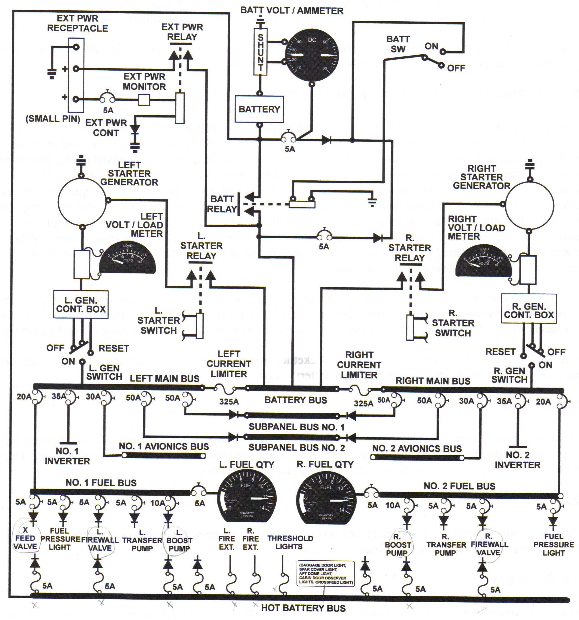
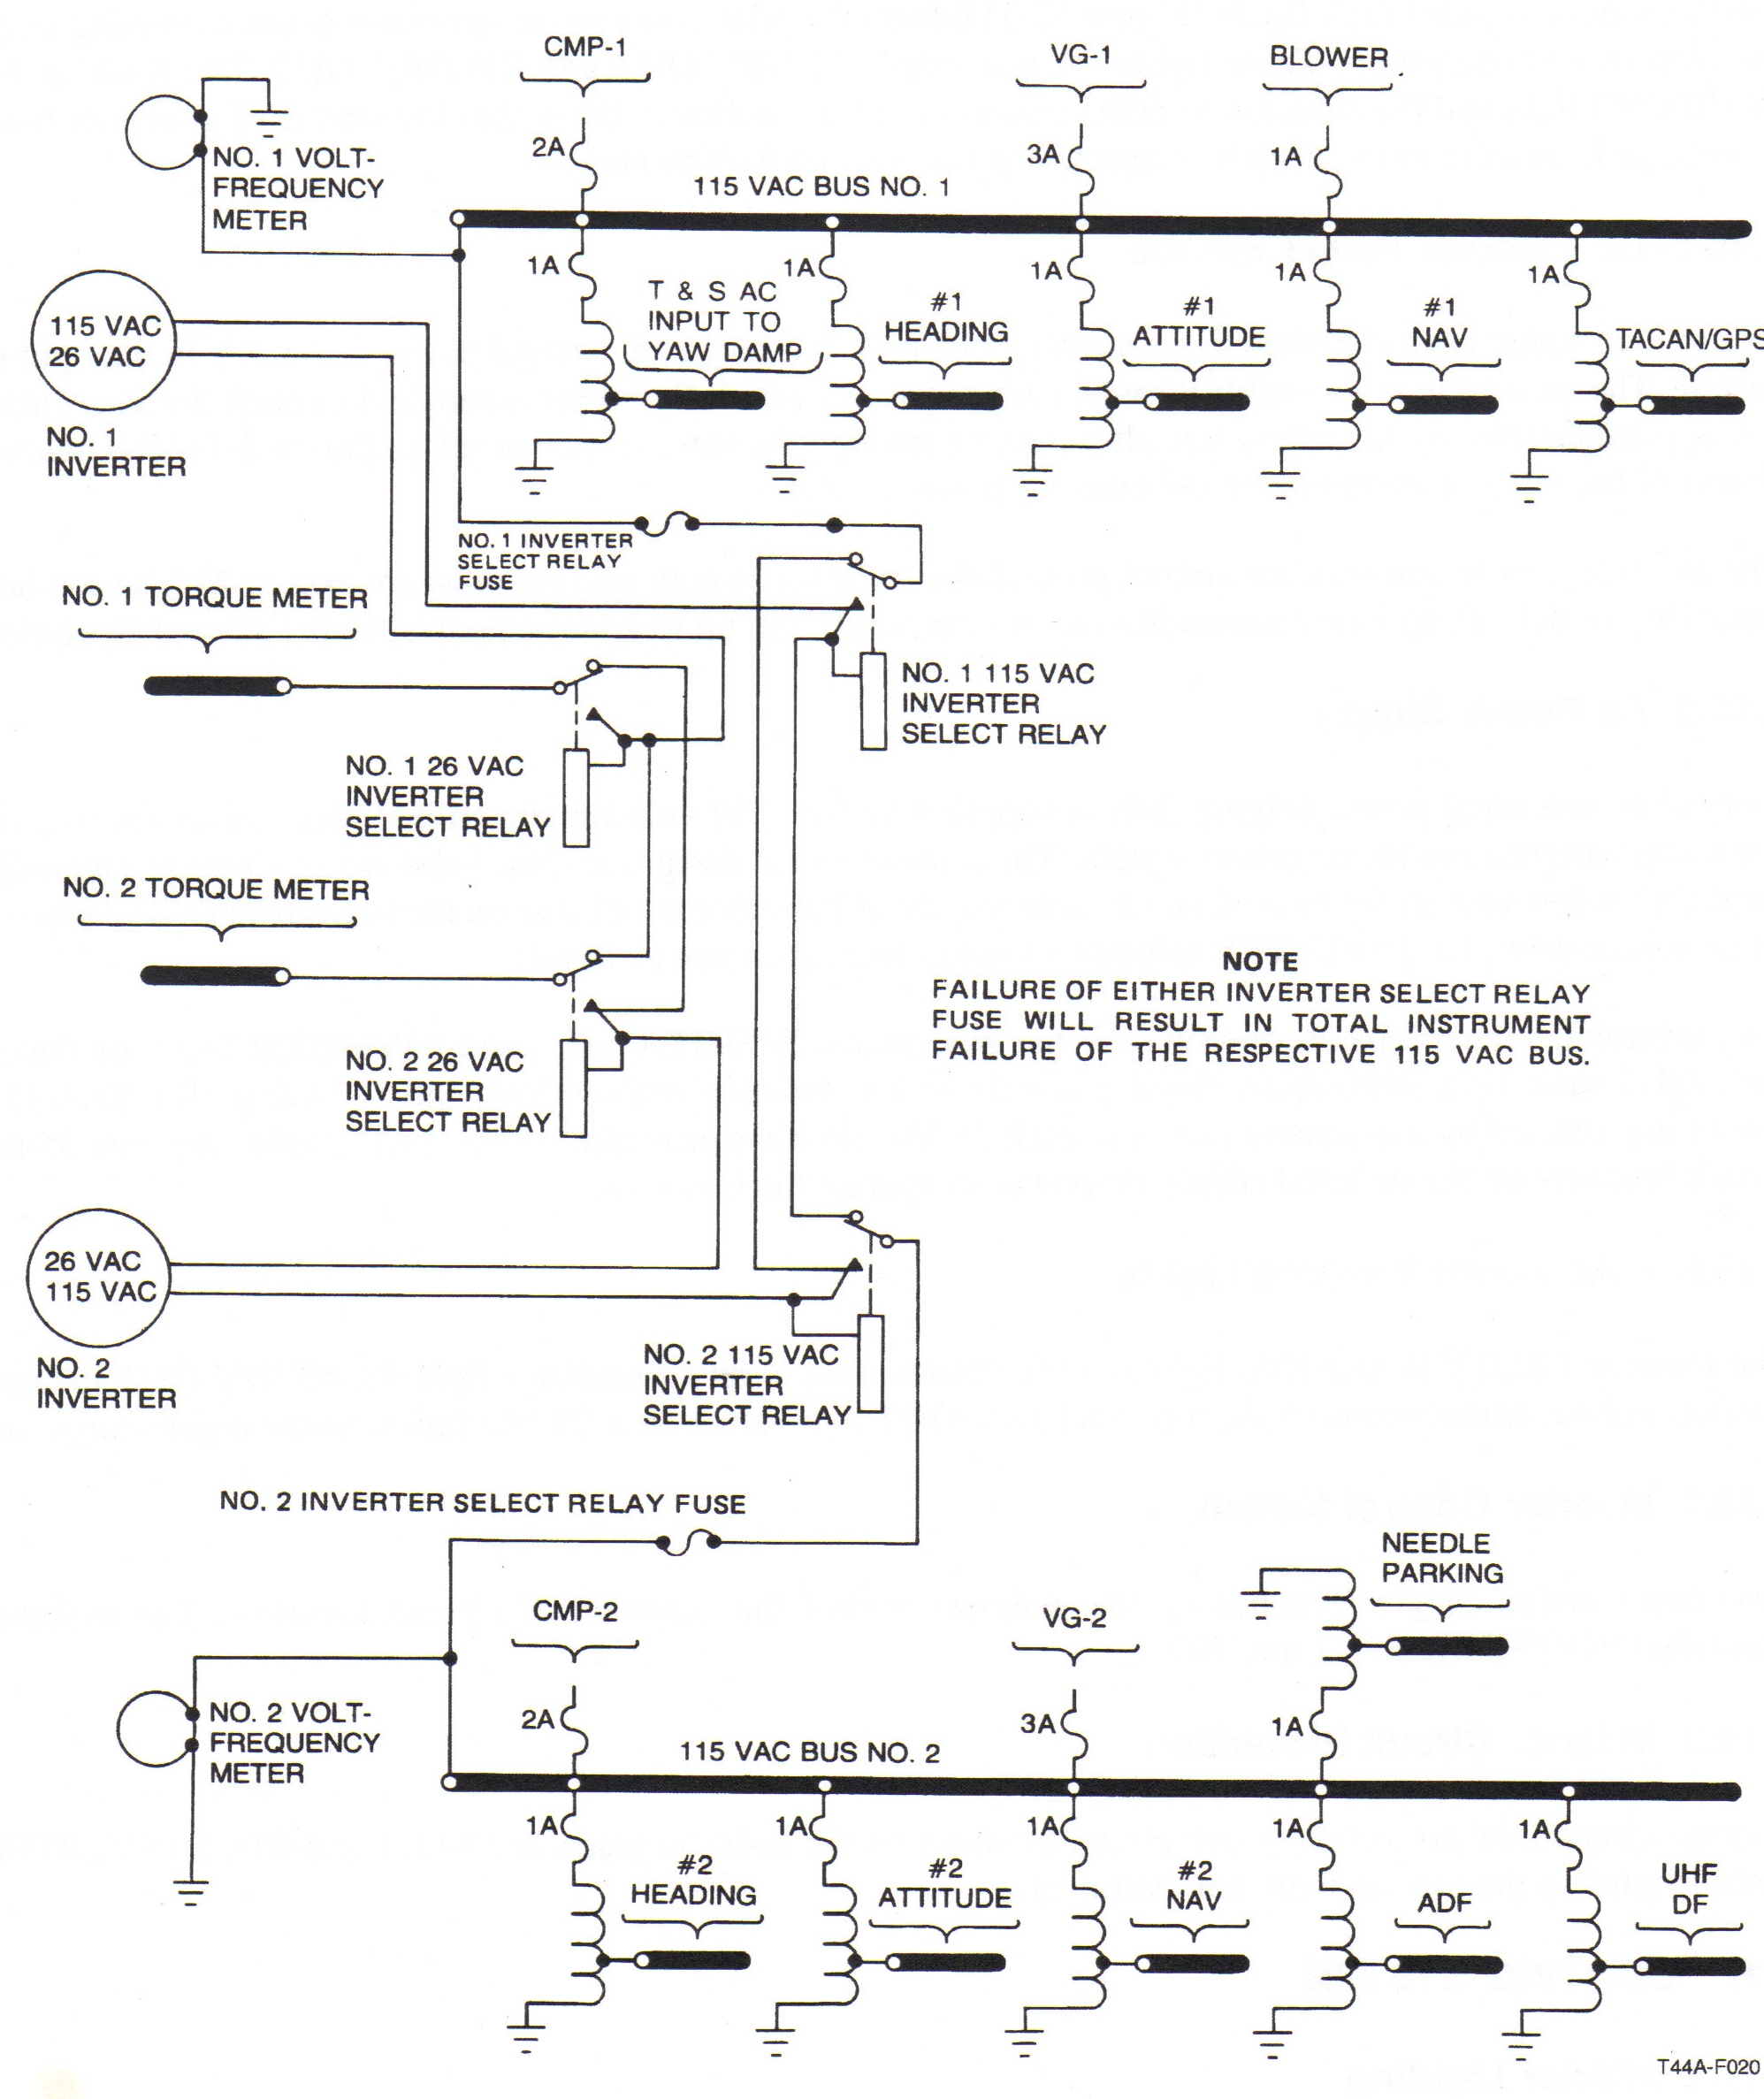

Malfunction: Gen Failure
Evaluate Current Limiters, 3 possibilities:
1) Good Current Limiters: no drop in batt, everything works. Keep load under 1.0.
2) Bad CL (same side): lose avionics bus, fuel bus, inverter for that side.
3) Bad CL (opp side): batter discharging, everything works. Conserve batt.
1) Gen - OFF, Reset, back on
2) Gen - OfF (if still broke)
If works in reset, Gen Control Box broke.
3) CLs check
4) Op gen - don’t exceed 1.0
5) Land as soon as practibile
NOTE: Fail w/ smoke+fumes=internal failure. Check by closing bleed air. Consider engine shutdown.

Dual-gen Fail:
Ensure maximum battery duration
1) Cabin Temp, heater, antiice/deice, autoignition, lights, radar - OFF
2) Emergency voice report - complete
3) VMC - Gang Bar - OFF, IMC - Gens -OFF
4) Boost pumps - OFF
5) VMC - Inverters - OFF, IMC - #2 Inv:OFF
6) Pull a lot of CBs.
7) VMC: Avionics Master - OFF, Batt - ON
8) IMC w/ GCA: Pull a lof of Nav CBs
9) IMC w/VORTAC: Pull more CBs for other stuff.
Note: No-flap, pump down the gear.

Excessive Load:
Due to ground fault or excessive batt charge.
1) Battery/Ammeter - Check
>30 A: 2) Battery - OFF
3) Battery/ammeter - Check
>30 still: battery relay failed. Land as soon as possible. If it drops:
4) Recheck loadmeters
If normal, excessive battery charge. Land as soon as practibile. If excessive, ground fault land as soon as possible. Watch for fire. Note: load splits >0.1=bad paralleling. W/ AC on, CL broke.

Inverter Fail
1) Failed Inv - OFF
2) Check for AC Switchover.
3) Land as soon as practibile.

Inst Inv Fail
Torquemeters Lie. Can’t fix.

Tripped CB:
1. Nonessential - Don’t reset.
2. Essential- Push to reset. If pops again, do not reset.
DON’T Reset Subpanel Feeder CBs.

Avionics Master
Lose all avionics, power is good. Pull MASTER POWER CB.

1) Battery: 24v 42a lead acid, in right wing root. Emergency power, starts engines, acts as damper.

2) Starter/Generator: 250 amps (Accessory gearbox) Generator Control Box located under main wing spar in center aisle. (Regulates voltage, automatic paralleling, overvoltage protection 31VDC, undervoltage protection 18VDC, reverse current protection) Load is measured in percent of 250 amps. (.3-.6)

3) APU in rt engine nacelle... No more than 28VDC, capable of 300A with 0.1 sec bursts of 1000A.

4) DC Busses: 10: Hot Batt Bus, Batt Bus, #1/2 Subpanel Bus, #1/2 Avionics Bus, L/R Main Bus, #1/2 fuel bus. Hot batt bus: Singularly powered: L/R Fire Extinguishers, Threshold lights (wing spar, baggage door, cabin door observer lt, aft compartment lt, xfeed lt) Dual powered (w/fuel bus): L/R Boost Pumps, L/R Firewall Valves, Xfeed valve.

5) Current limiters: Bus ties. Allow either bus to get power from other generator.. Also isolates shorts from rest of system. 325A Slow fuse.

6) Inverters: 750 Volt-Ampere single phase inverters. Supplies 26Volt AC for Torquemeters, 115 vac for the avionics. Inverter relays driven off inverters, fail-safe? System adjusts for failed inverters. If you lose an inverter relay select fuse, you lose the AC avionics on that side.

7) Lights: Master Cockpit is everything except for Threshold lights, Door locking light, Seatbelt light, reading light, utility light, indirect instrument lights, aft compartment light. Pull GYRO INST CB if Master Cockpit lights fails, for all lights other than gyro lights. Exterior lights (Landing/Taxi) shutoff with gear retraction.

1. Sources of DC power: 1 24V/42A battery, 2 28V/250A starter-generators
2. Sources of AC power: DC power routed through 2 750V-A single-phase inverters.
3. The generator control box: overvoltage protection (31V), undervoltage protection (18V), reverse current protection, & automatic paralleling.
4. The generator control boxes are under the cabin center aisle aft of the main spar.
5. The inverters are located outboard of the engines on the wings.
6. The current limiters: tie the main buses & provide fault protection.
7. To get around a faulty master avionics switch, pull the master power CB.
8. Limitations of the generators: 28.25 (+/- 0.8)V.
9. Limitations of the inverters: 114 (+/-7)V, 400 (+/-6)Hz.
10. For APU start, the unit must be able to provide 1000 Amps for 0.1sec and 300Amp continuous load thereafter.
11. A failed Inverter Select Relay Fuse will cause failure of respective AC bus without illum of inverter light (switch over impossible).
12. Illum of INST INV OUT light indicates loss of 26VAC inverter select relay & torquemeters.

