T-44A Briefing Guides
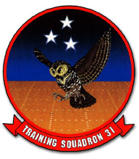

EVENT: C4102

DISCUSS ITEMS: Porpoised landings, aircraft airframe operating limits, full-flap landings, engine fire on deck, stalls/spin recovery, and fuel system/malfunctions.

Porpoised landings – A porpoised landing may occur if the nosewheel touches down before the main mounts. The nose will generally bounce back up and induce an uncontrollable oscillation until airspeed decreases below 40-50 kias. If a porpoised landing is encountered, immediately reduce power levers to idle and apply back pressure to maintain a “flare attitude” until the oscillation stops, and then accomplish a full stop landing. A waveoff is not recommended due to proximity to V_{sse} and V_{so}. It is better to accept a hard or rough landing rather than attempt a waveoff.

Aircraft airframe operating limits – See VT-31 website

Full-flap landings – Select full flaps after the 90, but before rolling onto final at 105 kias and selecting props full forward. Additional power is normally required to compensate for increased drag. Cross the threshold at 95 kias. Slowly close the power levers while bringing the nose up (flare). Beware of porpoised and/or flat landings.

Engine fire on deck – Stop the aircraft and set the parking brake, confirm is possible the fire actually exists, request firefighting assistance and proceed as follows:

Emergency Engine Shutdown on Deck
*1. Condition Levers – Fuel cutoff
*2. Firewall valves – Closed
*3. Boost Pumps – Off
*4. Fire Extinguisher – As required
*5. Gang Bar – Off
*6. Evacuate aircraft.

There are ¾ lb fire extinguishers under the CP seat and on the left riser.

Stalls/spin recovery –
Stall recovery – Relax, Max, Level, Ball, Lever and 85, Flaps, Gear, Flaps (see NATOPS Ch11 and FTI)

Spin recovery
- Power levers – Idle
- Rudder – Full deflection in the opposite direction of turn needle
- Control wheel – Rapidly forward
- Rudder – Neutralize after rotation stops
- Control wheel – Pull out of dive by exerting smooth, steady back pressure.

WARNING
- Abrupt pullout during spin recovery could result in excessive wing loading and a secondary stall or structural damage.
- Do not exceed 3g’s during pullout in a clean configuration or 2g’s if flaps are fully extended.

Fuel system –
- Total fuel capacity is 387.6 gallons, of which 384 are usable
- Transfer pumps are energized by 42-gallon (ON), 51-gallon (OFF), and 59-gallon (upper level) float switches in the nacelle tank.
- When all wing tank fuel has been used, a pressure sensing switch will sense the drop in fuel pressure in the transfer line and, after a 30-second delay, will terminate transfer pump operation, and a red NO FUEL TRANSFER annunciator light will illuminate.
- Boost pump failure will show a flashing fault light, a FUEL CROSSFEED light if the crossfeed switch is in auto, and a LH or RH FUEL PRESSURE light.
- Unboosted engine operation is limited to 10 hours throughout the TBO period.
- When AUTO is selected with the crossfeed switch, the crossfeed valve remains closed until fuel boost pressure (LH, RH, or both) drops from a nominal 30 psi value to 5 psi.
- The LH RH firewall valves, LH RH boost pumps, and crossfeed valve (not the crossfeed light!) are dually powered by the hot battery bus.

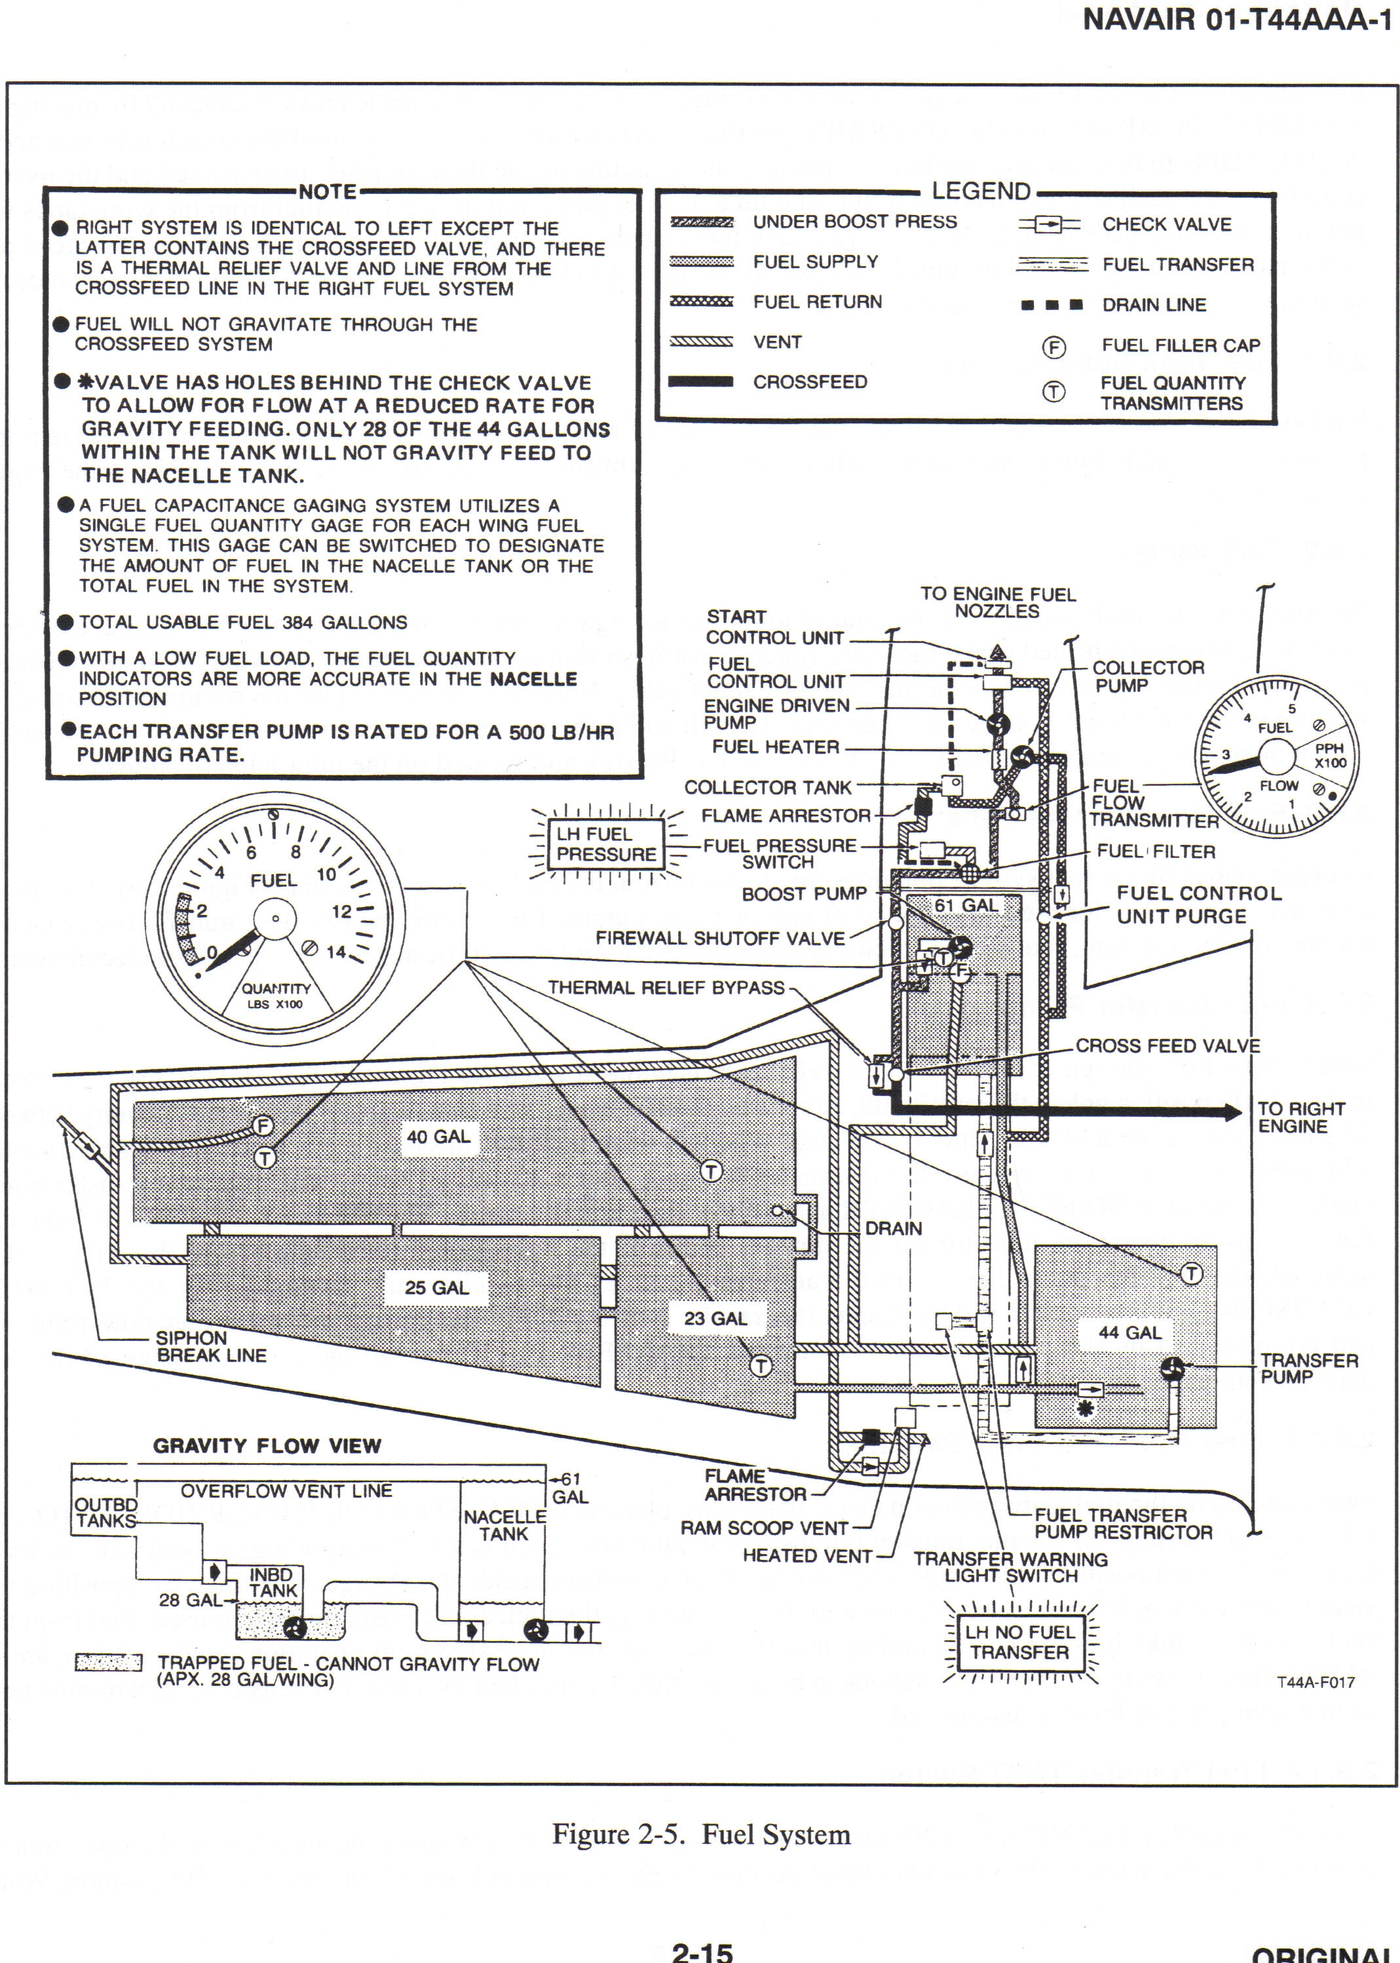

Fuel system failure –
15.11.1 Engine-Driven Fuel Pump Failure
The engine-driven fuel pump will sustain engine operation after failure of the electric boost pump; however, failure of the engine-driven fuel pump will result in flameout. Perform the EMERGENCY SHUTDOWN CHECKLIST in paragraph 15.2

15.11.2 Transfer Pump Failure
Illumination of the LH or RH NO FUEL TRANSFER light indicates a possible failure of the corresponding transfer pump.

- Check total and nacelle fuel quantity.
If no fuel remains in the wing tanks:
- Transfer pump — OFF.

If fuel remains in the wing tanks and it is deemed necessary to utilize the 28 gallons of fuel that would otherwise remain trapped:
- Transfer pump — OVERRIDE.
If light remains on:
- Transfer pump — OFF.

Note
Consider alteration of the flight plan because of unavailable fuel trapped in the wing (approximately 28 gallons).
- Land as soon as practicable.

15.11.3 Boost Pump Failure
A boost pump failure with crossfeed in AUTO will be noted by illumination of the yellow FUEL CROSSFEED annunciator light. The failed boost pump is identified by momentarily placing the crossfeed switch in the CLOSED position. The red LH or RH FUEL PRESSURE light will illuminate indicating the failed boost pump.
- Failed boost pump — OFF.
- Crossfeed — OPEN.

Note
Determination of range without resorting to suction lift is dependent upon fu el load remaining on the side opposite the failed boost pump.
3. Land as soon as practicable.

Note
If range because of crossfeed operation is critical, suction lift may be utilized at all cruise altitudes but should be discontinued in favor of crossfeed (boosted pressure) when initiating descent for landing in the event of a missed approach.

Boost pump failure during rapid climbout will cause a gradual power loss on the affected engine beginning at approximately 13,000 feet. This altitude will vary with the prevailing fuel temperature in the tank (the higher the fuel temperature, the lower the altitude at which the gradual power loss will occur). Complete power loss will occur if the climb is continued under these circumstances. This condition results from the highly aerated condition of the fuel caused by rapidly decreasing tank pressure during climb, allowing entrapped air in the fuel to expand. Once the pressure has stabilized and excess air has escaped from the fuel, loss of a boost pump has less effect on engine operation with maximum power settings available at altitudes up to 31,000 feet. The time required to stabilize the fuel from this highly aerated condition cannot be determined exactly since it is a function of both rate of climb and fuel temperature. Fuel stabilization should occur after a few minutes of stabilized cruising operation. Descents from a from a high altitude with the boost pump inoperative do not affect engine operation.

If engine power loss is experienced during the climb-out or initial phase or cruise because of an inoperative boost pump and a condition of aerated fuel, satisfactory engine operation may be regained by initiating crossfeed, reducing power, and/or descending to a lower altitude. If the crossfeeding is continued for a prolonged period, a major unbalancing of fuel load will occur and a range loss will be encountered because the surplus fuel in the tank with the inoperative boost pump cannot be crossfed to the other engine.

CAUTION
Engine-driven fuel pump operation without boost pump fuel pressure is limited to 10 hours. This time shall be recorded.

15.12 FUEL LEAKS
A fuel leak may be evidenced by the smell of fuel in the cockpit, a rapid drop in fuel quantity, or sighted visually. The first concern of the crew must be to guard against the outbreak of an engine fire. Consideration should be given to securing electrical systems that may contribute to the outbreak of a wing fire. Outboard wing electrical items in each wing that may be individually secured from the cockpit are the navigation and strobe lights and the fuel vent heaters. In addition, the left wing contains the AOA sensor and the sensor heater circuits. Inboard wing systems may be secured using the gang bar. If a wing or nacelle fuel leak is evidenced and power is not necessary to sustain flight or reach a safe destination, consideration should be given to securing the engine as follows:

*1. Condition lever — FUEL CUTOFF.
*2. Emergency Shutdown Checklist --Execute.

15.13 FUEL SIPHONING
If fuel filler cap siphoning occurs, proceed as follows:
- Airspeed — 140 KIAS.
- Land as soon as practicable.
Note
Extreme nose-low attitudes will aggravate the fuel siphoning condition.
SSE Waveoff at altitude –
SSE waveoffs allow safe transition from SSE descending flight to maximum power, SSE climbing flight. The maneuver is designed to stop altitude loss as soon as possible while transitioning to a climb at desired climb speed. Practice at altitude prepares the student fro SSE waveoffs in the pattern.

Level off on a 1000’ altitude plus 800 (i.e. 4800, 5800, etc), 120 KIAS, on a numbered heading. One technique is to align the CDI with your heading, tail at the top. This simulates 800’ on the downwind leg of the traffic pattern. The IP will simulate a single-engine by reducing one power lever to idle or simulating an emergency situation requiring an engine to be secured. “Power up, rudder up, clean up.” Complete the Emergency Shutdown Checklist without delay. The IP will call “Approaching the 180.” Lower the flaps and gear and complete the Landing Checklist. Immediately start a descending left turn to arrive at the “90” at 500’ and 120 KIAS (minimum 110 KIAS). Continue the turn to “final,” rolling out on the head of the CDI at 250’ with a minimum of 110 KIAS, maximum of 120 KIAS. Smoothly place the props full forward; when IP calls “Waveoff,” execute the following procedures:

- Power Maximum allowable. Simultaneously transition to a climb attitude. Anticipate significant rudder with power. Keep the ball nearly centered (¼ to ½ out towards the operating engine) while using up to 5° AOB into the operating engine. Maintain a minimum of V_{xse} (102 KIAS), a maximum of V_{yse} (110 kias), preferably V_{yse}. Level off or descend if required to maintain flying speed. Under no circumstances allow speed to approach V_{sse} (91 KIAS).
- Flaps Approach (unless already up). Immediately select flaps to approach.
- Gear Up. The gear is raised when the descent has been stopped or there is no possibility of touchdown on a prepared surface. Do not delay in raising the gear.
- Flaps Up. Immediately after selecting gear up, raise the flaps. Anticipate a slight attitude adjustment to prevent settling.
- Props Reduce to 1900 RPM after CP reports “Gear up.” In an actual situation, one prop would be feathered. A positive single-engine climb is not possible in any configuration with a windmilling prop.

Direct the CP to make a waveoff call. The maneuver is complete at the IP’s discretion, when established in a clean climb, minimum of 102 KIAS (preferably 110 KIAS), with the aircraft trimmed and in balanced flight.

Return to dual engine flight following single engine training – At the completion of SEE training returning to dual-engine flight is simple, but must be performed smoothly, especially if an engine has actually been secured or prop actually feathered. The objective is to allow the engine and prop to smoothly come up to speed. If power is added abruptly,. Prop or engine acceleration limits may be exceeded, and yaw may be excessive. Maximum torque is 2100 ft-lbs for 2 seconds. Never add power to a feathered prop without placing the prop out of feather and allowing it to come up to idle RPM first. Slowly add power, allowing time for engine spool up and smooth prop acceleration, then continue to advance power to match the other engine. Smoothly adjust both power levers as required, match props to 1900 RPM and fine tune to reduce cabin noise.

Dynamic engine cut – The dynamic engine cut simulates an engine failure immediately after takeoff with a windmilling prop. It allows practice of critical single-engine skills at a safe altitude. Emphasis is on heading and airspeed control, minimum loss of altitude, and completion of emergency checklist items.

Begin on a numbered heading at 150 KIAS with prop sync off. Maintain level flight prior to setting a takeoff attitude. Utilize the following steps:

Altitude | Minimum 5000’ AGL
Power | 300 ft-lbs. Trim 2° up and do not re-trim until after rotation. Utilize pitch to maintain altitude as airspeed bleeds off.
Flaps | Up (normal takeoff configuration).
Gear | Down. Landing Checklist complete.
Props | Full forward.

Takeoff at 95 KIAS, smoothly apply takeoff power and rotate to the takeoff attitude (7-10 degrees up). Maintain heading. Anticipate the need for right rudder with power application.

NOTE: IP will not call “Go” as airspeed approaches 95 KIAS. Once takeoff power is set, the IP will call “Rotate.”

At a speed above 91 KIAS (Vsse) the IP will pull one power lever to idle, simulating an engine failure. Raise your hand slightly when you feel the IP pull a power lever back; do not grip the power levers so tightly the IP cannot move the control. Do not attempt to anticipate which engine will be failed. An actual engine failure will be a surprise and requires prompt recognition and action.

Primary scan should be outside on the horizon. Pick a point (cloud) to assist in controlling yaw. Immediately stop the yaw utilizing rudder and aileron while lowering the nose to horizon. Substantial rudder pressure will be required. Bank to a maximum of 5° into the operating engine. Execute the following procedures:

- Power As required. Check maximum on the operating engine.
- Gear Up.
- Airspeed As required. At 102 KIAS raise the nose to stop any altitude loss and accelerate to 110 KIAS if possible.

Identify the failed engine utilizing engine instruments (torque, ITT, N1, fuel flow) and rudder pressure. Your foot working hard to maintain heading is on the same side as the operating engine. Your non-working foot (“dead foot”) is on the same side as the dead engine. Do not look at the power levers to initially determine which engine has failed. During an actual engine failure they would both be matched.

- Emergency Shutdown Checklist Execute

Hold the checklist momentarily after executing the first three memory items, pull the props back to 1900 rpm, reset maximum power, then continue the checklist if malfunction is fuel or fire related. Otherwise transfer comms to CP, declare an emergency, and address the Dead Engine Checklist. The maneuver is complete when trimmed at 110 KIAS (minimum of 102 KIAS), established on takeoff heading, and the Emergency Shutdown Checklist has been executed.

