T-44A Briefing Guides
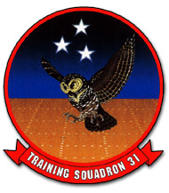

EVENT: C4101

DISCUSS ITEMS: Outside scan techniques, see and avoid, takeoff, crosswind takeoff and landing, aborted takeoff, landing pattern, full stop landings, touch-and-go procedures, training time-out, NATOPS brief, dual engine waveoffs, aircraft engine operating limits, engine start procedures, abnormal starts/malfunctions, and brake system/malfunctions.

Outside scan techniques – 10 degrees, looking at blocks, look at sky in pieces. Also, clear into any turn, anywhere you’re going. Pilot + OBS Clears Left. IP clears rt.

See and avoid – When operating on an instrument clearance, you are still required to scan for other traffic. The only separation normally provided by ATC is between other IFR traffic. Even at or above FL180, where all aircraft are required to be IFR, near misses have occurred between other IFR aircraft and illegal VFR aircraft. Even though other aircraft may be operating legally, never assume you are protected in any airspace. Clearing procedures must be adhered to at all times. The OBS is also very valuable in searching for traffic.

Use “Traffic in sight” or “negative contact” when talking with ATC.

Crosswind takeoff and landing –
- In accomplishing a crosswind takeoff, directional control may be more difficult to maintain. Leading with the upwind power at the beginning of the takeoff roll will assist in maintaining directional control. Keep the nosewheel on the surface and apply upwind aileron to maintain a wings-level attitude. Firmly pull the aircraft off when flying speed is reached. Make the pulloff positive to keep from side-skipping as weight is lifted from the shock struts. Initial drift correction is made by turning into the wind with a shallow bank to counteract drift, then roll the wings level. Continue to climb straight ahead maintaining drift correction.
- No unusual technique is required in a crosswind landing. Use the wing low method. Allow for drift while turning on final approach so that the approach leg will not be overshot. Establish drift correction as soon as drift is detected. Use ailerons and top rudder as necessary to counteract drift during flare and touchdown. Crosswind correction (ailerons) should be maintained during the ground roll.

Aborted Takeoff – The decision to abort or continue the takeoff is dependent on length of remaining runway, airspeed, gross weight, and density altitude. When aborting a takeoff, proceed as follows:
- Announce “Abort.”
- Power levers – IDLE
- Reverse – As Required.

WARNING
- Mechanical stops in the throttle quadrant prevent rapid movement from beta to the flight range. Downward pressure is required.
- A misrigged linkage between a power lever and propeller could cause directional control problems while reversing during an aborted takeoff. If this is encountered, advance both power levers to flight idle.

- Brakes – As required

WARNING
- Single engine reversing may be applied if required. Use extreme caution if takeoff surface is not hard and dry.
  - Accelerate-stop distances increase by 900 feet when HIGH IDLE and no reverse is used.

Immediately prior to departing the prepared surface:

- Condition levers – FUEL CUTOFF.

As soon as practicable:

- Firewall valves – CLOSED.
- Boost pumps – OFF.
- Fire extinguisher(s) – As Required.
- Gang bar – OFF.
- Evacuate aircraft.

Landing pattern –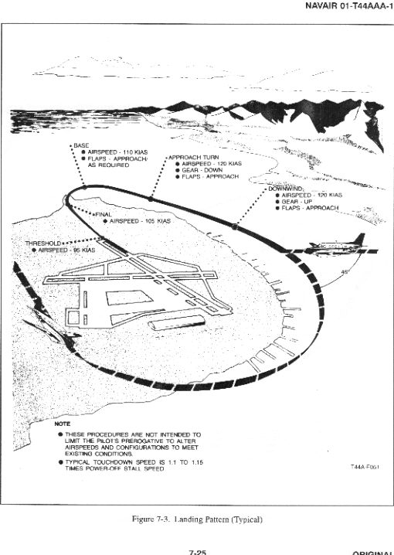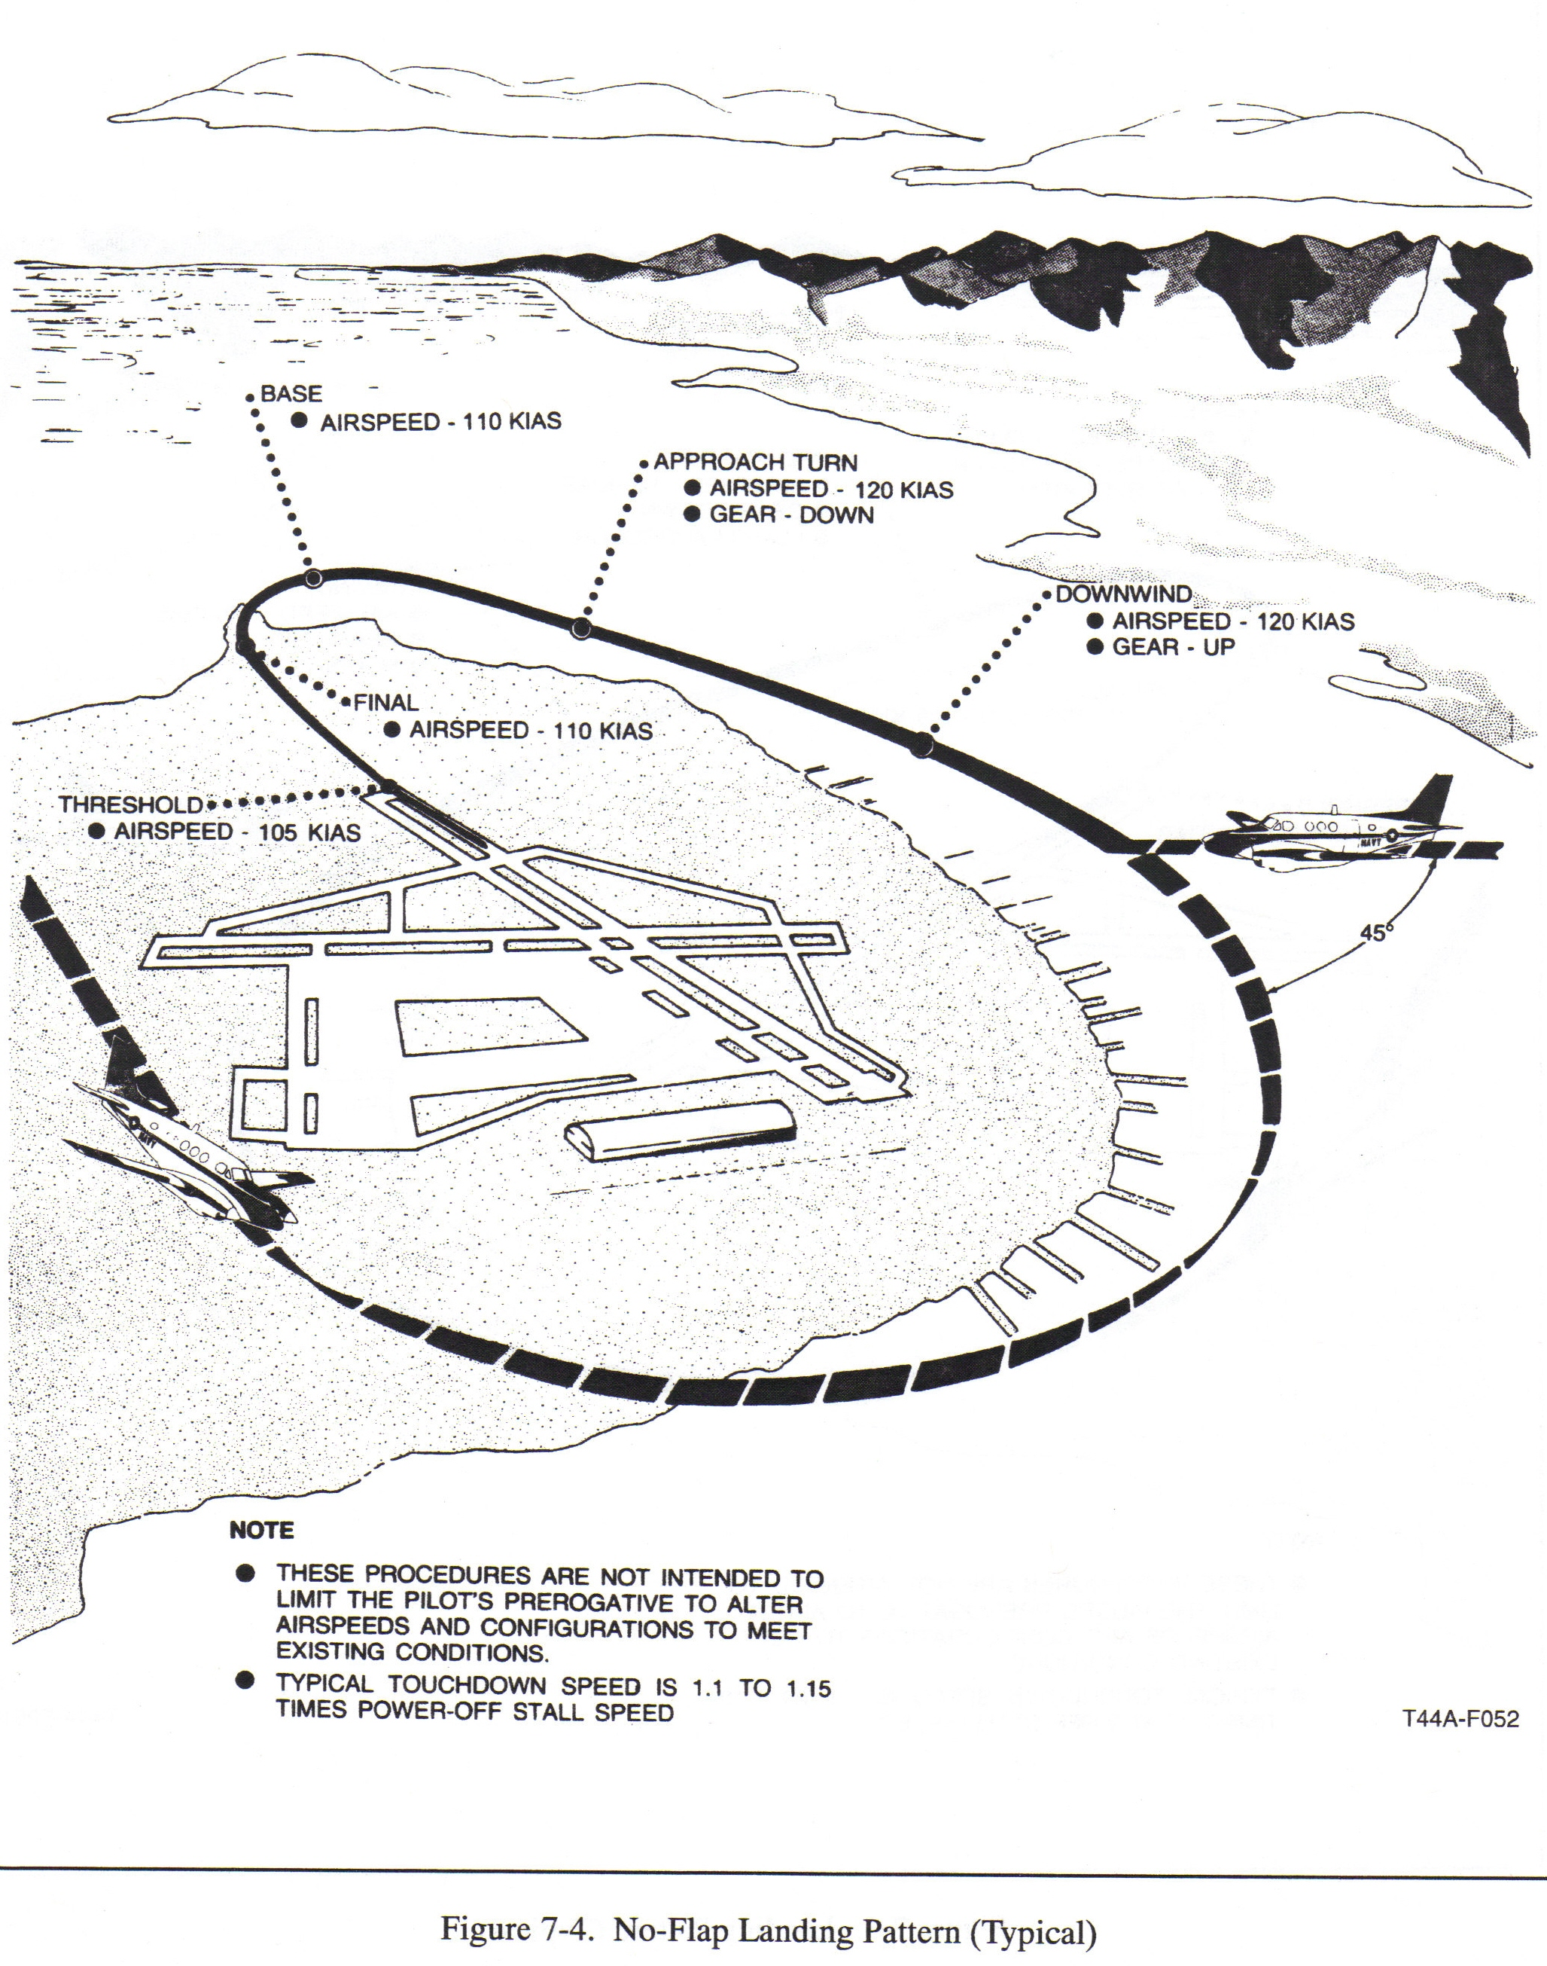
Upwind –
- Gear Up
- Props slowly retard to 1900 rpm
- Extended runway centerline at 300-500’ AGL and a max airspeed 130 kias
- Receive downwind clearance, check clear, turn as soon as possible after reaching 300’ AGL
- Interval is 15° ahead of the wing, abeam for aircraft still turning crosswind, and 30° behind for aircraft at full stop (unless you are intending to wave-off)
Crosswind –
- Max AOB is 30° anywhere in the pattern
- Maintain 130 kias
- Passing 600’ AGL select approach flaps (unless no-flap), adjust power to 500-600 ft-lbs
- Level off downwind at 800’ AGL with 120 kias

Downwind –
- Maintain 800’ AGL and 120 kias
- Fly one mile abeam by keeping AOA probe on runway edge (left pattern)
- Crab into crosswind as required
- Just prior to midfield, call “Gear Down, Landing Checklist”
- Complete checklist and add power to maintain 120 kias
- “Down and locked” when there are 3 green lights in the gear handle

180° Position (Abeam) –
- Quickly check green lights in gear handle before making radio call
- Report the 180 – “Navy Corpus Tower, Montana __, left 180, three down and locked, full stop.”
- Gear must be down by the 90° position

Approach Turn (Base) –
- Commenced abeam the runway approach end
- Reduce power to 300-375 ft-lbs
- Roll into 15-30° AOB

90° Position –
- Arrive at 90° at 110 kias, 500’ AGL, balanced, and perpendicular to runway heading

Final –
- Intercept extended runway centerline 1000-1200’ from the threshold at 250’ AGL
- Use wing low, top rudder method to maintain centerline. Don’t angle in.
- Descent slop is slightly steeper than a 3° glide slope.
- Smoothly move props full forward
- Verify three green lights and gear handle down with no red light and respond “Props full forward, three down and locked, review me complete.”
- CP verifies props full forward, three green lights, gear handle down and no red light and responds “Reviewed complete.”
- Land on first 1/3 of runway

No-flap landing
- Roll onto final at 110 kias, cross threshold as 105 kias
Approach-flap landing
- Roll onto final at 105 kias, cross threshold at 95 kias
Full-flap landing
- Select full flaps after the 90, but before rolling final at 105 kias
- Cross the threshold at 95 kias
Full stop landings – Dual-engine full-stop landings may be made in any configuration. Crosswind corrections must be maintained throughout the landing rollout. Once the nosewheel is on the runway, lift the power levers over the detent and smoothly pull into the reverse range. Reverse will be as required and possible prop erosion should be avoided. Augment with smooth, even braking as required. Prop reverse is more effective at higher airspeeds and brakes more effective at lower airspeeds. Scan the length of the runway to maintain centerline. Come to a slow taxi prior to making any abrupt turns to avoid stressing the gear. The After Landing Checklist should not be commenced until clear of the runway.

If a landing is made with props inadvertently at 1900 RPM, slowly advance the props full forward prior to utilizing reverse, or stop using brakes only.

Touch-and-go procedures – Touch and go landings are an integral part of the curriculum. They require concentration, quick scan, and thorough briefing. Maintain crosswind corrections throughout the landing and rollout. Maintain centerline and alignment. Do not fixate inside the cockpit.

After touchdown the Pilot shall:
- Raise the flaps. Only the Pilot positioned in the left seat will move the flap handle on a touch and go.
- Advance power levers to the 12 o’clock position.
- Advance power levers to maximum allowable torque (lower red line) when CP calls “go.” Do not remove your hand from the power levers until the aircraft is climbing, clean, and well clear of the ground.
- Execute a normal takeoff when CP calls “Rotate,” but not less than 91 KIAS.

After touchdown the CP will:
- Reset all trim for takeoff.
- Confirm flaps up, all trim set, and props at a minimum of 2000 RPM, by calling “Go.”
- Back-up the power levers, monitor engine instruments, verify takeoff power set (minimum of 1000 ft-lbs), and call “Rotate” at a minimum of 91 KIAS. Fine-tune power levers as required to prevent exceeding limits.

When the Pilot in the right seat is executing the landing, the left seat Pilot selects flaps up, reset trim, call “Go” after spool-up, back-up the power levers, make fine adjustments if required to prevent exceeding maximum limits, and call “Rotate” at 91 KIAS.

If a malfunction occurs during the touch and go, consideration should be given to runway remaining prior to aborting. It is recommended with less than 2000’ remaining and power levers advanced beyond the 12 o’clock position that the takeoff be continued. This recommendation does not replace pilot judgment during a catastrophic emergency. Immediate action must be taken to determine if the takeoff can be continued.

Once airborne, with insufficient runway remaining to safely land, and a positive rate of climb visually noted, call “gear up.” The CP shall also visually confirm a positive rate, then respond “gear selected up.” After the gear indicates up, the CP shall report “gear up.” Reduce power to approximately 900 ft-lbs; pull the props back to 1900 rpm, then set approximately 1000 ft-lbs. Maintain 130 KIAS in the climb. Do not allow the aircraft to accelerate past 130 KIAS. A nose attitude of 7-10 degrees up ensures a 130 knot climb. Scan over the nose to aid in maintaining the desired climb attitude. Adjust power as required to obtain the desire climb rate. Fine tune the props as soon as possible to reduce cabin noise and airframe vibration. Be prepared to reduce power to prevent climbing through 500’ if the crosswind turn must be delayed. Transition to balanced flight and crab into the wind to maintain departure centerline. Listen carefully for clearance to turn downwind. If not received, do not delay requesting a clearance. Keep the pattern as tight as possible.
Training time-out –
- All aircraft, flight-training events are considered “High Risk” events
- “Only verbal TTO signals will be used for aircraft flight events”
- In any training situation when a student, or an instructor expresses concern for personal safety, or a need exists to clarify procedures or requirements, the student or instructor shall call for a “Training Time Out.” This does not necessarily mean the event must be terminated. The situation shall be examined and additional explanation, and or instruction will be provided. If the TTO concerns are corrected, the training evolution may continue. When the student refuses to continue after additional instruction is provided, and the safety concern has been resolved, or when excessive use of TTO occurs, the event will be terminated and the student will be removed from training. “TTO requests and the action taken by the instructor shall be documented on the ATF.”

NATOPS brief – See blue briefing guide

Dual engine waveoffs – Waveoffs shall be accomplished in accordance with NATOPS. Waveoffs allow a safe transition from low-powered, descending flight, to high-powered, climbing flight. The maneuver is designed to stop altitude loss as soon as possible while transitioning to a climb at the desired climb speed. Minimum altitude for an IP initiated practice waveoff is 100’. The IP may take the controls and execute any waveoff required below 100’. A waveoff shall be executed under the following conditions:
- Excessive overshoot of the runway/greater than 30° AOB required during the approach turn.
- Landing clearance has not been received by short final.
- The IP, wheels watch, Tower, or RDO issues any verbal or visual waveoff signal.
- Any time three green lights are not visible after rolling onto final.
- Any time the P feels an unsafe condition exists.
- Give consideration to waving off if touchdown cannot be accomplished on the first one-third of the runway.

Be alert to reducing power and leveling at 500’, unless cleared downwind. Do not exceed 130 KIAS or overtake other aircraft. Initiate the waveoff by adding power as required and establishing a positive rate of climb. Then offset slightly from the runway to allow a better view of traffic over or on the runway. Finally, report the waveoff and reason to the Tower. Common errors include beginning the offset too early or communicating with Tower before flying the airplane.

Execute a waveoff by performing the following:
- Power – As required, Establish Positive Rate of Climb (V_{x} minimum).

CAUTION
Rapid advancement of the power levers may result in prop surging and asymmetric power application that could result in directional control problems.

- Flaps – APPROACH (unless already UP)
- Gear – UP

WARNING
The landing gear is raised when the rate of descent has been stopped or there is no possibility of a touchdown.

- Flaps – UP
- Props – 1900 rpm

Note
Reducing prop rpm to 1900 reduces drag, enhancing climb performance.
Aircraft engine operating limits – See VT-31 website

Engine start procedures – See Appdx E-4 to E-6 of FTI

Abnormal starts/malfunctions –
13.1 ABNORMAL START
Monitor interstage turbine temperature during normal start. If the ITT rate of increase appears likely to exceed 925 °C or no rise in ITT is evident within 10 seconds after selecting LOW IDLE with the condition lever, proceed as follows:

*1. Condition lever — FUEL CUTOFF (note ITT decrease to below 790 °C).
*2. Starter —OFF.

CAUTION
Starter use is time limited to 40 seconds on, 60 seconds off, 40 seconds on, 60 seconds off, 40 seconds on, then 30 minutes off.

Note
If starting attempt is discontinued and another start is to be attempted, allow 60 seconds delay to drain fuel and cool starter, then motor the starter for 15 seconds minimum. Allow the engine to come to a complete stop before another start is attempted.

13.2 EMERGENCY ENGINE SHUTDOWN ON DECK
If an emergency situation dictates immediate discontinuation of engine operation such as fire, fire warning light, chip light, etc., stop aircraft and set the parking brake, request assistance as necessary and proceed as follows:

Note
Confirm, if possible, that fire actually exists by checking engine instruments and nacelles.

*1. Conditions levers — FUEL CUTOFF.
*2. Firewall valves — CLOSED.
*3. Boost pumps — OFF.
*4. Fire extinguisher — As Required.

Note
The engine fire extinguisher is a single-shot system with one cylinder for each engine. Do not attempt engine restart until the cause of the fire is determined and corrected.

*5. Gang bar — OFF.
*6. Evacuate aircraft.

Brake system/malfunctions –
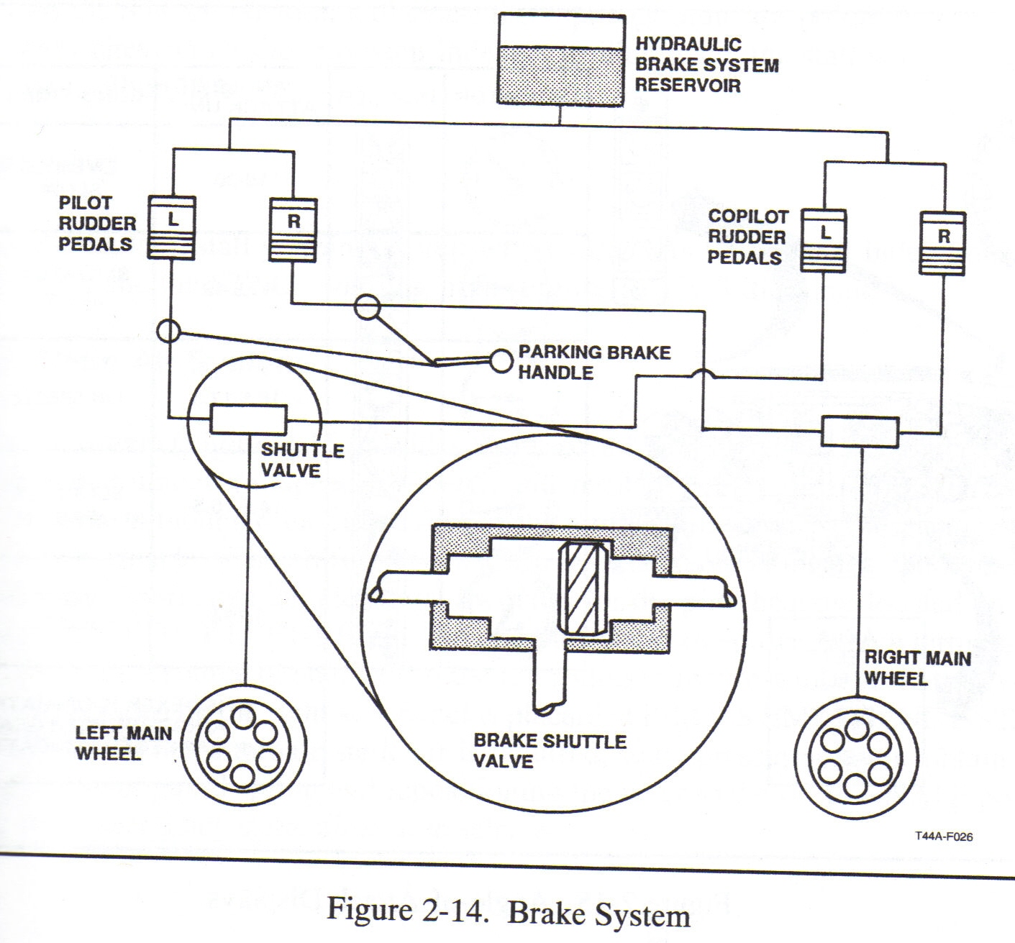
loss of brakes –
(NATOPS 13-1)
Maintain directional control with rudder, nosewheel steering, or differential power. Use prop reversing (-5 to –11) or beta range (15 to –5) to decelerate. If possible, maneuver to an open area and allow the aircraft to stop. Don’t taxi! If the shuttle valve is sticking, try reseating them by pulling aft on the top of the brake pedals.

hot brakes –
(NATOPS 13-1)
Hot brakes are usually caused by excessive or heavy braking. Stop aircraft using reverse thrust and minimal braking. Request assistance if needed and allow the brakes to cool with propwash. Allow brakes to cool and ensure they are checked before using again. CAUTION: The high energy absorbing capacity of the wheel brakes could lock the wheels during max braking which could result in blown tires.

brake fire –
(NATOPS 13-2)
*1. Firefighting assistance –Request
*2. Stop aircraft
*3. Emergency Engine Shutdown on Deck Checklist – Execute

WARNING: all crewmembers stay a safe distance from the aircraft, preferably well aft because if a wheel blows from rapid cooling, the fragments tend to fly sideways. A tire could explode from the heat of a fire. Don’t fight the fire!
Level Speed Change –
Norm 150 kias (650-700 ft-lbs)
Fast 170 kias (900-1000 ft-lbs)
Slow 130 kias (450-500 ft-lbs)
Norm 150 kias (650-700 ft-lbs)

Turn Pattern –
Cardinal heading, 150 kias (Lead turns by 1/3 AOB)

15° AOB for 90
30° AOB for 180
45° AOB for 360

Slow Flight –
Begin on an assigned altitude and heading with props at 1900 RPM

Power - 400ft-lbs (initially, then as required)
Flaps - APPROACH (174 KIAS max, anticipate ballooning, trim)
Gear - DOWN (155 KIAS max, landing checklist complete)
Airspeed - 100 KIAS (600-700 ft-lbs as aircraft approaches 100 KIAS)
Turn - 90° (30° AOB) reverse
Flaps - FULL (balloon, trim)
Airspeed - 90 KIAS (800-900 ft-lbs), TRIM FULL UP
Turn - 90° (30° AOB) reverse
Recover (level)
P-Max allow
F-APPR
G-UP
F-UP
A-150KIAS (650-700 ft-lbs)

Approaches to Stalls –
Begin on an assigned altitude and heading, at 150 KIAS.

Pre-stall check (LACY PC)
L-Loose items stowed
A-Alt 5000’ AGL minimum (VMC to deck) or 8000’ AGL (5000’ above cloud deck)
C-Cabin sign-BOTH
Yaw damp-OFF (CP checks off)
P-Props-1900
C-Clear turn (90 at 30AOB)

Clean, Pwr Off
1. Immed after level clearing turn, set 400 ft-lbs
2. Roll out after 90 deg
3. P-IDLE, Pitch 10 UP, Trim to 100 KIAS
(Maintain wings level 10deg UP)
4. Immed recover after 1st stall indication

Clean, Pwr On
Same as Clean Pwr Off except don't pull pwr to IDLE!

Dirty, Pwr Off
1. Immed after clear turn, set 400 ft-lbs
2. F- APPR
3. G-DOWN (Landing Checklist)
4. Roll out after 90deg
5. F-DOWN, P-IDLE, Pitch up 10deg, Trim to 100K
6. Immed recover 1st stall indication

Dirty, Pwr On
Same as Dirty Pwr Off except don't pull pwr to IDLE!

Appr Turn
1. Immed after clear turn, set 400 ft-lbs
2. F- APPR
3. G-DOWN (Landing Checklist)
4. After 90deg, maintain 30AOB
5. P-reduce to 300ft-lbs, Pitch 10deg UP, Trim to 100K, then stop trim. Maintain turn and pitch.
6. Immed recover 1st stall indication

Stall Recovery
1. Relax, max, level, ball, 85 and level, flaps, gear, flaps
2. Once recovered, incr pitch and accel
3. Once level or climbing (>85 KIAS) immed F-APPR
4. G-UP
5. F-UP
6. Complete when climb on hdg < 110K

