T-44A Briefing Guides


EVENT: C2106

DISCUSS ITEMS: Anti-ice/deice systems, windshield heating failure, in-flight damage/bird strikes, pressurization system malfunctions, propeller malfunctions, and ditching.

anti-ice/deice systems –

15.16 PILOT EMERGENCY STATIC AIR SOURCE
The possibility of obstructed static ports should be considered when the aircraft has been exposed to moisture and or icing conditions (especially on the ground). Partial obstructions will result in sluggish VSI indications during climb or descent. A suspected obstruction may be verified by switching to the emergency system (ALTERNATE) and noting a sustained change in VSI indication. This may be accompanied by abnormal indicated airspeed and altitude changes beyond normal calibration differences (Chapter 25). When obstruction exists or is suspected, the | ALTERNATE position on the pilot emergency static air source should be selected.

WARNING
Position error may be significant with EMERGENCY STATIC AIR selected. Refer to the altimeter and airspeed position error correction charts in Chapter 25.

Note
With a complete loss of the pilot-static system, check pitot heat on and fly known combinations of attitude and power.

windshield heating failure – DOES NOT APPLY / TC-12 ITEM ONLY

in-flight damage/bird strikes –
- 15.24 IN-FLIGHT DAMAGE
If the aircraft should sustain damage because of a midair collision, bird strike, or overstress, the single most important concern is maintaining or regaining aircraft control. Monitor engine and flight instruments for unusual indications.
- Check controls for freedom and correct response.
- Prior to landing, a landing configuration check should be conducted above 5,000 feet. The aircraft should be
checked for controllability in the landing configuration by slowly decreasing airspeed in 10-knot increments
to determine the minimum airspeed at which the aircraft can be safely controlled for landing.
- Land as soon as possible with minimum control movement.
WARNING
• Careful consideration should be given before making any configuration changes.
- Airframe deformation may significantly increase stall speed.
- Fly approach a minimum of 10 knots above minimum controllable speed
to provide a safe margin for landing and possible waveoff.

15.24.1 Cracked Windshield
1. If it positively determined that the crack is on the external panel, no immediate action is required.
CAUTION
Windshield wipers may be damaged if used on a cracked outer panel.

Note
Heating elements may be inoperative in area of crack.

2. If the crack is on the inner panel of windshield or cannot be determined, gradually descend and slowly depressurize the aircraft to 2.5 psi or less differential pressure within 10 minutes. Visibility through the windshield may be significantly impaired.

15.24.2 Cracked Cabin Window
If a crack appears in a cabin window, depressurize the aircraft and/or descend to a lower altitude.

Note
Heating elements may be inoperative in area of crack.

2. If the crack is on the inner panel of windshield or cannot be determined, gradually descend and slowly depressurize the aircraft to 2.5 psi or less differential pressure within 10 minutes. Visibility through the windshield may be significantly impaired.
15.24.2 Cracked Cabin Window
If a crack appears in a cabin window, depressurize the aircraft and/or descend to a lower altitude.

pressurization system malfunctions –
15.19 LOSS OF PRESSURIZATION
Note
Approximately 75-percent ni (single engine 85-percent ni) is required to maintain the pressurization schedule during descent.
If gradual pressurization loss is experienced:
- Cabin altitude — Checked (P).
- Pressurization controller — Checked (CP).
- Bleed air — Checked (CP).
- Press dump test switch — TEST (CP) (hold 15 seconds).
Note
If activating the test switch restores pressurization, it may be necessary to
hold the switch in TEST until the cabin altitude profile is adjusted to 10,000 feet or less. If pressurization is regained through the test switch, pulling the PRESS CONTROL CB will remove electric power from the system, thereby maintaining pressurization.
If unable to restore pressurization:
- Oxygen masks/MIC switches (100 percent) — As Required (P, OBS, CP).
- Descend — As Required (P).
WARNING
Verify obstacle clearance and altimeter setting.
CAUTION
On descent when cabin altitude matches pressure altitude, ensure the PRESS CONTROL CB is reset to preclude landing pressurized.
15.20 EXPLOSIVE DECOMPRESSION
If explosive decompression occurs, the cabin pressure changes to the outside pressure in less than I second. Explosive decompression causes a fog that should not be confused with smoke. An explosive decompression affects all crewmembers and can be extremely dangerous if it occurs at high altitude. Some of the effects accompanying explosive decompression are rush of air from lungs, a momentary dazed sensation that passes immediately, possible gas pains, and hypoxia if oxygen equipment is not immediately available. Maintaining a safe pressure differential and having oxygen equipment immediately available are precautions that should be observed in pressurized compartments. If explosive decompression occurs, proceed as follows:
*1. Oxygen masks/MIC switches (100 percent) — As Required.
*2. Descend — As Required.
15.21 EMERGENCY DESCENT PROCEDURE
The emergency descent procedure is a maximum effort descent intended to be used for a sustained descent. Aircraft damage and meteorological conditions should be considered.
*1. Power levers — IDLE.
*2. Propellers — Full Forward.
*3. Flaps — As Required.
*4. Landing gear — As Required.
*5. Airspeed — As Required.
*6. Windshield heat — As Required.
CAUTION
Do not exceed airframe limitations.
15.22 CABIN DOOR OPEN LIGHT ILLUMINATED
If the CABIN DOOR OPEN warning light illuminates, indicating the airstair door may not be secure, ensure all
passengers and crewmembers are seated with seatbelts fastened and depressurize the cabin. |
WARNING
Do not attempt to check the airstair door for security until the cabin is depressurized and the aircraft is on the ground. If the cabin is pressurized and the door is not completely latched, any movement of the handle toward the locked position may cause a rapid and complete unlatching and opening of the door.
The airstair door latching mechanism is an overcentering mechanism and must be in the overcentered position to be fully locked. Check security of door (aircraft depressurized and on the ground) by lifting cabin door step and checking position of the arm and plunger. Determine that door lock pins are properly locked into door frame. If a position other than locked is indicated, turn the door handle toward the locked position until positive locking is assured.

propeller malfunctions –

15.15 PROPELLER FAILURE
15.15.1 Primary Governor Failure/Malfunction
Normally, the primary governor controls propeller speeds within the range of 1,800 to 2,200 rpm. If the propeller governor fails, the propeller will either feather or overspeed.

An uncommanded and uncontrollable propeller overspeed greater than 2,200 rpm indicates failure of the primary governor. The overspeed governor will maintain a maximum propeller speed of 2,288 ±40 rpm, but may not control minimum blade angle. Certain failures of the primary governor will cause the speed control as well as the minimum blade angle control (beta valve) to be inoperative. In this case, aircraft control will be marginal at lower airspeeds and lower engine power settings. Landing with an overspeeding propeller is therefore strongly discouraged. However, if forced to land with an overspeeding propeller, extra airspeed should be carried on final. This will increase rudder authority while reducing the probability of the propeller going into beta in flight. Should the propeller blades become jammed during engine power addition, the pneumatic section of the primary governor will act as a fuel topping governor as propeller speeds exceed 2,332 rpm. If propeller rpm is out of the normal governing range, proceed as follows:

- Attempt to adjust propeller rpm to normal operating range by manipulating the propeller lever. If normal rpm limits are restored, continue operation. If normal governing range cannot be maintained, as soon as practicable accomplish the following:
- Power lever — IDLE. (DC)
- Propeller lever — FEATHER. (DC)

WARNING
Propeller rpm exceeding 2,420 may result in reduction gearbox failure and/or Na turbine damage.

Note
- The engine with the disabled propeller may be operated to provide
electrical power.
- The right propeller may not fully feather with the propeller sync on.
- A fully feathered propeller will still be turning at approximately 200 RPM
with the engine running.

- Alternate Propeller Feathering Checklist — As Required.
1

15.15.3 Alternate Propeller Feathering
If the propeller linkage or governor fails and when the propeller has not feathered by itself or the normal feathering procedures are ineffective, the propeller can be feathered utilizing the autofeather system. In this situation, should a need for feathering arise, proceed as follows:

- Power lever — IDLE (failed propeller). (DC)

WARNING
A positive single-engine rate of climb will not be obtained in any configuration with the inoperative engine propeller windmilling.

- Condition lever — FUEL CUTOFF. (DC)
- Autofeather — ARMED (P).
- Power levers — Above 90-Percent ni Position (P).

Note
Do not pull the power lever to idle during the autofeathering sequence as the autofeather system would be disarmed while feathering.

- Emergency Shutdown Checklist — Execute (P).

15.17 ELECTROTHERMAL PROPELLER DEICE
Abnormal readings on propeller deice ammeter (normal: 14 to 18 amps)
1. Zero amps
a. Propeller deice switch — Check Position.
b. If OFF, reposition to ON.
c. If ON, system is inoperative. Switch — OFF.
2. Greater than zero, but less than 14 amps.
a. Continue operation.
b. If propeller imbalance occurs, increase rpm briefly to aid in ice removal.
3. Eighteen to 23 amps
a. Continue operation.
b. If propeller imbalance occurs, increase rpm briefly to aid in ice removal.
4. More than 23 amps
a. Do not operate the system.
15.18 SURFACE DEICE
If boots fail to inflate: Operate manually.
If boots fail to deflate: Pull SUR DE-ICE circuit breaker and reset as necessary to operate boots.
WARNING
Stall speeds will significantly increase with the wing deice boots inflated.

ditching –
To assist the pilot in making a forced landing, a pattern describing optimum altitudes at selected positions is provided (Figure 16-5). This diagram has been included for information purposes only and is not considered a trainings objective for qualification in the aircraft.
16.8 DITCHING
'H
The following ditching procedures are based on the experiences of pilots who have successfully ditched other i
multiengine aircraft. The success of those ditchings was the result of all crewmembers carrying out the correct ditching procedures. Ditching commenced from low altitudes do not always allow time for more than minimum preparation and planning and may not permit relying on checklists. Therefore, it is essential that each crewmember ^ be thoroughly familiar with ditching procedures and assigned responsibilities. Further, the pilot in command must ensure that all passengers have been briefed on ditching procedures and that they understand how to use installed survival equipment.
If at all possible, ditching should be made while power is still available on both engines. However, if an engine has failed, the ditching should be accomplished in as near symmetrical condition as possible. An engine and/or wing fire is probably the most serious condition from the standpoint of structural integrity and lateral control. A fire ••/£ concentrated within the wing or nacelle will be sustained by fuel or oil and will destroy effective use of flaps and
ailerons in a very short time. With such a fire, immediate ditching or forced landing is essential.
3

16.9 DITCHING HEADING AND SEA EVALUATION .5
i
Except in extremely high wind conditions, the aircraft should be ditched parallel to the primary swell system. Model
tests and actual ditchings of various aircraft indicate that ditchings into the wall of water created by the major swell is roughly analogous to flying into a mountain. Accordingly, a careful evaluation of sea condition is essential to / successful ditching. While descending, begin analyzing the sea condition as soon as the surface can be seen clearly (2,000 feet or more if possible). The primary swell can readily be distinguished from high altitude and will be seen first. At lower altitude, it may be hidden beneath another system plus a surface chop, but from altitude the largest ,../;: and most dangerous system will be the first one recognized. The wind-driven sea, if any, will be recognized by the appearance of whitecaps.
; i
Where IMC conditions or night operations preclude visual determination of sea conditions, forecast data should be utilized, and the ditching must be made on instruments. With no surface reference, the aircraft must be flown into the water on heading and in a fixed attitude that combines safe control speed and rate of descent. Whenever possible, ditching should be made as close as safety permits to coastlines or in the vicinity of surface vessels to improve the rescue situation. If radios are still available, attempt to contact stations or surface vessels for current wind, sea swell, and altimeter setting.
|
Note
- Ditch parallel to and near the crest of the swell unless there is a strong
crosswind of 20 knots or more. In strong winds, ditch heading should be
more into the wind and slightly across the swell, planning to touch down •
on the upslope of the swell near the top. Refer to Figure 16-6.
- Wave motion is indicative of wind direction, but the swell does not
necessarily move with the wind. Water surface conditions are indicative of
windspeed, as related below.
j
Immediately prior to impact, proper aircraft attitude and rate of descent are more critical than airspeed. However, to optimize survivability, a proper attitude and appropriate airspeed are both needed.
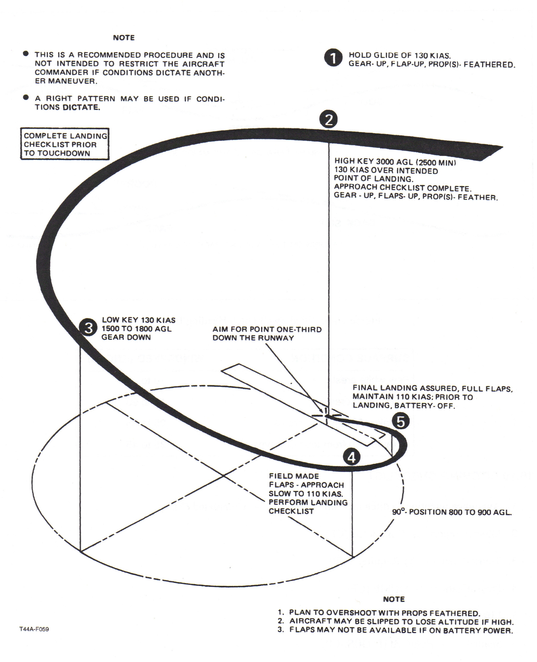

DIRECTION OF SWELL MOVEMENT
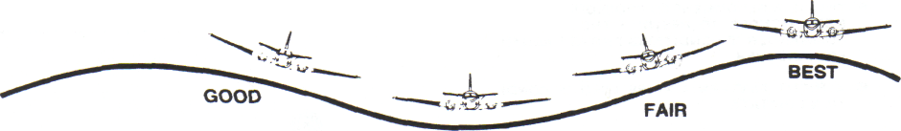
GOOD
LANDING PARALLEL TO THE MAJOR SWELL

GOOD!!
POOR!!!
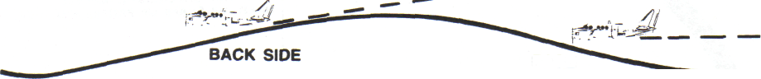
FACE
LANDING ON THE FACE AND BACK OF SWELL
T44A-F060

Figure 16-6. Wind Swell Ditch Heading Evaluation

SURFACE CONDITION
WINDSPEED (KNOTS)

Few white crests
Many white crests
Streaks of foam from crests
Spray blown from tops of waves
10 to 15 15 to 25 25 to 35 35 to 45

16.10 DITCHING CHECKLIST
- Announce intention to ditch and time to impact — Completed (P).
- Mayday report — Completed (CP).
- Transponder — As Required (CP).
- Pressurization - - DUMP (CP).
- Lifevests - - On and Adjusted (P, OBS, CP).
- Seatbelts — Fastened (P, OBS, CP).
- Gear - - UP (P).
- Flaps — As Required (P).
- Passengers assume braced position.

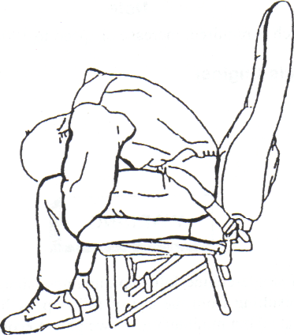

It is essential that an attempt be made to control the attitude of the aircraft throughout the ditching until all motion stops.

WARNING

Do not unstrap from the seat until all motion stops. The possibility of injury and disorientation requires that evacuation not be attempted until the aircraft comes to a complete stop.
Evacuate the aircraft through the emergency exit or airstair door. Take the liferaft and first-aid kit. See paragraph 16.13 for information on raft inflation.
WARNING
Do not remove the raft from its carrying case inside the aircraft. Do not inflate raft before launching.
16.11 DITCHING TECHNIQUE
16.11.1 Power Available (Both Engines)
- Gear - - UP.
- Flaps - - APPROACH.
- Rate of descent, 100 feet per minute (fpm) during final stages of approach (last 300 feet utilizing radar
altimeter).
- 90KIAS.
Note
If a no-flap ditch is required, increase airspeed to 100 knots.

16.11.2 Power Available (Single-Engine)
- Gear - - UP.
- Flaps — APPROACH.
WARNING
In the event of single-engine full-flap ditchings, abnormally high power requirements resulting from the use of full flaps will result in marginal controllability at all but minimum gross weights. Reconfiguration from full flaps to APPROACH flaps may result in settling and/or stall. The use of APPROACH flaps is strongly recommended in single-engine ditchings.
- Rate of descent, 100 fpm during final stages of approach (last 300 feet utilizing radar altimeter).
- 91 KIAS.
Note
If a no-flap ditch is required, increase airspeed to 100 knots.
16.11.3 No Power Available
- Gear - - UP.
- Flaps - - UP.
- Rate of descent should be such that airspeed be maintained at 130 knots (maximum glide KIAS) until approximately 200 feet AGL. At this time, transition should be made to approach flaps allowing airspeed to bleed off with a slight noseup attitude prior to impact by using radar altimeter or any visual reference to the water surface. Water entry should be at a minimum airspeed of 90 knots with a maximum rate of descent of 500 fpm.
Note
- Flaps and/or radar altimeter may be inoperative because of no generators
and low battery voltage.
- If a no-flap ditch is performed, adjust airspeed to enter the water at
approximately 100 KIAS with a maximum rate of descent of 500 feet per
minute.
It is essential that an attempt be made to control the attitude of the aircraft throughout the ditching until all motion stops.
WARNING
Do not unstrap from the seat until all motion stops. The possibility of injury and disorientation requires that evacuation not be attempted until the aircraft comes to a complete stop.
Evacuate the aircraft through the emergency exit or airstair door. Take the liferaft and first-aid kit. Sec paragraph 16.13 for information on raft inflation.
WARNING
Do not remove the raft from its carrying case inside the aircraft. Do not inflate raft before launching.
Pull inflation ring to inflate the raft.

CAUTION
Keep liferaft away from any damaged surfaces which might tear it.
Tie down first-aid kit in the center of the raft to prevent it from being lost in case the raft capsizes. After all personnel have been evacuated, move raft out from under any part of the aircraft which might strike them as it sinks. Remain in the vicinity of the aircraft as long as it remains afloat.

