T-44A Briefing Guides
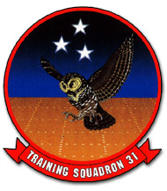

EVENT: C2102

DISCUSS ITEMS: Takeoff procedures, checklist management, landing procedures, checklists: climb, cruise, descent, approach, landing, and starting malfunctions.

takeoff procedures – Accomplish the takeoff in accordance with the NATOPS, Appendix A, and Appendix E. When approaching the hold short line of runway 13L, offset to the left when IFR and right when VFR. This expedites departures. The procedure also allows returning airplanes that are clearing runway 13R on the centerline of runway 4 to taxi between aircraft holding for takeoff.

Once cleared onto the runway, scan for traffic and verbalize the departure and approach end of the runway clear. Then complete the Takeoff Checklist while crossing the hold short line and taxiing into position for takeoff on the runway centerline. The “high idle” response must not be made during the Takeoff Checklist until N1 reads between 64-67%. Set 70-80% N1 when aligned with the centerline, unless you anticipate a long delay for your takeoff clearance. Check the wing/nacelle for fuel caps in place, panels secure, and no fluid leaks. Report “checked left.” The other pilot will do the same and report “checked right.” Without delay, check engine instruments/props stabilized and note heading aligned with the runway. Excessive time on the runway checking instruments, fuel, and nacelles before takeoff should be avoided. Time holding short can also be used for these tasks.

Crosswind takeoffs shall be accomplished in accordance with the NATOPS. Release the brakes, drop your heels to the deck and smoothly apply maximum allowable power. Do not use brakes to maintain centerline during the takeoff roll. Anticipate the need to add right rudder with power application. Monitor torque limits (lower red line with props full forward, 1315 ft-lbs.), ITT limits (red line, 790°), and auto feather armed lights illuminated (passing 90% N1 power lever position. The PNAC shall back up the power levers with his hand to keep them from creeping aft (and fine tune the levers if required to prevent exceeding limits), monitor aircraft and engine instruments, and call out any malfunctions. If the decision is made to abort, the PAC will call out “abort” loudly. Maintain directional control with smooth rudder application. Asymmetric power may be used in extreme crosswind situations. Normally the power levers are matched evenly and maximum allowable power is utilized throughout the takeoff roll. Scan the entire length of the runway to visualize lineup. If the aircraft drifts, gradually merge the track back to the centerline.

Scan airspeed throughout the takeoff roll. Do not depend exclusively on the CP to call rotate. At 91 KIAS (V_{SSE}) the CP will call “rotate.” Smoothly pitch up 7-10 degrees and relieve control pressure with electric trim once airborne.

Once airborne, with insufficient runway remaining to safely land, and a positive rate of climb visually noted, call “Gear Up.” The CP will also visually confirm a positive rate, then respond “Gear selected up.” After the gear indicates up, the CP will report “Gear up.”

A malfunction after the rotation requires the pilot to immediately determine if it is safer to continue flying or return to the runway. In most cases, it would be safer to continue flying while executing the NATOPS procedure for Engine Failure After Takeoff. Runway length must be considered before takeoff to determine if an immediate landing after rotation is feasible.

checklist management – The pilot will initiate and is responsible for the proper execution of all checklists. The CP ensures all checklists are completed when appropriate. The “challenge and reply” method is utilized for normal checklists; during emergencies, the “challenge-reply-reply” method is utilized. The CP will read the challenge and the reply for non-memory items. The appropriate crewmember will then complete the required action and respond with the reply.

If a particular checklist item is required to be performed by the CP, he/she will read the challenge, complete the action, then reply. When the response is listed “As required,” the crewmember will respond by stating the present operating status of the system. Some checklist items performed by the CP may require direction as to the desired action. If there is a desire to delay completion of a checklist, direct the CP to “hold the checklist.” When ready to continue, direct the CP to “continue the checklist.” The CP will report the completion of all checklists. The Landing Checklist is never held.

landing procedures – normal landings are descending, decelerating approaches to obtain the optimum angle of attack prior to entering the flare. Adjust power to idle at touchdown. Upon ground contact, lower the nosewheel to the runway. Maintain directional control with rudder and apply braking and propeller reversing (propellers full forward) as required by runway length.

This sim will introduce touch and go procedures, which should be memorized prior to the event.
7.17.2 Touch-and-Go Landing
After touchdown, ensure the propellers are full forward, retract the flaps, retrim elevators, and take off in a normal manner. With safe altitude, turn to the downwind leg of the traffic pattern.
WARNING
- Mechanical stops incorporated in the throttle quadrant prevent rapid
forward movement of the power levers from the beta range to the flight
range. Downward pressure must be applied to the power levers to permit
movement into the flight range and allow power to be added.
- Only the pilot in the left seat should reset the flaps while on the runway
during touch-and-go operations.
- Failure to properly reset flaps and/or trim will result in abnormal control
surface pressures when seeking to obtain a normal flying attitude upon
rotation. The aircraft can be safely flown out of this hazardous situation, but
extreme care must be taken to apply adequate control forces to achieve the
proper flying attitude. The flaps should not be raised until reaching a
minimum of 300 feet AGL.
- During runway operation, insufficient weight on the right main landing
gear squat switch may cause the landing gear handle downlock J-hook to
unlatch and allow the landing gear handle to be inadvertently raised while
the aircraft is on the ground.

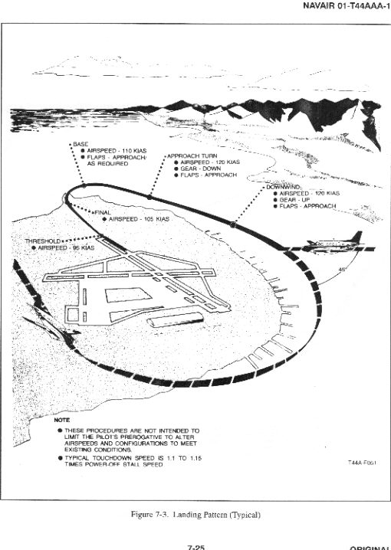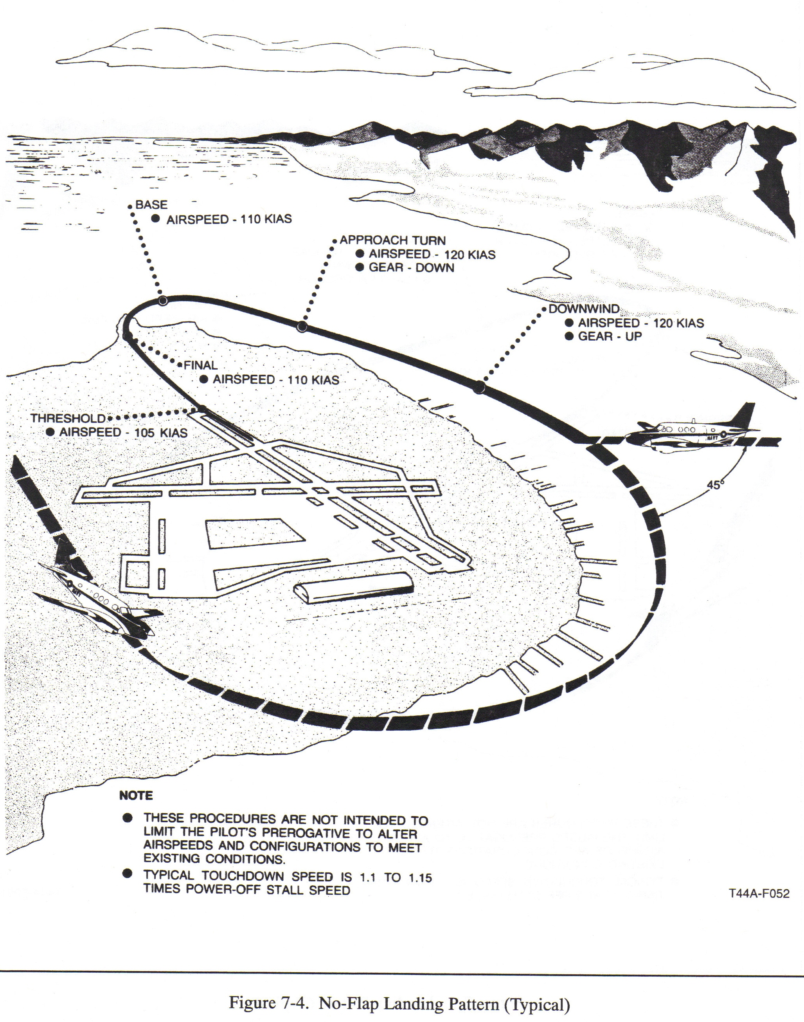
The Basic Landing Pattern

Upwind –
- Gear Up
- Props slowly retard to 1900 rpm
- Extended runway centerline at 300-500’ AGL and a max airspeed 130 kias
- Receive downwind clearance, check clear, turn as soon as possible after reaching 300’ AGL
- Interval is 15° ahead of the wing, abeam for aircraft still turning crosswind, and 30° behind for aircraft at full stop (unless you are intending to wave-off)
Crosswind –
- Max AOB is 30° anywhere in the pattern
- Maintain 130 kias
- Passing 600’ AGL select approach flaps (unless no-flap), adjust power to 500-600 ft-lbs
- Level off downwind at 800’ AGL with 120 kias

Downwind –
- Maintain 800’ AGL and 120 kias
- Fly one mile abeam by keeping AOA probe on runway edge (left pattern)
- Crab into crosswind as required
- Just prior to midfield, call “Gear Down, Landing Checklist”
- Complete checklist and add power to maintain 120 kias
- “Down and locked” when there are 3 green lights in the gear handle

180° Position (Abeam) –
- Quickly check green lights in gear handle before making radio call
- Report the 180 – “Navy Corpus Tower, Montana __, left 180, three down and locked, full stop.”
- Gear must be down by the 90° position

Approach Turn (Base) –
- Commenced abeam the runway approach end
- Reduce power to 300-375 ft-lbs
- Roll into 15-30° AOB

90° Position –
- Arrive at 90° at 110 kias, 500’ AGL, balanced, and perpendicular to runway heading

Final –
- Intercept extended runway centerline 1000-1200’ from the threshold at 250’ AGL
- Use wing low, top rudder method to maintain centerline. Don’t angle in.
- Descent slop is slightly steeper than a 3° glide slope.
- Smoothly move props full forward
- Verify three green lights and gear handle down with no red light and respond “Props full forward, three down and locked, review me complete.”
- CP verifies props full forward, three green lights, gear handle down and no red light and responds “Reviewed complete.”
- Land on first 1/3 of runway

No-flap landing
- Roll onto final at 110 kias, cross threshold as 105 kias
Approach-flap landing
- Roll onto final at 105 kias, cross threshold at 95 kias
Full-flap landing
- Select full flaps after the 90, but before rolling final at 105 kias
- Cross the threshold at 95 kias
climb checklist – the Climb Checklist is designed to check and set systems after takeoff, when safely established in a climb. P should normally call for the appropriate Climb Checklist anytime after passing 1000 feet AGL when cockpit duties permit. P calls “Abbreviated Climb Checklist” if remaining the area. If P calls “Abbreviated Climb Checklist,” CP completes items 1 through 4. If P calls “Climb Checklist,” CP completes the entire checklist. Neither checklist is required if entering directly into the home field bounce pattern or proceeding directly to and from Cabaniss.

cruise checklist – perform the Cruise Checklist if operating above 10,000 feet or if the leg is planned to exceed 1 hour. Initiate after level-off at cruise altitude.

descent checklist – the Descent Checklist must be completed if the Cruise Checklist was performed. Commence upon initiating descent from cruise altitude.

approach checklist – the Approach Checklist must be performed whenever the Climb Checklist is completed. The Abbreviated Approach Checklist must be performed whenever the Abbreviated Climb Checklist is completed. If P calls “Approach Checklist,” CP commences checklist at Step 1 and completes the entire checklist. If P calls “Abbreviated Approach Checklist,” CP commences checklist at Step 5 (Yaw Damp—OFF) and omits step 9 (Pressurization—SET).

The “Crew” item in this checklist requires a special touch and go crew brief, which must be memorized prior to this sim:

“When safely on the runway, I’ll reset the flaps and advance the power to the 12 o’clock. You reset the trim, call “Go” when the engines have spooled up, and call rotate at 91 knots with takeoff power set.”

landing checklist – the Landing Checklist is never held. It must be completed no later than the 90° position or 1 mile on a straight-in. P always calls “Gear down, Landing Checklist” when calling for gear handle to be placed down, whether landing is intended or not. If the gear is retracted or the checklist is interrupted for any reason, the entire checklist must be completed again prior to landing.

starting malfunctions –

13.1 ABNORMAL START

Monitor interstage turbine temperature during normal start. If the ITT rate of increase appears likely to exceed 925 °C or no rise in ITT is evident within 10 seconds after selecting LOW IDLE with the condition lever, proceed as follows:
*1. Condition lever — FUEL CUTOFF (note ITT decrease to below 790 °C). *2. Starter —OFF.
CAUTION
Starter use is time limited to 40 seconds on, 60 seconds off, 40 seconds on, 60 seconds off, 40 seconds on, then 30 minutes off.
Note
If starting attempt is discontinued and another start is to be attempted, allow 60 seconds delay to drain fuel and cool starter, then motor the starter for 15 seconds minimum. Allow the engine to come to a complete stop before another start is attempted.
13.2 EMERGENCY ENGINE SHUTDOWN ON DECK
If an emergency situation dictates immediate discontinuation of engine operation such as fire, fire warning light, chip light, etc., stop aircraft and set the parking brake, request assistance as necessary and proceed as follows:
Note
Confirm, if possible, that fire actually exists by checking engine instruments and nacelles.
*1. Conditions levers — FUEL CUTOFF.
*2. Firewall valves — CLOSED.
*3. Boost pumps — OFF.
*4. Fire extinguisher — As Required.
Note
The engine fire extinguisher is a single-shot system with one cylinder for each engine. Do not attempt engine restart until the cause of the fire is determined and corrected.
*5. Gang bar — OFF.
*6. Evacuate aircraft.

