Tactical Formation
Maneuvering (TFM)

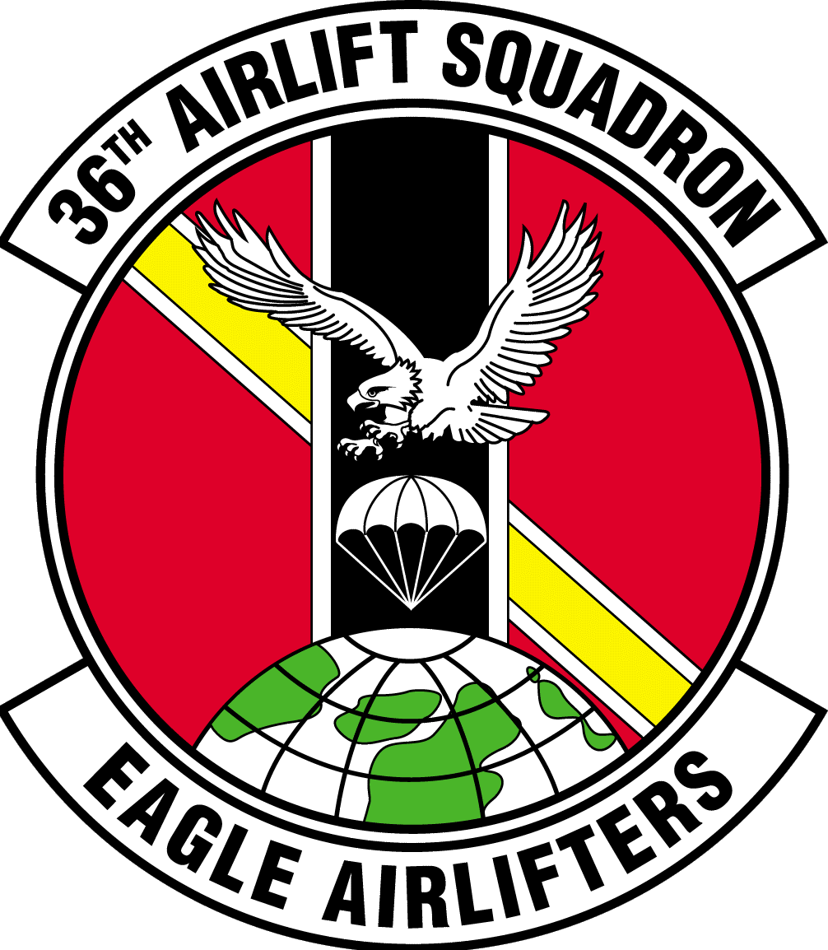


TFM Guide Notes & Disclaimers:

36 AS TFM CONTRACTS:

- Lead is Lead!... regardless of position after maneuver
- Wingmen will always climb to avoid a conflict (500’ is the standard) – whether it’s a planned maneuver or unplanned…
- Lead will announce variables such as bank angles and roll-out headings when different from those defined
- Wingmen will be proactive to maintain intended position
- Threat reactions: Wingmen will be assumed supporting unless called “egressing” (Lead will announce a Rally plan)

All TFM maneuvers in this guide assume a 2-ship element. 3-ship element operations are possible but can very quickly become unmanageable for basic aircrews. If interested in learning more about 3-ship element TFM, see your friendly neighborhood Weapons Officer.

When executing TFM, one concept becomes critically important -- the standard distance between the participating aircraft. This is referred to as the "Combat Spread". While there are no standards defining a max or min for the Combat Spread, most experienced aviators will agree that 4000' – 12000' Combat Spread covers the most comfortable visual range to work within. A 6000' Combat Spread has become an unofficial standard. Calculations in this guide will be predicated on a 6000' Combat Spread. If SKE is available, definitely use it to help gauge your "Mark-1" eyeballs to what the other aircraft looks like at Combat Spread – but always remember, TFM is completely VISUAL, and SKE should only be used an SA tool.

Each TFM maneuver is defined below in its most basic form. Variations such as changing bank angle or roll-out headings will very definitely become necessary when executing TFM in a fluid (i.e. combat) environment.

Remember, TFM is not intended to be some gee-whiz airshow fluff, but as a tool for Lead to fluidly and smartly maneuver the formation to take best advantage of terrain-masking and threat mitigation. Although training with a pre-planned TFM "script" for a route can be very helpful when first becoming familiar with TFM concepts, challenge yourself to perform maneuvers spontaneously with the goal of smart & effective formation placement!

Typical radio calls are given along with each maneuver description. As a general format, adhere to the following: "Kanto XX, (maneuver name/direction) x 2, (extra info as required), NOW".
… At "NOW", all aircraft will begin the maneuver...
TACTICAL FORMATION MANEUVERING

LINE LEFT / RIGHT COMBAT LEFT / RIGHT
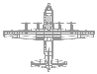
6k’-12k’
(4k’ min)
◄ Wing
45º
▲ Lead

6k’-12k’
(4k’ min)
Radio Call example:

"Kanto XX, Line Right, Line Right, NOW"
&
"Kanto XX, Combat Right, Combat Right, NOW"

BREAK / NOTCH or HOOK LT / RT (60^{O} AOB / 2g)
Expect rollout heading on break / notch call. Hook = 180º turn
Radio Call example:

"Kanto XX, Notch Right, Notch Right, Rollout 060, NOW"

CHECK LEFT / RIGHT (30^{O} AOB, 30^{O} turn)
Radio Call example:

"Kanto XX, Check Right, Check Right, NOW"

IN-PLACE LT / RT (45^{O} AOB, 90º turn or roll-out called by Lead)

Radio Call example:

"Kanto XX,
In-Place Left,
In-Place Left, NOW"

(without more amplifying information, the turn would be to 90º left)

LINE and COMBAT calls are typically used as a pre-emptive maneuver to put the formation in an advantageous position when either approaching an upcoming threat or when pre-positioning wingmen for an upcoming maneuver – whether that "threat" is terrain, actual threats, or just a vulnerable area crossing, these two formation geometries offer increased survivability. Reference 3-1 Vol 25 or see an Instructor for more information.

The LEFT or RIGHT portion of the call is meant to direct the wingmen to that side of Lead; in this example, the wingman is in the LINE RIGHT and COMBAT RIGHT positions respectively....

For a LINE call, wingmen will establish directly abeam lead at the designated Combat Spread (or as lead directs). To determine the abeam position, move to line up lead's props as you look across and "through" them.

For a COMBAT call, wingmen will establish themselves at combat spread (or as lead directs), 45º aft abeam from lead on the designated side.

These maneuvers are primarily used defensively. All three maneuvers require 60º AOB and 2g level turns. These maneuvers can be initiated from any formation geometry since all players will execute the maneuver simultaneously.

The HOOK turn is used to turn the entire formation around 180º in a hurry. This maneuver is most commonly associated with a RETROGRADE directive.

Vol 25 only defines a BREAK call, but the NOTCH call has evolved as a technique to distinguish between different classes of threats. Most experienced aviators will advocate the technique of associating NOTCH calls with radar threats and BREAK calls with IR missile threats (since both defensive maneuvers should invoke quite different Pavlovian responses from the pilot [what to do with power, which way to turn, expendables, etc]). Since the first part of a proper threat call should be the maneuver, it's obvious where the need for an immediate distinction is critical! Get with an Instructor for more info & opinions about this.

This CHECK turn maneuver seems to bring it pretty weak in this wild world of TFM... Just 30º AOB and 30º heading offset??? What's the deal? Well, the CHECK turn is intended for and used to make simple course corrections and also to mitigate certain threats when they are known to be at a non-lethal range. The CHECK turn is a nice-and-easy, simultaneously-executed maneuver to get the formation away from far-off threats or to just get back on course, without making abrupt maneuvers that would otherwise serve to highlight the formation! The CHECK turn is executed simultaneously and can be called from any formation geometry.

Similar to a BREAK turn, the IN-PLACE turn is a simultaneous, level turn to a directed heading (90º turn is the standard), but uses 45º AOB instead of 60º AOB... The IN-PLACE turn is not intended to be the abrupt defensive maneuver such as the BREAK turn, so a lesser AOB is more desirable (why is that??? Reference 3-1 Vol 25 or see an Instructor for details...).

This turn can also be initiated from any formation geometry, and is used to position wingmen for upcoming maneuvers or to mitigate specific threats.

Typically, these turns are either 90º or 45º off heading, and will be commonly announced as such ("...In-Place 45 left..."), but can be to any heading at all ("...In-Place Left, Rollout 310..."). Remember, the key is 45º AOB.

SHACKLE (45^{O} AOB, 45º initial HDG change)

45^{O}
45^{O}
Radio Call example:

"Kanto XX, Shackle, Shackle,
Base Altitude xxxx,
NOW"

CROSS TURN (45º AOB, 180º turn)
Radio Call example:

"Kanto XX, Cross, Cross,
Base Altitude xxxx,
NOW"

DELAY TURN LT /RT (45^{O} AOB, usually 90º turn)

The SHACKLE is used to reposition wingmen or to re-establish formation integrity. The primary benefit of the SHACKLE is the ability for both aircraft to help ensure their collective 6 o’clock is clear. The SHACKLE will "cost" ~30 seconds in a low-level environment…

As a standard, it involves 45° AOB and 45° heading change. The SHACKLE must be initiated from the LINE geometry; at “NOW”, each aircraft will turn towards the other using 45° AOB. Lead will announce an MSL Base Altitude for the maneuver… Wingmen will immediately initiate a climb to announced Base Altitude + 500 ft as they begin to turn. From an initial 6000’ Combat Spread, the two aircraft should be approximately crossing over one another as they complete a 45° heading change; continue the roll to smoothly transition to 45° AOB in the opposite direction while returning to original base heading. Both aircraft should then retain ~6000’ Combat Spread at the completion of the maneuver.

From other Combat Spread distances, the geometry of timing the mid-way roll-out can be much trickier (the goal being to maintain the integrity of the initial Combat Spread at completion) -- to assist Lead can call for lesser intercept angles (such as 30° HDG change) or pre-plan timing prior to initiating a turn back to base heading. Also, completely “level” Shackle maneuvers are possible (because any climbs may serve to highlight aircraft in a low-level environment); for more information on any of these variations, see a Weapons Officer...
____________________________________________________________________________

The concept of the CROSS is similar to the HOOK – to make a 180° turn. The CROSS involves only 45° AOB and can be initiated from any geometry (most commonly from LINE). Similar to the SHACKLE, Lead must announce an MSL Base Altitude, and wingmen will fly Base Alt + 500 ft as they initiate the turn. Both aircraft turn towards one another and complete the 180° turn.

Even more so now, maintaining the integrity of the initial Combat Spread will be complicated. However, that is not the primary concern, so don’t sweat it -- the climb will ensure deconfliction and wingmen can readjust position as required while rolling out… For a non-highlighting level-altitude CROSS, just have wingmen automatically delay their turn by 2” to ensure deconfliction.

By now, you should be wondering: “What possibly is the advantage of the CROSS since we already have the more aggressive HOOK to make a 180?” The answer may save your life someday! … Reference 3-1 Vol 25 or see a Weapons Officer for more details.
____________________________________________________________________________

Perhaps the most intimidating concept of TFM is the DELAY turn… To understand the DELAY turn, one must understand the “Outrigger Rule”. The specific definition can be found in 3-1 Vol 25. However, the Outrigger Rule can be summed up as follows: Look in the direction that Lead announces for the maneuver… If you SEE the other airplane, turn immediately into the called direction (using 45° AOB). This maneuver is primarily used to make enroute turns.
2

The DELAY turn must be initiated from the LINE geometry, and can be accomplished from any Combat Spread. Unless a roll-out heading is announced by Lead, the DELAY turn will be a 90° turn in the called direction. For this maneuver, it doesn’t matter what side Lead begins on…
Radio Call example:

"Kanto XX,
90 Right,
90 Right, NOW"

(Lead can be in either position!)

But what if you look over in the called direction and you don’t see the other plane? Then just continue on base heading until you see the other plane in your 5 or 7 o’clock (depending on the called side – 5 o’clock for right turns, 7 o’clock for left), and then you start a turn in the called direction using 45° AOB. Have your Bubbleer call the 5 or 7; otherwise, the respective pilot can look over their shoulder and initiate the turn when the other aircraft becomes visible on that side.
2
1
1

The 2-ship should roll out in LINE geometry on the new heading while maintaining approximately the same initial Combat Spread. For turns less than 90°, a good rule of thumb for the “later turner” is to turn when you see the other plane cross your 6 o’clock… See a Weapons Officer for more info on other roll-out angles...

